1. **He grew up on a dairy farm in North Carolina.**Graham was born on Nov. 7, 1918, in Charlotte, North Carolina. He was the first of four children born to William F. Graham Sr. and Morrow Graham.
2. **His “breakthrough” as an evangelist began in 1949.** Graham’s breakthrough arguably came when he embarked on a three-week tent campaign, or “crusade,” in Los Angeles and proceeded to extend it to eight weeks.
3. **He spoke to more than 215 million people in more than 185 countries and territories.**Graham’s first crusade was in Grand Rapids, Michigan, in 1947. His final crusade was in New York in Madison Square Garden in 2005.
4. **He came to be known as “America’s pastor.”**Graham met with 12 U.S. presidents, beginning with Harry Truman in 1950 and ending with Barack Obama in 2010.
5. **He received the Presidential Medal of Freedom from President Ronald Reagan.**“This medal is given to those who have risen to pinnacles of achievement in their fields. It’s a recognition of their accomplishments, hard work, and dedication for America and for humanity,” Reagan said at the presentation ceremony on Feb. 23, 1983.
6. **He was listed on Gallup’s annual U.S. poll of most admired people 61 times, more than any other world figure.**Graham was also included on the 2017 list. The person with the second-most appearances on the list, which began in 1946, is Reagan with 31.
7. **Graham was knighted in 2001.**In Washington, on Dec. 6, 2001, Graham received an honorary knighthood from Sir Christopher Meyer, the British ambassador to the U.S., on behalf of Queen Elizabeth II. “He is being honored for his huge and truly international contribution to civic and religious life over 60 years,” a Foreign Office spokeswoman said.
8. **He received a star on the Hollywood Walk of Fame in 1989.**

[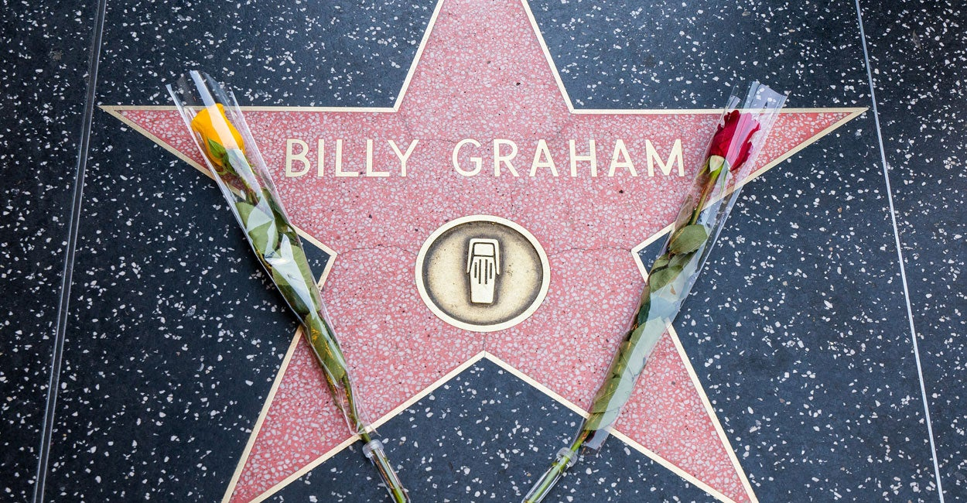](http://dailysignal.com/wp-content/uploads/billygraham.jpg)

*(Photo: AaronP/Bauergriffin.com/Newscom)*

1. **He pledged never to be alone in a room with a woman other than his wife.**To avoid temptation and remain faithful, he vowed never to be alone in a room with a woman other than his wife, to whom he was married from 1943 until her death in  2007. (Vice President Mike Pence has taken the same pledge as Graham.)
2. **He helped George W. Bush stop drinking.**President George W. Bush attests that meeting with Graham and talking about religion was a turning point in his life. After Bush met with Graham, his perspective on alcohol consumption changed.