**Readability**

**Goal:** Implement a program that computes the approximate grade level needed to comprehend some text, per the below.

To determine the reading level of some texts, the Coleman-Liau index is a popular readability test that is highly utilized. The Coleman-Liau index of a text is designed to output what (U.S.) grade level is needed to understand the text. The formula is:

Here, ‘L’ is the average number of letters per 100 words in the text, and ‘S’ is the average number of sentences per 100 words in the text.

Let’s write a program called readability that takes a text and determines its reading level. For example, if user types in a line from Dr. Seuss:

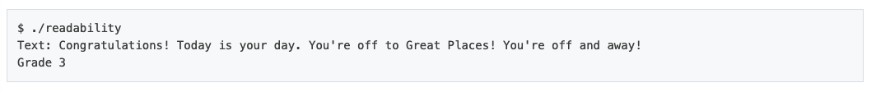

The text the user inputted has 65 letters, 4 sentences, and 14 words. 65 letters per 14 words is an average of about 464.29 letters per 100 words. And 4 sentences per 14 words is an average of about 28.57 sentences per 100 words. Plugged into the Coleman-Liau formula, and rounded to the nearest whole number, we get an answer of 3: so this passage is at a third grade reading level.

**Specification**

Design and implement a program, readability, that computes the Coleman-Liau index of the text.

* Your program must prompt the user for a string of text (using get_string).
* Your program should count the number of letters, words, and sentences in the text. You may assume that a letter is any lowercase character from a to z or any uppercase character from A to Z, any sequence of characters separated by spaces should count as a word, and that any occurrence of a period, exclamation point, or question mark indicates the end of a sentence.
* Your program should print as output "Grade X" where X is the grade level computed by the Coleman-Liau formula, rounded to the nearest integer.
* If the resulting index number is 16 or higher (equivalent to or greater than a senior undergraduate reading level), your program should output "Grade 16+" instead of giving the exact index number. If the index number is less than 1, your program should output "Before Grade 1".