Monash University
MEC3416 Machine Design
Semester 2, 2022
Project: Maintenance of offshore wind turbines
Groups: 4-6 students
- Background
Offshore wind power (energy) is to use wind farms built offshore, to harvest the wind energy and generate electricity given the high wind speed offshore. It is one of the fastest growing sustainable energy sources, and operation and maintenance often bring new engineering challenges. The components of the turbines such as bearings need to be serviced, and the service engineers are often required to land on the turbines from the helicopters. The objective of the project is the design a passenger/material hoist or climbing system to support the workers to work on the turbine tower after arriving in a boat.
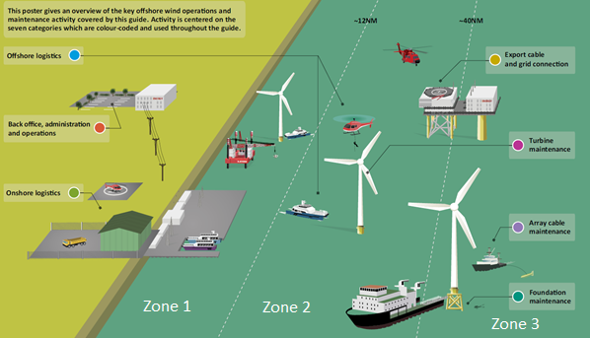
Figure 1. Offshore wind operations and maintenance activity (Source: A Guide to UK Offshore Wind Operations and Maintenance)
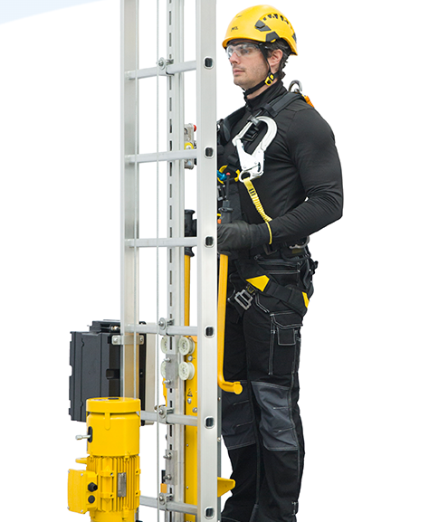
Figure 2. Commercial climb assist system (source: https://www.3slift.com/product/climb-auto-system/)
Commercial climb assist device has been developed (Figure 2) to “transport” the engineers to the top of the turbines inside the turbine tower. Details of the design can be viewed at https://www.youtube.com/watch?v=lAFlV0_F-JY. However, breakdowns can occur due to the lack of maintenance, and the engineers are often required to climb and inspect the exterior of the turbine tower (https://www.youtube.com/watch?v=bNBQKlHt6rg). There is no emergency exit during major incidents such as fires. You are employed to design a new self-powered equipment, and after the completion of this project, the equipment can still be transferred to and used in other turbines.
- Project Introduction
- Your design will focus on the hoist or climb mechanism (see example in Figure 2) and its tower clamping system which secures the passenger platform onto the tower preventing it from fall-off. Your design should be different from existing commercial systems.

- The equipment needs to be sized properly so that it can accommodate the specified passenger and loads. Weight estimation of the equipment is needed so that you could design the drive and tower clamping system accordingly. However, structural design of the tower, rack and/or rails is out of your scope.
- The wind turbine design is out of your scope, but you may need to estimate / assume the dimensions of the tower so that the tower clamping system layout and design can be performed. Simple sketch of the tower needs to be presented as one of the design boundaries.

- You shall decide on the number of drives and select appropriate electrical motors as the prime movers.
- Total cost for the design including the base (based on the estimated weight) shall be considered. The costs of the major components include the base, motor(s), drive mechanisms and clamping system. This includes material and manufacturing costs, costs of small components including bearings, gears, etc.
- Control and electronics, including any cable management systems, are not included in this project.
- Taper angle of the turbine tower is considered to be negligible.
- Wire ropes or safety ropes from ground or from the top of the turbine tower can be installed and used.
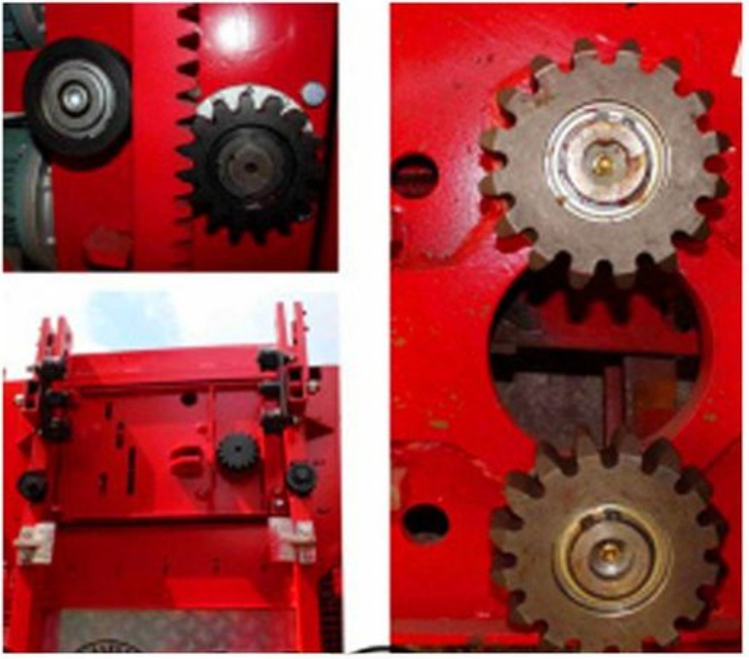
Figure 3. Rear view of a typical passenger / material drive system (source: https://www.pinterest.com/pin/392235448787592911/)
- Scope of Work
3.1 Specifications
Below expectations have been outlined by the main contractor so that the suppliers can finalize the design parameters, manufacture and supply accordingly:
- The equipment shall be able to reach the maximum height of 120 m.
- Travel 120 m between 5 to 7 minutes.
- The base shall be able to carry whichever higher loading of the below conditions, at the maximum travel speed:
- Maximum 1 person and 20 kg cargo
- 100 kg cargo
- For equipment service life design, below assumptions are to be taken:
- Average traveling height of 120 m per trip.
- Hoisting up: full load, and lowering: 20% of full load
- Hoist up speed = Lowering speed.
- Approximately 4 hours continuous use per working day.
- Single-phase or three-phase power supply can be provided from the service boat. Or lithium batteries can be considered as the primary power source.
3.2 Components
Your design is to include selection and specification of all functional components of this appliance (which include motors, power transmission, shafts, bearings, gears, mounting structure) as well as a structure and fasteners / weldments (cosmetic items such as controls interface and coverings are not required). Note that design of some components may lie outside the material covered in this unit; you will likely need to apply knowledge gained from your own, independent research. The focus of this project is mechanical design, and electronics and control will be designed by electrical engineers.
In order to help you to narrow down the design boundaries, below have been decided:
- Rack and pinion system shall be used for the mechanism. Pinions are preferred to be designed and manufactured, not to be purchased off the shelf.
- Commercial racks can be used, such as those used in the construction sites, and additional rails can be installed for attaching the equipment to prevent falling.
- Either electrical motors coupled with gearboxes, or geared motors could be used.
- Use hollow shaft gearboxes so that you have to design shafts to be inserted into the gearboxes.
- Recommended bearing brand: SKF
3.3 Safety
The design should include redundancy measures (fail-safe) which prevent sub-system loss in the event of drive fails. Fail-safe brake motors shall be used. The safety factors (SFs) are recommended to be at least 3 in this project, and you will not be required to design extensive safety measures. Occurrence of excessive noise or vibration is assumed to be non-existence. These considerations and others that your group deem important should be addressed in your design / report.
3.4 Environment
Your equipment will be used outdoors in inclement weather. While the outer housing will be made by conventional means (readily available materials which are painted or otherwise coated to provide corrosion protection), it should be shaped in such a way that it provides protection to more sensitive components. You should also give consideration to maintenance requirements such as consumable replacement and periodic lubrication.
3.5 Cost
As with all engineering projects, a detailed understanding of costs is important. For this project, you are required to document all aspects of the design which contribute to cost and describe your efforts to minimise them. This should include, but is not limited to: area of steel sheet used (including scrap from standard sheets), length of a given size of bar or shaft-stock consumed, individual manufacturing processes required (turning, cutting, jigging, fastening, etc.), total length and number of welds, and subcomponent part and their actual cost. Note that details such as cost of welds and labour cost for setup are not required, but it is important that you document your design complexity and actively critique it, eliminating complexity or substituting features for more cost effective ones where possible. The costs of control system, motor(s) and racks/rails of proper sizes are not included in this project.
- Project Assessment
There will be 2 graded submissions:
Part 1 – Project Concept | 8% | Due Week 6
Part 2 – Progress Review | N/A | Week 8. No submission needed
Part 3 – Final Report | 30% | Due Week 12
Part 1 – Project Concept Submission (8% due Week 6)
File name format: Concept-XX.pdf (replace “XX” with your team number, submitted in a single file. Please include the individual Assessment Cover Page as a separate file). There is a strict limit of 25 PowerPoint Slides excluding the individual Assessment Cover Page. These PowerPoint Slides should be converted to PDF before submission. Animation is not required. Use colour coding and well-labelled diagrams to present your ideas.
The purpose of this project concept submission is for your team to explain your ideas and how you plan to carry out a systematic design analysis for your system. The following three items must be reported and you must decide how they are presented:

1a – Concept Design / Sketches:
Provide estimation on load conditions and expected life cycles by considering the working time and sequence of events. Provide your conceptual plan of the equipment and the tower clamping system in the form of a SolidWorks CAD model based on the decision of your team. An isometric assembled view and an “exploded” view would be ideal. Precise dimensions are not required at this stage.
1b – Free-Body-Diagrams (FBD)
You may use your existing 2D and/or 3D CAD renders (preferred) and/or hand-sketched diagrams to show predicted forces within your system. Support these values with relevant calculations. FBD’s would typically include all external forces and supports (calculated reactions).

1c – Design Analysis Framework (DAF)
Once you have the FBD’s, provide a summary to describe what sort of analyses (minimum of 8 sets) to be carried out for each major part/component of your system (which shall be in consistent with the main report as specified in Section 5.0). At this stage, you should use components from your 3D CAD renders of the draft assembly with hand-written and/or typed annotations/notes. You will need to mention which failure analysis will be carried out but no finite-element analysis is required at this stage.
Part 2 – Final Report Submission (30%, due Week 12)
A separate document of detailed instructions will be provided after concept submission.

- Suggested weekly project targets:
Week | Milestones
1 | Meet and greet
2 | Project Team Finalized. Brainstorm for ideas and finalize design with estimated sizing
3 | CAD major parts of entire assembly and sketch load paths over the assembly
4 | Use snapshot s of 8 major parts in CAD to draw FBDs & decide on DAF
5 | Prepare your slides for Prelim Submission
6 | Prelim Submission on Moodle Assignment Box  Do your CATME (Round 1), then take a break
7 | Based on the 8 approved DAF items, distribute workload to individuals (or pairs if that is preferred) to do the following:  - add-on fasteners to your CAD  - carry out initial design analysis (calculations based on estimated sizing in Prelim Submission)  - search for catalogues for purchased parts  - run FEA simulations for machined complex parts (each part will require 3 different mesh sizes)
8 | Update each other on individual progress and make corrections if required, continue with work listed in previous week
9 | Optimization phase (this will may take more time but you will have some buffer to utilize your semester break if necessary)  Create spreadsheets to find optimum sizing  Run multiple simulations to improve design (either shape or size), depending on your strategy
10 | Update CAD Assembly generate Assembly and Detail Drawings based on finalized sizing (and/or shape)  Draft your report and compile necessary & relevant pages of catalogue
11 | Add on general, specific and GD&T tolerances to your drawings  Compile submission items for review
12 | Tidy up report and generate individual Assessment Cover Page  Do your CATME (Round 2)  Submit report, drawings and catalogues on Moodle Assignment Box

- Further Information
The final report should be professionally presented. Resources include: https://www.monash.edu/learnhq/resources/write-like-a-pro
Figures and tables should be labelled and numbered appropriately. References should be made where necessary. Your team’s ability in selecting suitable subtopics for the main contents of the report will play a huge role in giving your report a logical and proper structure.

