
Gilmour NASA KSC Test Plan Proposal
VERSION 1 DRAFT: B.Jessett 16/04/2022

Please make a copy of this file before editing
Add completed proposal to this folder by Thursday 21/04/2022 11:59pm

Test Plan Name: | Kiln repurpose to measure thermal resistance
Test Plan Owner(s): | J.Abi Chebli, E.Creaser, L.Peng, J.Li, S. Michael, H.S. Shaqat
Submitted on:

Hand draft sketch or CAD model(s) of test concept (if applicable)
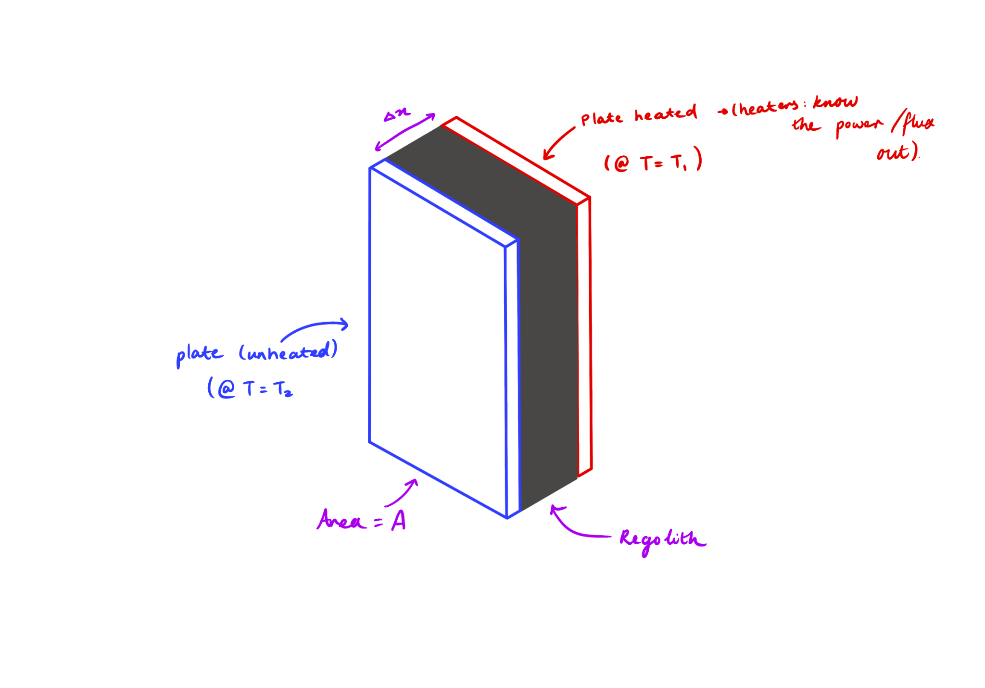

Hardware Configuration | Configuration of rover / payload  Design, as seen above, has two plates with a layer of regolith between them. One plate is heated using heat pads, another is a ‘cold plate’ . The hot plate will heat the plate and eventually the system will reach steady state and the temperature difference between the two pads can be used to determine thermal conductivity of BP-1 and therefore its insulation potential.  Existing Hardware  Reuse Kiln system, Heat pads, Pics and battery that were used for the kiln control system.  Additional components required  - plates to heat /housing for regolith  - temperature sensors
Test Objectives | What are you aiming to achieve, how does this support the team / X area of research  Background:  Because we can’t perform water extraction in the RTB, we could alter the kiln system to a design that measures regolith insulation potential of regolith (thermal conductivity) as well as observe how the system performs and interacts with regolith.  Scientific background: lunar regolith has been found to be a good thermal insulator and utilising regolith as insulation has been floated as a way to protect people/infrastructure/equipment during the extreme lunar temperature cycles, from -170 C lunar nights to 170 C lunar days, both lasting 14 days.).  How does this support the team?  Is the closest the team has come as of yet to testing an analysis system on actual regolith. Experience gathered from undergoing testing would be very helpful to informing any future projects development phases.  How does this support research?  Currently Bp-1 has been used for mainly testing of mechanical systems and its thermal properties haven't been here. By estimating the thermal conductivity we could assist in determining these properties as well as test out an in situ style systems ability to test this potential.  If findings indicate a similar insulation ability to lunar regolith, BP-1 could then be used for future testing of systems that analyse or utilise this property.  main objective  - Determine thermal conductivity and insulation potential of BP-1(currently not well documented) and using an in situ system to determine  - thermal conductivity (using a cold and hot plate with regolith in between - Similar to Guard Hot Plate/Heat Flow Metre methods described here)  - (testing different layers of regolith thickness)  - density/compactness  - Using thiswe discover, we can see if BP-1 is similar to lunar regolith (in terms of thermal properties because it hasn’t been researched a lot (properties of BP-1 here and here )  - if so then could be used for future thermal properties analysis tests  - or tests that examine methods of protecting heat intense systems( e.g. water/oxygen extraction) or sensitive equipment from hot lunar days.y  - benefits of using regolith for insulation  - readily available  - free  dust interaction/mitigation objective  - the regolith compartment needs to be sealed to protect pads and any electricals.  - can monitor wear of materials used to house the regolith, particular if we are refilling the compartment a few times  - can also observe how much regolith remains/ how hard it is to clear system (if system were on moon and sampling different sites, different compositions from old tests would effect results)  - if sealing was insufficient observe regolith interaction between  - heat pads  - temperature sensors  - electricals  create a design that prevents regolith getting stuck, and test effectiveness. could attempt to empty the kiln and then collect another sample (as if rover was sampling different lunar sites)
Environment | What specific environment is the system subjected to?  Inner parts of the plates will contact the regolith. Parts of the temperature sensors will/may need to contact regolith as well. Once regolith is placed within the system, the box that will hold the system could be placed in the corner of the side room that KSC team members will be in (or could be placed in the RBT in the corner if we cannot place it in the side room).
Methods and Primary measurement(s) | Measurements:  Background Research:  This peer review article categorises the presentation of measurement methods for thermal properties in 5 parts:  - Thermal transport properties  - Phase transitions and chemical reactions of materials  - Physical properties, which are affected when heat is supplied to a body.  - Thermogravimetry  - Temperature measurement methods  Conclusion: We aim to measure the ‘thermal transport properties’.  Background Research:  As outlined here, to calculate thermal conductivity, we will need:  - the steady‐state temperatures (Steady‐state conditions occur when the amount of heat flux is equal at each point of the layered system)  - the specimen's thickness  - the specimen's metered area  - the heat flux input to the hot plate are used  Conclusion: Hence, key parameters to measure:  - The initial temperature of both plates  - The temperature of the plates as we heat it up  - The final temperature (steady-state temperature) of both plates  - the regolith thickness  - the regolith metered area (before and after heating)  - the heat flux input to the hot plate are used  Potentially also:  - Measuring the temperature of the air as the system operators may help us determine how much energy was lost to external system  Method of Measurement  Background Research:  This peer review article summarised the most commonly used techniques to measure thermal conductivity include:  - Steady-state methods  - Guarded Hot plate  - Cylinder  - Heat-Flow metre  - Comparative  - Direct heating  - Pipe method  - Transient methods  - hot wire, hot strip  - hot disk (TPS technique)  - laser flash  - Photothermal (PT), photoacoustic  Illustrated in the table taken from the article  Conclusion: We will be using a steady-state method, called the heat-flow meters, to measure the thermal conductivity of BP-1.  Measurements of temperature will be done by using thermocouples (as done/mentioned in [1], [2]) and thermocouple amplifiers.  Measurements of power will be done by reading the current, power, voltage outputs.  To compress the regolith, can do something similar to this:  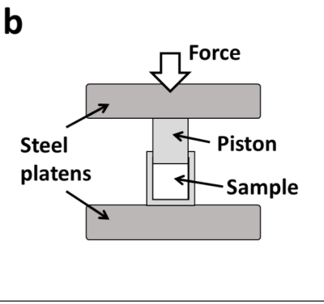  Before the test:  - Determine/measure the starting height for the regolith  - Determine/measure the metered area  - Determine/measure the thickness of the specimen  - Determine/measure the volume of the initial specimen  Testing Procedure:  - Weigh the system  - Place regolith in section  - Compress regolith  - Repeat steps 2-3 until regolith is compressed as much as possible and at a certain height specified.  - Reweigh the system  - Record the temperature of both plate and regolith  - Turn on heating and let it heat until it reaches steady state  - Once steady state is reached, record temperature  - Mark/measure the height of the specimen and whether it was grown or shrunk  - Reweigh the system  - Remove the regolith  - Determined the change in height  Post test:  - Determine the thermal conductivity: 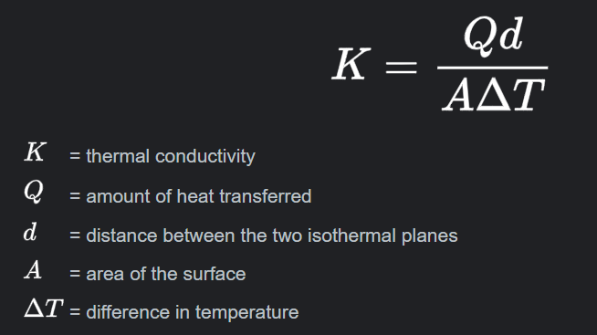  - Determine the thermal transmittance (U-value)  - Determine how much heat escaped into the atmosphere  - Determine a very basic, straight line (if any) Thermogravimetry  - Could calculate the specific heat capacity and see if we can compare this with any resources  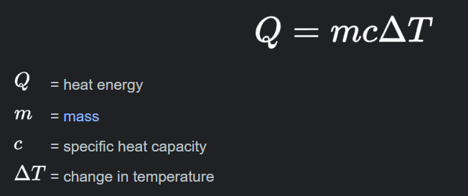
Mechanical requirements | In the case you are mounting items to the existing system, where will they go? How will they interface mechanically to the existing system?  . A box to house this system is required to be designed and made - probably best made out of sheet metal. This box should hold the kiln body system, insulation pads and any electrical requirements - such as batteries, heat controllers, head pads, thermocouples, breakout boards etc. Need to design a compression plate to compress the regolith.
Software requirements | How do the sensors interface with a PC / rover etc. what are the expected sensor outputs? UART I2C SPI etc.  Parts of the current software system used in the ARC 2022 science kiln could be used - i.e. the system used to turn on the heat and turn it off.  However, some new software will be required for temperature reading/ for monitoring the system. We would be interfacing with an arduino (I2C device) that would be connected to a PC for data collection (currently unsure of specifics as dependent on specific temperature sensors chosen and budget for this test, however, that is the general idea - especially if we go with the thermocouples and breakout board mentioned below).  Code to interpret the sensor readings should be pretty quick to write since there are examples for each of the boards online.
Electrical requirements | Power requirements, communications, connectors etc. Does the rover already have what we need? Do we need expansion? or can it all be external?  The main electrical requirement necessary is to provide power so heating pads can heat the plates that will heat the regolith. This could be done using the system the team has already created - i.e. using the electrical system used in the ARC 2022 science kiln; including the battery, electrical wiring, heat controller etc. Alternatively, another method of powering the heat pads could be to use an external power source in the RTB if we have access to one - instead of using the ARC 2022 science battery (the benefit of this would be that we wouldn’t have to carry another battery to America and the a longer power time if required, however, this is not essential and the science battery should be adequate).  Electrically, the system would need to be modified slightly to take temperature readings to monitor the system - and would require some thermocouples and a breakout board hooked up to an arduino. We could get other boards to convert the signal to other forms such as analog, SPI, etc. whatever is easiest - currently, we plan to use analog as we think it is the easiest. All the breakout boards can be placed on some veroboard and have connectors going out to the thermocouples.  More research is required to determine how we plan to save the readings - one potential idea is to connect an sd card to the arduino and have it write to a text file.  A lot of the additional electrical parts mentioned is estimated to not take too long to make.  Optional: Additionally, if we want to set up any cameras to video/document the whole process, we would require some cameras. These cameras could be the ones used in the current ARC and URC payloads.
Personnel requirements | How many people are needed to undertake the testing at KSC?  What might their roles be?  1 KSC team member would be required to initially set up the system, disassemble the system when complete and record any data (at the beginning/end). This person could work on other tests after setting up the system. An electrical member would also be useful for troubleshooting - in case issues arise with providing energy for heating the system.
Estimated time on site to perform testing | How long will the proposed test take to undertake? Are there ways that this test could be completed in parallel with other tests? ie. test stand instead of everyone using the rover at the same time etc.  Overall not very intensive for KSC team. This test would mostly be automated. Hence, as this test can be started and left alone while other rover testing is being done, it would/should not be a large time burden on the KSC team.  Tests would be done off rover in an external system using the kiln battery.  The operation of the test may take a long time as the design needs to reach steady state before taking readings. Saying that, it is possible to reduce the duration of the test required - in particular, if the duration of the test needs to be reduced, a smaller density of regolith could be tested, resulting in a quicker time to heat up and reach steady state (i.e. the test could be scaled down). However, since this test would run simultaneously and autonomously while other rover testing is done, if it is set up near the start of the day and left to its own accord until steady state is reached, reducing the duration of the system may not be required.  Some monitoring and documentary of the system would be suggested and this could be done at different stages: initially, after being filled with regolith, after heating the regolith to steady state and after emptying the heated regolith. We would like it if photos are taken at each stage and physical observations are recorded . Additionally, cameras could be set up in the system to potentially video the whole process. Additionally, automated system monitoring could be implemented to see/make sure the system is operating properly throughout the heating process.
Supporting documents | Links to any research papers which the testing is similar to, or is based off  https://doi.org/10.3390/app11093853 ‘Utilisation of Moon Regolith for Radiation Protection and Thermal Insulation in Permanent Lunar Habitats’  https://denning.atmos.colostate.edu/readings/lunar.regolith.heat.transfer.pdf  alternative regolith thermal conductivity sensors https://www.sciencedirect.com/science/article/pii/S0168900205000112  Measuring Thermal Conductivity  Range of different methods determining Thermal Conductivity: https://arxiv.org/ftp/arxiv/papers/1605/1605.08469.pdf  https://www.intechopen.com/chapters/51497  Radial/Rod method: https://iopscience.iop.org/article/10.1088/1742-6596/395/1/012081/pdf  Soil Thermal Conductivity Analysis  https://sci-hub.hkvisa.net/10.1016/j.rinp.2019.102830  Springer Handbook of Materials Measurement Methods  https://link.springer.com/referencework/10.1007/978-3-540-30300-8  Thermal Properties  https://link.springer.com/referenceworkentry/10.1007/978-3-540-30300-8_8

