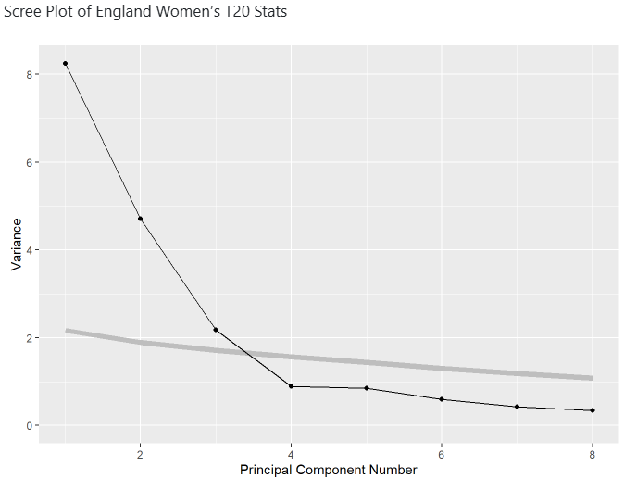
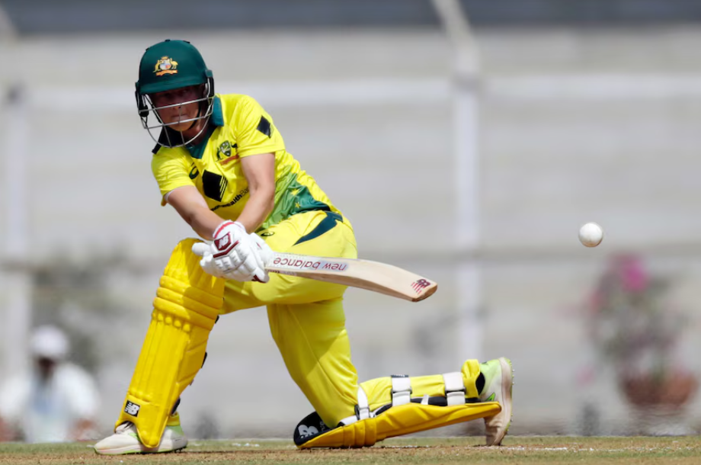

https://www.abc.net.au/news/2018-04-01/australian-women-set-international-t20-record-score/9608318

