
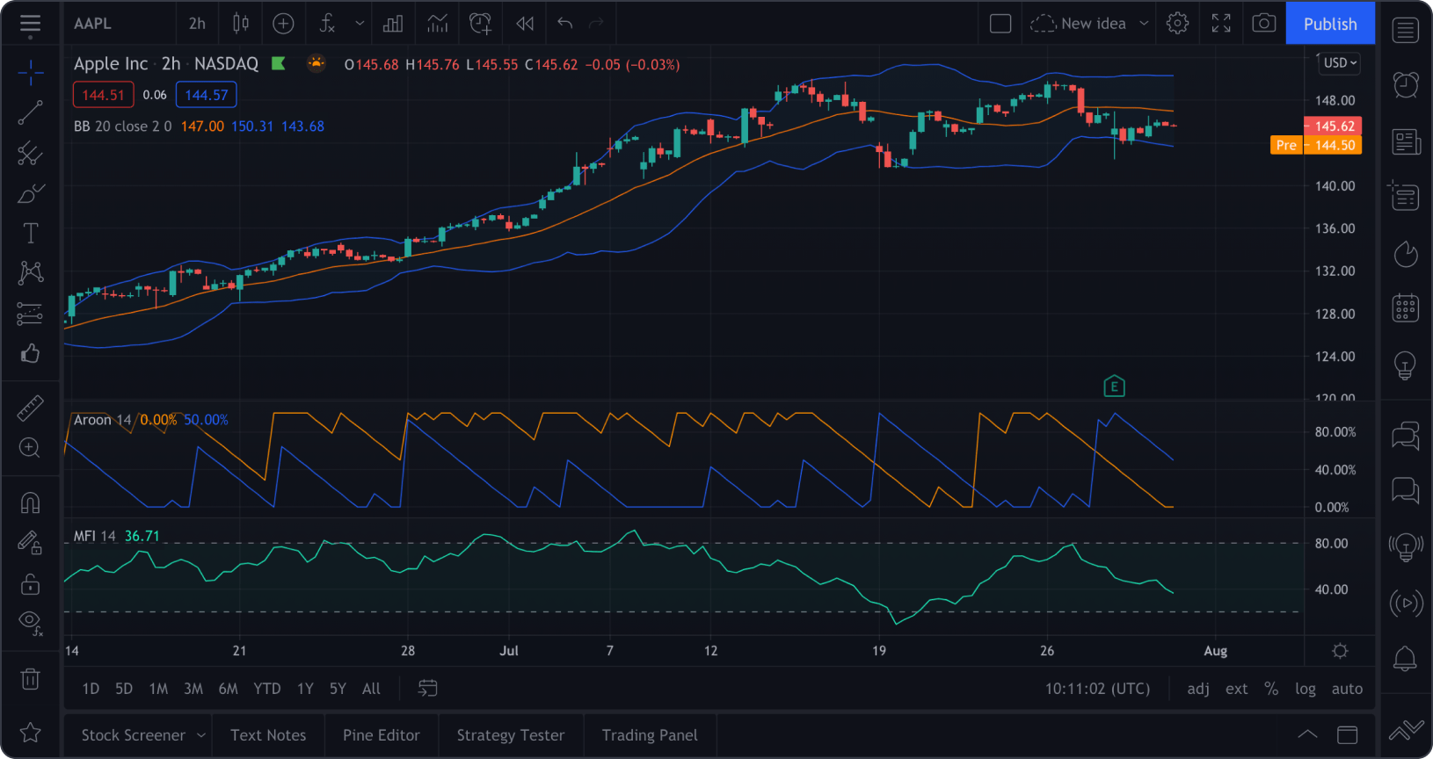
vs
https://www.wallstreetzen.com/blog/best-stock-chart-apps/


