**Documentation**

* **Flow Chart :**

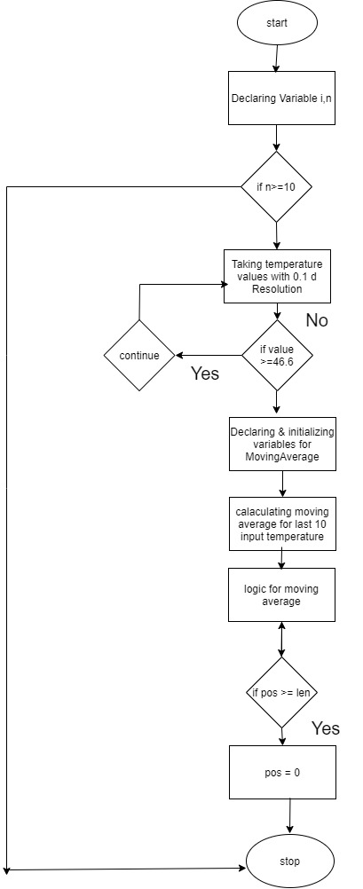

Moving average logic :

*ptrSum = *ptrSum - ptrArrNumbers[pos] + nextNum;

ptrArrNumbers[pos] = nextNum;

return (*a=*ptrSum/len,*b=((*a)*9.0/5.0+32.0));

Local Variables used :

int i,n;

int dummy;

float s[n];

int arrNumbers[5];

float a=0.0,b=0.0;

int pos = 0;

long sum= 0;

int len;

int count;

* **Compiled and Tested Source Code**

#include <stdio.h>  
  
  
  
int movingAvg(int *ptrArrNumbers, long *ptrSum, int pos, int len,  
               float nextNum,float *a,float*b)  
{  
     
*ptrSum = *ptrSum - ptrArrNumbers[pos] + nextNum;  
ptrArrNumbers[pos] = nextNum;  
return (*a=*ptrSum/len,*b=((*a)*9.0/5.0+32.0));  
}  
  
int main(int argc, char *argv[])  
{  
     
int i,n;  
printf("enter n value greater than or equal to 10 ");  
scanf("%d",&n);  
float s[n];  
  
   
if(n>=5)  
{  
  for(i=0;i<n;i++)  
   {  
      printf("enter the temperature");  
      scanf("%f",&s[i]);    
       if(s[i] >=46.6)  
        {  
           printf("enter the correct data with in  0 to 46.6");  
            i--;  
            continue;  
        }  
   }  
   
int dummy=n-10;  
int arrNumbers[5] = {0};  
float a=0.0,b=0.0;  
int pos = 0;  
long sum= 0;  
int len = sizeof(arrNumbers) / sizeof(int);  
int count = sizeof(s)/sizeof(float);  
   for(int i = dummy; i <count;i++)  
    {  
         movingAvg(arrNumbers, &sum, pos, len, s[i],&a,&b);  
         printf("a is  degree centigrade value %f,b is degree farenheat value %f \n", a,b);  
         pos++;  
         if (pos >= len)  
          {  
              pos = 0;  
               
          }  
   
    }  
  
   
}  
  
else  
{  
      printf("please enter the n value greater than 10");  
}  
return 0;  
  
}

* **Test Cases :**
  + - 1. Taking array size dynamically greater than or equal to **10**
      2. Temperature values are dynamically taken at the time of console with 0.1 degree resolution
      3. Centigrade to Fahrenheit conversion while printing outputs
      4. Printing the last 10 sample inputs after caluculating the movingaverage