Text Editor

# [Intro]

In this lab, we will make a text editor by using WPF in C#.

# [Key Words]

CommandBindings, Toggle Font Styles, Menu, ToolBar, RichTextBox

# [Expected UI Design]

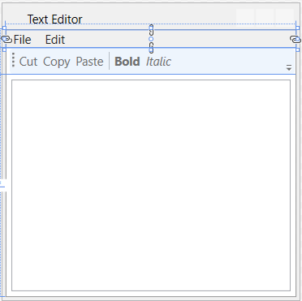

# [Content]

* Commanding in WPF?

Commands allows for multiple and disparate sources to invoke the same command logic, and it allows the command logic to be customized for different target. Simple examples of the editing operations using commanding are **Copy**, **Cut**, and **Paste**. (See More Details: <https://docs.microsoft.com/en-us/dotnet/framework/wpf/advanced/commanding-overview>)

* CommandBindings
  + It enables command handling for elements related to a collection of CommandBinding objects, and declares the linkage between a command, its events, and the handlers.
  + More Details:

<https://docs.microsoft.com/en-us/dotnet/api/system.windows.input.commandbinding?view=netframework-4.8>