

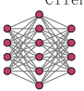

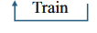












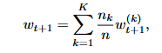
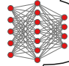





Clean local samples
Clean local samples
Clean local samples
Clean local samples
Poisoned local samples
Benign client
Benign client
Benign client
Client 5
Client 4
Client 3
Client 2
Benign client
Malicious client
D₅
D₄
D₃
D₂
D₁
$$ω_{5}^{t}$$
$$ω_{4}^{t}$$
$$ω_{3}^{t}$$
$$ω_{G}^{t+1}$$
$$ω_{2}^{t}$$
$$ω_{G}^{t+1}$$
$$ω_{G}^{t+1}$$
$$ω_{G}^{t+1}$$
$$ω_{G}^{t+1}$$
$$ω_{1}^{t}$$

Aggregation
Server
Client 1

