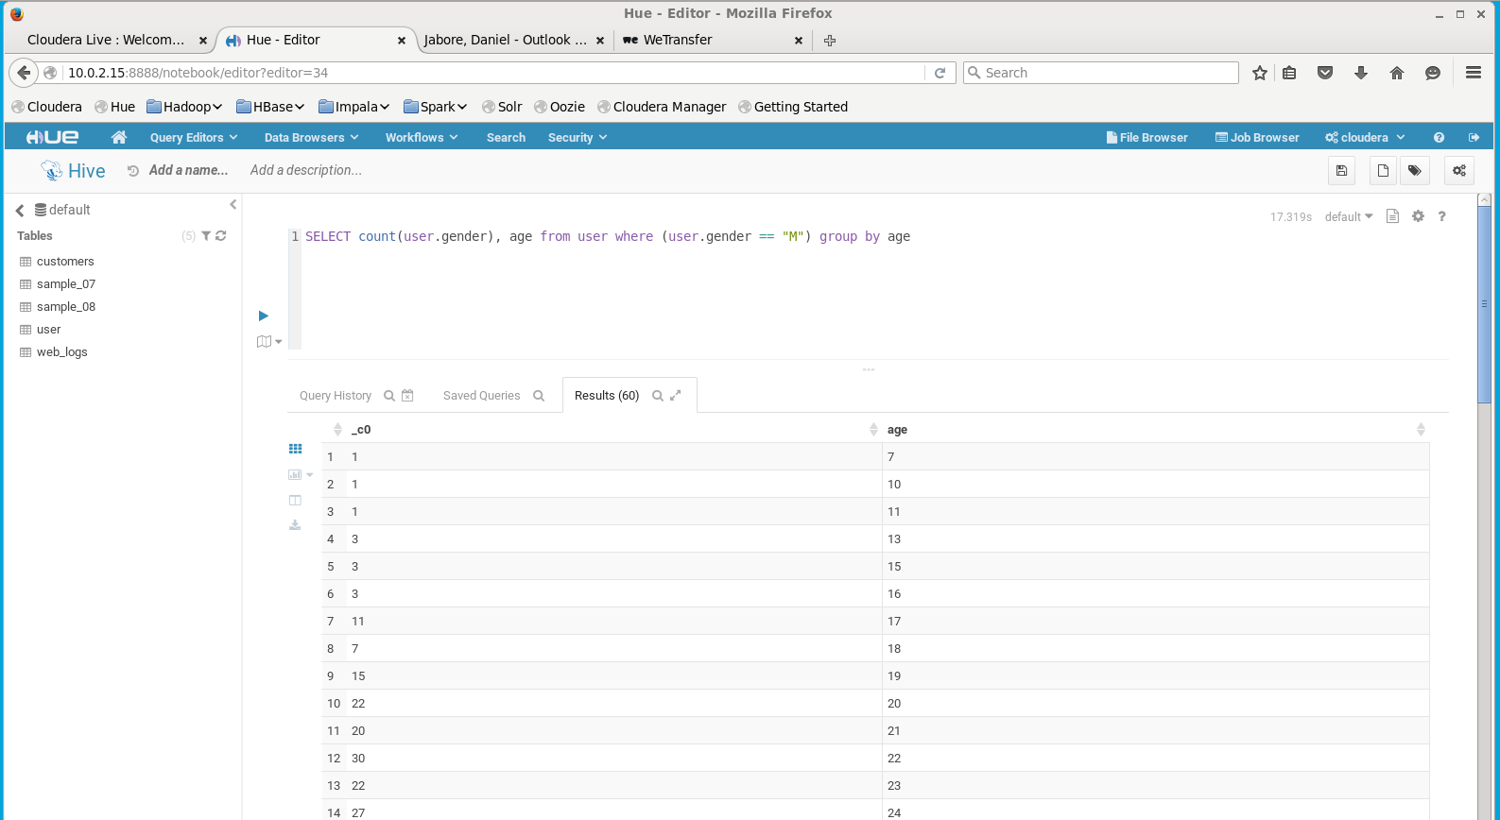

Just a simple select statement to confirm that the table was imported correctly. (task 1,3)

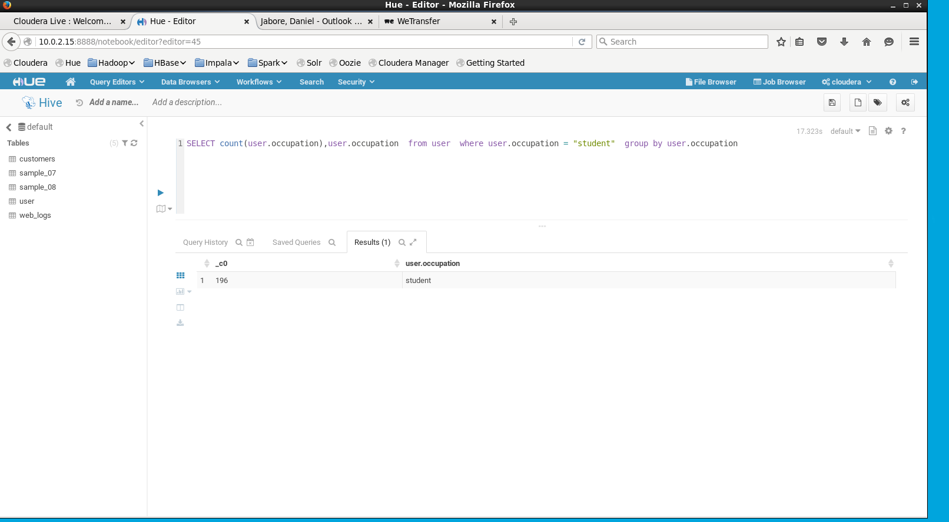

Simple select statement that counts the amount of students that are in the user table. (tasl4)

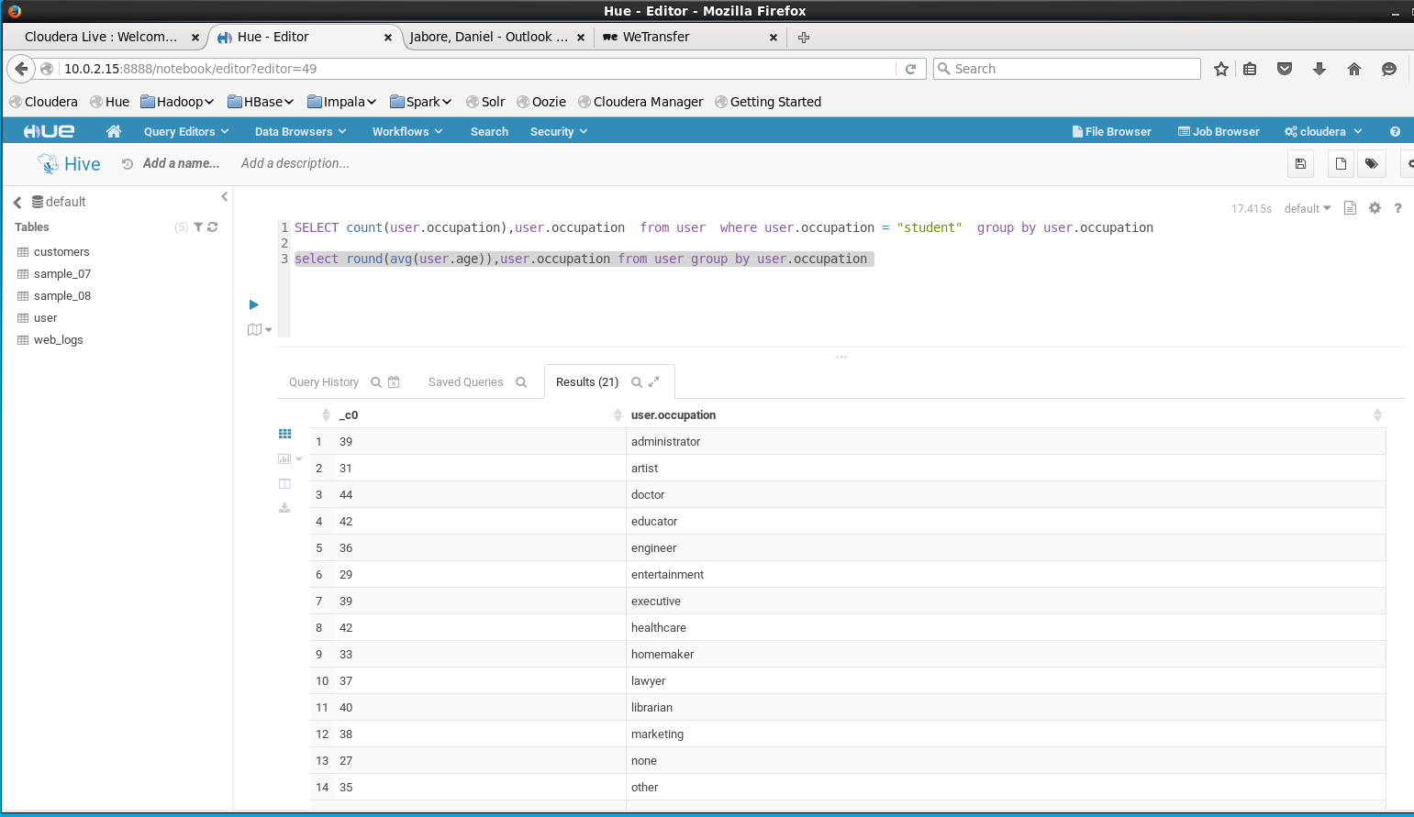

Just a select statement to work with task 5 (task 5)

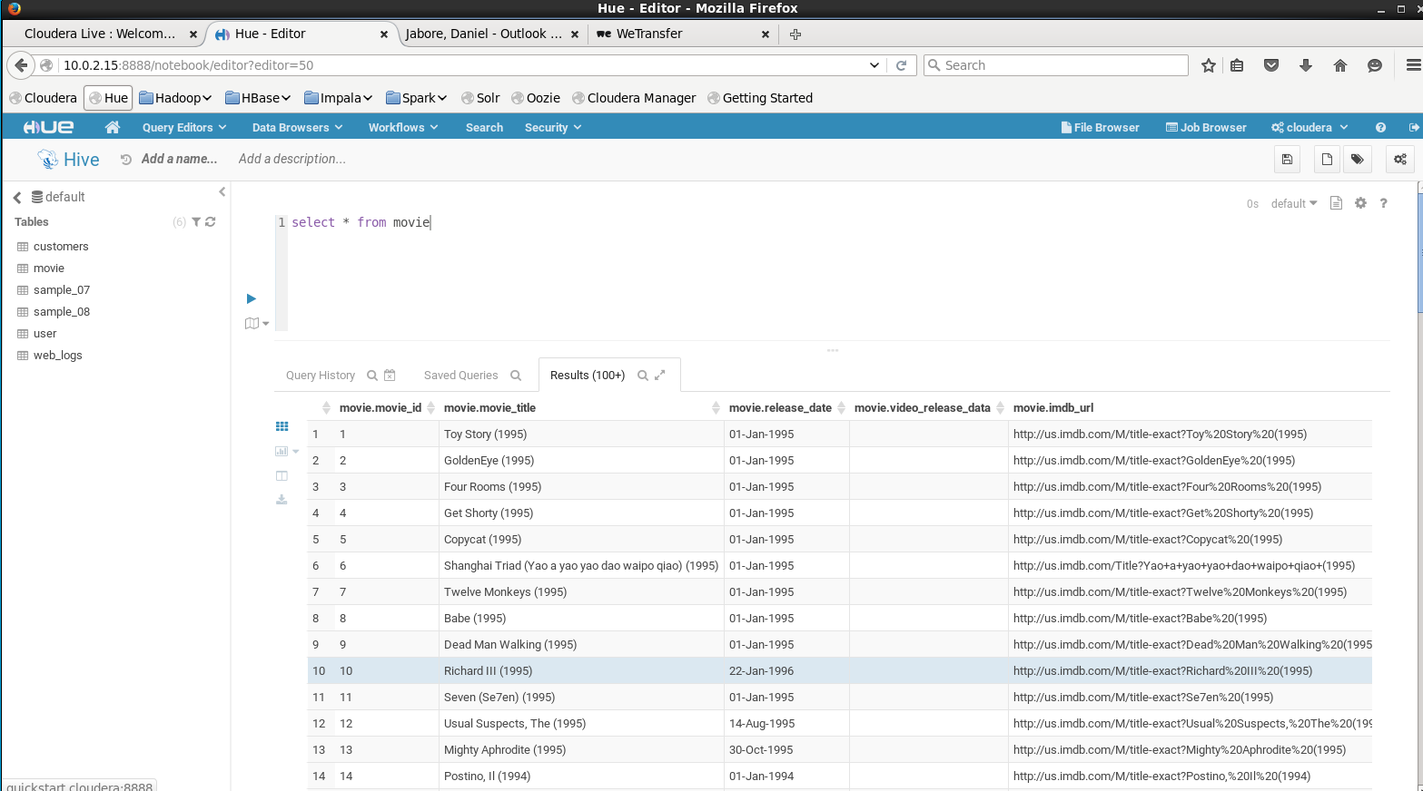

Quick select statement that shows the files have been added

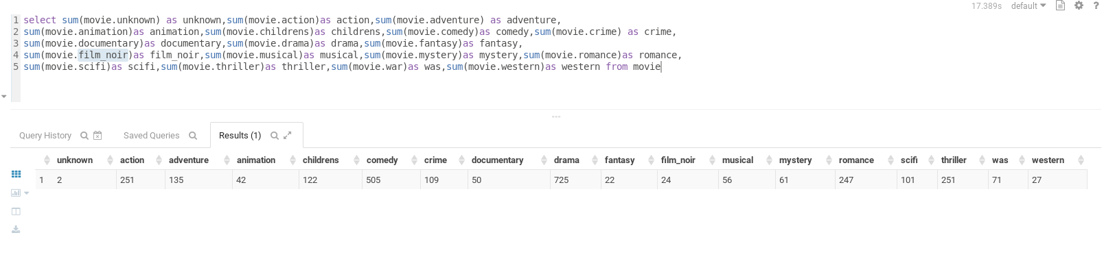

A select statement that uses sum to get the total of each genre (exercise 4)



Loading the data into the hive warehouse so that I can accesses it in impala (exercise 5 part 2)