Machine Learning Foundations
A Case Study Approach

https://www.coursera.org/learn/ml-foundations/home/welcome

Week 1
10/02/2016
10/08/2016
Set up a Virtualbox
- Machine parms:
  - 4 CPs
  - 10 GB memory
  - 64 GB disk
  - 128 MB video memory
  - Bi-directional cut/paste
  - Shared file systen
- Install Ubuntu gnome16.04 LTS <reboot>
- sudo apt install build-essential dkms
- Install guest additions <reboot>
- sudo apt update
- sudo apt upgrade <reboot>
- Set up for shared folders
  - sudo usermod -a -G vboxsf joshua <log out, log in>
- Perform user setup
  - Dash-to-dock gnome extension
  - Install chromium
  - Mount and bookmark the network drive
    - afp://192.168.1.2

Install the class software
- Read through Reading_GettingStarted_Toolset.pdf
- Setup for the environment:
  - python2.7.12 comes with Ubuntu
  - anaconda 4.2.0 – download the python 2.7 version from https://www.continuum.io/downloads
    - bash Anaconda2-4.2.0-Linux-x86_64.sh
    - This installs to ~/anaconda2, and adds this you PATH
  - pip 8.1.1
    - sudo apt install python-pip
  - Install Graphlab create (from /home/joshua/MachineLearning/ML_1/Install GraphLab Create _ Turi.pdf)
    - conda create -n gl-env python=2.7 anaconda
    - source activate gl-env
    - conda update pip
    - pip install --upgrade --no-cache-dir https://get.graphlab.com/GraphLab-Create/2.1/jabostian@gmail.com/BD4C-D57C-3662-7985-02BF-8CFC-658F-281F/GraphLab-Create-License.tar.gz
    - Can see some strange failures that seem to go away after exiting the shell and re-starting. Note that I had updated ipython to make a problem with this error:
      - ImportError: No module named shutil_get_terminal_size
      - Saw a posting saying that this:
        - pip install -U ipython
        - solves the problem, but if it did, then it didn’t until I exited my shell and entered a new one. Anyhow, things seem to work now.
    - When running the first notebook that references the graphlab package, the module was not found. Ran this:
      - pip install graphlab-create
      - and everything was found. I wonder if the earlier pip install that references graphlab actually did the install. After this pip install, everything seemed to work well.
- Read the Turi User’s guide to learn the platform:
  - https://turi.com/learn/userguide/index.html

To run any of the notebooks, just start up jupyter. This is a python part that resides in ~/anaconda/bin. Conda/anaconda was installed as a pre-req for graphlab.
- jupyter notebook
This starts the server, and opens the Jupyter interface in a browser.

10/11/2016
Getting started with ipython and ipython notebooks
- Notebooks ~= python + wiki pages
- Shift-enter to run a cell
- Cell type -> markdown to enter markdown in a notebook
- Within a cell, Enter == start a new line
- Enter at the end of a markdown cell completes the cell
- lambdas are ways to code simple functions

Getting started with SFrames
- SFrame is a scalable data structure for dealing with really large sets of data
- Spills to disk if short on memory
- Part of GraphLab Create
- sf.canvas brings up graphical interface for looking at data:
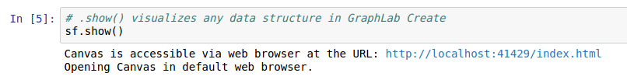
- Can open the visualization within the notebook:

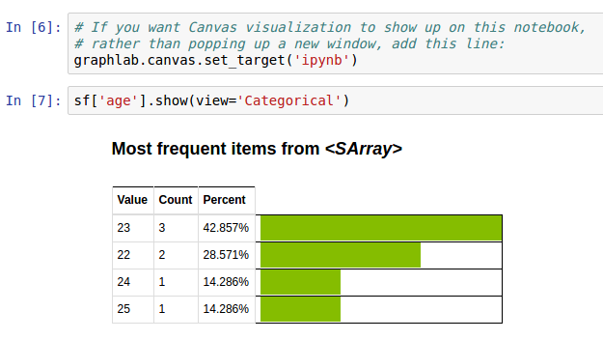
- feature engineering - taking columns of a table and transforming them into new ones.
- .apply function in SFrames applies a specified function to all rows of a table:
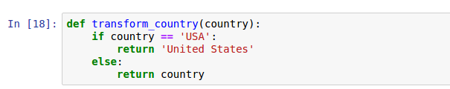
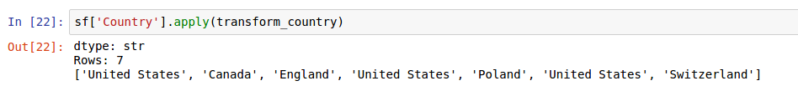

Week 2 - Linear Regression Modeling
10/11/2016

Predicting House Prices
- Determining house values
  - Look at recent sales in my neighborhood. For each sale:
    - Sales price
    - Size of house - will signify if a recently sold house is similar to mine.
  - Plot house size (X-axis) and sales price (Y-axis)
    - X is feature/covariate/predictor. Also called independent variable.
    - Y is observation/response. Also called dependent variable.
  - Look at data points to find a house with same size as mine
    - Since there are none, look at sizes for a range of houses sold
    - This means that we throw out lots of observations. There may be only a small number of houses actually sold in this range.
    - Want to leverage all the information we can when making predictions
- Linear Regression
  - Want to understand the relationship between sq footage and house sale price
  - Simple model - fit a line
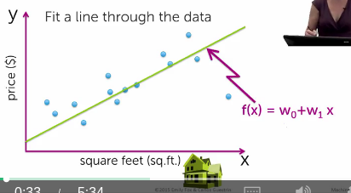

  - w0 == intercept.
  - w1 == slope. Also called the weight, or regression coefficient.
    - Tells us: as vary X, how much impact this has on the sales price y
  - w0 and w1 are the parameters of the model
  - Function f is parameterized by w = (w0, w1)
  - Which line would be best through this set of points?
    - Which set of parameters w would give the best line?
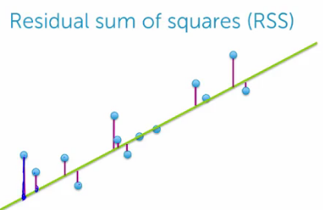
    - To think about this, consider the cost of a given line
  - Common cost function - Residual Sum of Squares (RSS)
    - Look a how far each observation is from the line
    - Actually look at the squares of the distances

      - Sum these squared differences over all points
    - Search over all possiblew0 and w1 values for the smallest squared sum.
      - The set of all w is
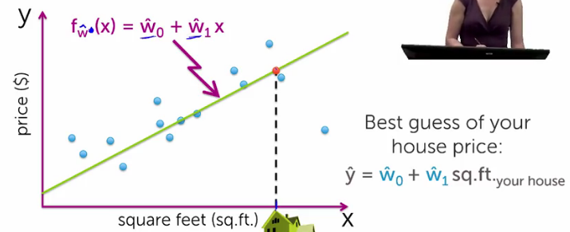

- Adding higher order effects
  - This is not a linear trend
  - What about a quadratic function?
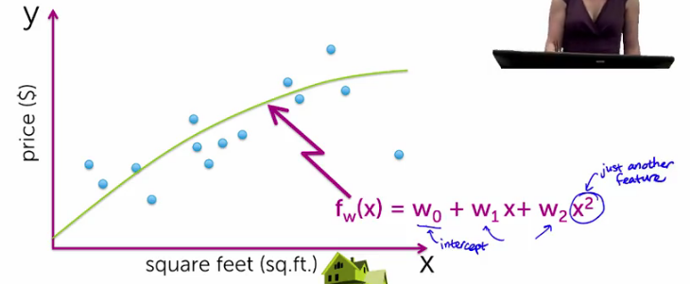
  - This is still linear regression, because the squared x term is just another feature in the linear equation. w terms are just terms. Not powers of other terms, etc.
  - Could use a high order polynomial. Would give a good fit to the points, but may not reliably predict the home price.
- Evaluating overfitting of data by a model
  - We want a good fit of the model to data, but we don’t want it fitted so well to 1 data set that it doesn’t generalize well to new observations
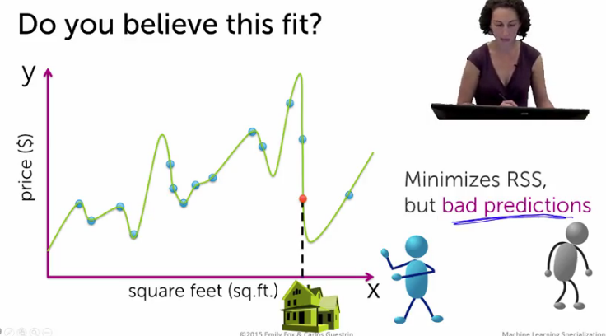

  - Use a training/test split
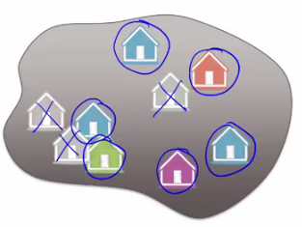
  - The original lower order polynomial fit probably generalized better, even if it didn’t minimize the cost function
  - Simulate predictions:
    - Remove some house prices from the model
    - Fit model to the remaining
    - Predict held out prices
  - Can compare modelled prices to actual ones that were removed from the original data set
    - Use this as a proxy for predicting house prices that we haven’t collected yet
  - This only works if we have enough data points to work with


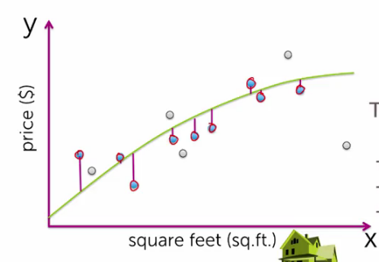

  - Only use points in blue when calculating training error (others are temporarily left out of the model)
  - Calculate training error in same way as RSS
  - Minimize training error to get estimated
  - Now we want to see how good is

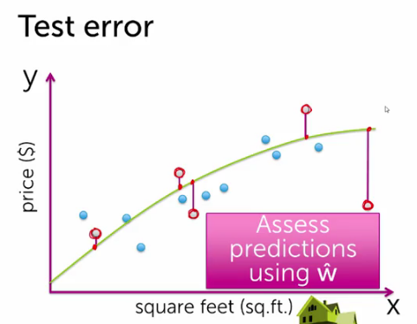

  - Look at test error
    - Calculate test error just like training error and RSS

- How does test error and training error vary as a function of the complexity of the model?
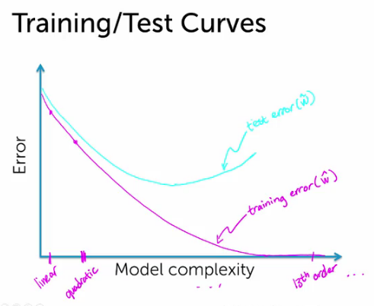
  - Training error decreases with increasing model order
  - When think about holding out some subset of data points from the original population, and then computing a test error for , this error won’t necessary decrease with higher order polynomials as with the training curve.

- Adding other features
  - House size may not be the only feature relevant to price. E.g. number of bathrooms should have an effect.
  - Now have a 3D space of features if include # of bathrooms
  - Now fit a hyperplane to the data
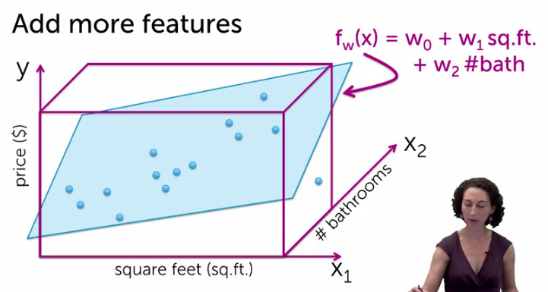
  - Lots of other features to include (# bedrooms, lot size, year built, ...). Where do we stop?
    - Will cover this in the regression course
- Other regression examples
  - Salary impact after taking this course
  - Stock price prediction
  - Tweet popularity
  - What’s the temperature at the desk of my home office, given my Smart house settings?
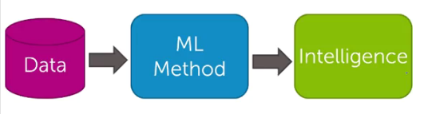
- Regression ML block diagram

  - From Carlos:

  - From house price example:
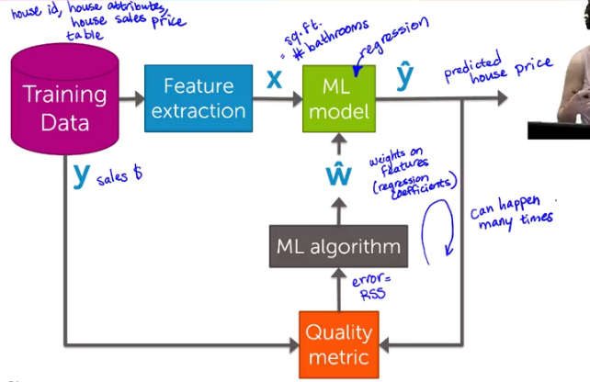
    - y == actual house price, == predicted house price (intelligence)
    - also called the set of regression coefficients
    - error calculation is RSS
    - ML algorithm updates our weights in
      - Updates happen iteratively

10/22/2016
- Notebook: Predicting House Prices
  - Using seed number for random functions like random_split is useful for creating consistent results from the random number gnerator.
  - Variable we’re trying to predict is called the target in graphlab api
  - RMSE == Root Mean Square Error



Week 3
10/23/2016
- Classification modeling
  - What is an intelligent restaurant review? (use case)
    - From review topics to sentiments
      - May not care that much about the Ramen, really care about the sushi rating
    - Break up all reviews into sentences
    - Feed into a sentiment classifier

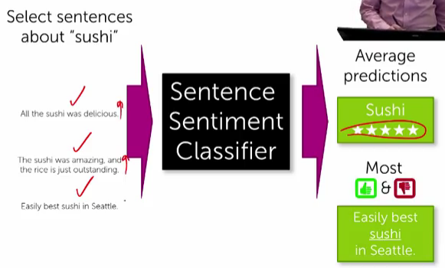
  - Classifier
    - Other types of classification
      - What web pages would interest me? (several categories - eg. finance, education, technology ...)
      - Spam filtering - spam vs non-spam. Not only analyze text, but IP of sender, email of sender, ...
      - Image classification - what is the picture of?
      - Personalized medical diagnosis - include genetics and lifestyle of the person
      - Read someone’s thoughts, based in FMRI input
    - Linear classifiers
      - Simple threshold classifier - positive or negative sentiment in a sentence
        - How to we get the list of positive and negative words?
        - Words have different degrees of sentiment. How to weigh the words?
        - Single words are often not enough
      - Can train linear classifier to learn weights for words
      - Called a linear classifier because output is a weighted sum of the inputs
        - Scoring a sentence
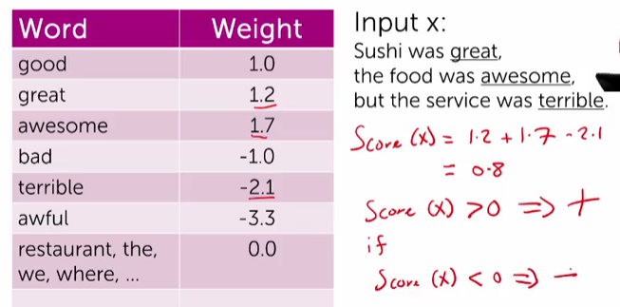
    - Decision boundaries
      - Suppose only have 2 words with non-zero weights
        - Boundary is the line determined by an equation relating the two words:
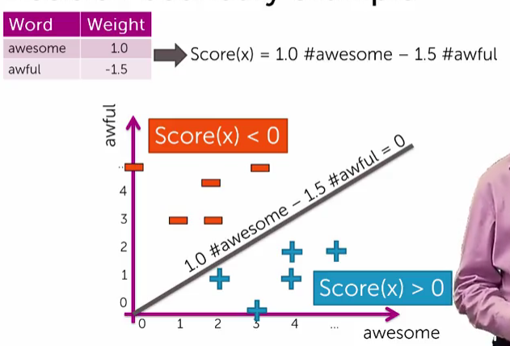
        - This is a linear decision boundary
        - If have 3 non-zero weights, then a 3D decision plane
        - Hyperplanes for spaces of high dimension, as when classifying thousands of words for sentiment
        - More general classifiers have more complicated shapes
- Evaluating classification models
  - Training a classifier == learning the weights
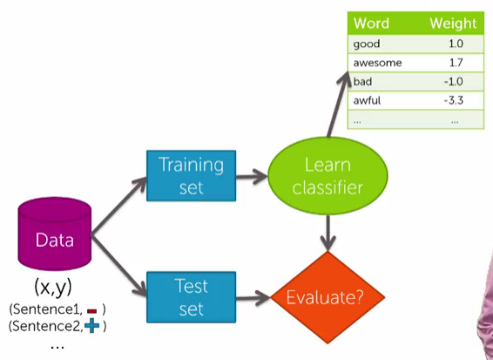

  - Classification error
    - Learned classifier applied to a test sentence, while true classification (positive or negative) is hidden
      - is the classification from the learned classifier
      - Compare classifier answers with the real answer to determine the correct and mistaken classifications
      - Error measure is the fraction of mistakes
        - Best possible value is 0.0
      - Often, accuracy measure is the fraction of correct predictions
        - Best possible value is 1.0
  - What is good accuracy?
    - What if you ignore the sentence, and just guess?
      - Half the time you will be right, on average.
        - Accuracy == 0.5
      - For k classes, accuracy == 1/k
        - 0.333 for 3 classes, 0.25 for 4 classes, ...
      - Should beat these accuracies by a healthy margin, otherwise, why bother?
    - Is a classifier with 90% accuracy good?
      - In 2010, 90% of all emails are spam, so predicting an email is spam with a guess will give 90% accuracy
      - Can get very good performance with a guess if one class is much more common than the others, if you know the majority class - just pick it
      - Should always ask hard questions about reported accuracies
        - Is there class imbalance?
        - How does your classifier compare to baseline guessing
          - Random guessing
          - Majority class
        - Most important - what does my application need?
          - What is good enough?
          - What is the impact of a mistake?
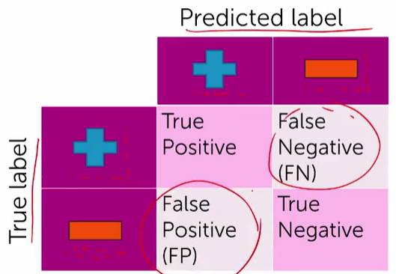
11/09/2016
- False positives, false negatives, confusing matrices
  - Types of mistakes
    - Classify with confusion matrix

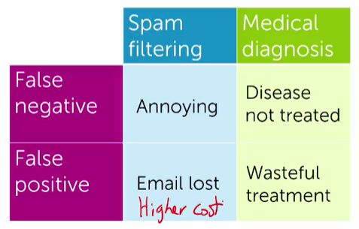

  - Cost of different types of mistakes can vary by application
    - confusion matrix:

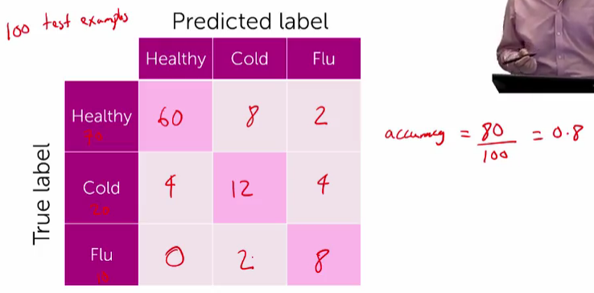
  - Multiclass classification

- Learning curves
  - How much data do I need for learning?
  - More data generally better
    - But data quality is the most important factor
  - Theoretical techniques sometimes can bound the amount of data needed
    - Typically too loose for practical application
    - They are useful for guidance
  - In practice:
    - More complex models require more data
    - Empirical evidence can provide guidance
  - Learning curve relates the amount of training data with test error
    - Small amount of data -> higher test error
    - More data -> lower test error
  - Is there a limit:
    - Yes - for most models
    - Error can’t practically be driven to zero by more data.
      - Gap between the curve, and zero error is the bias of the model
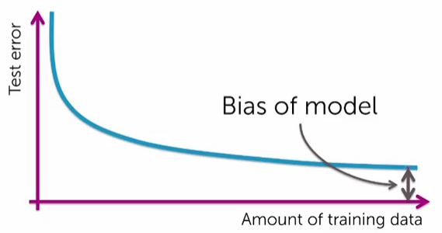

  - More complex models tend to have less bias
    - Sentiment classifier using single words can do ok, but can do better
      - Single word classifier will never classify this sentence correctly”
        - “The sushi was not good”
    - More complex models can consider pairs of words (bigrams)
      - Has less bias, potentially more accurate, but needs more data to learn
    - More complex model will be less accurate with little data than simpler models, but more accurate with more data (lower bias)

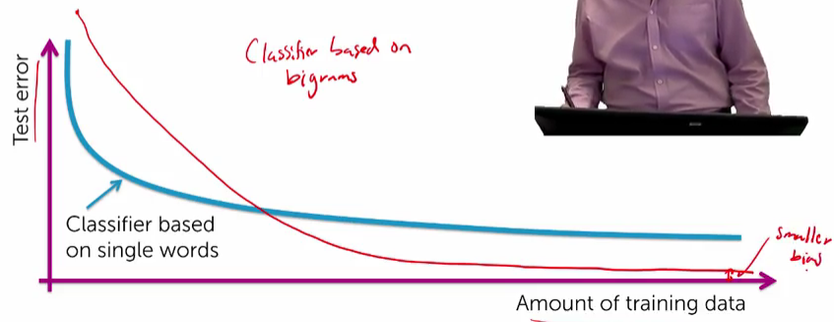
- Class probabilities
  - How confident is you prediction?
  - So far we have outputted +/-
  - For this sentence: “The sushi & everything were awesome”
    - This is a definite + (P(y=+|x) == 0.99)
  - For this sentence: “The sushi was good, the service was OK”
    - Probably a +, but not sure (P(y=+|x) == 0.55)
  - Many classifiers provide a confidence level: P(y|x)
    - y == output label
    - x == input sentence
    - Very useful in practice
- Classification for sentiment - block diagram
  - Training data is (text of reviews, labeled sentiment)
  - Feed this through a feature extraction phase to get word counts (x)
  - Also feed in weights for each word to ML model
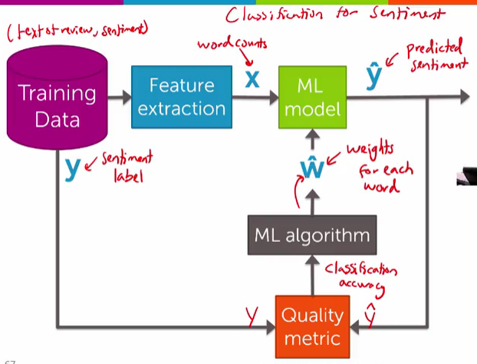
  - Generate predicted sentiments
  - Classification accuracy generated from sentiment label from training data (y) and predicted sentiment ()
  - Classification accuracy from the quality metric is fed into the ML algorithm to improve for the model

- Analyzing product sentiment - iPython notebook
  - roc curve is a means to explore false positives and negatives - confusion matrix
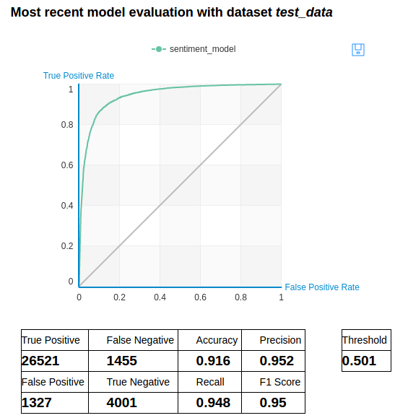
  - This roc curve allows us to see the number of true vs false positives.
  - Can adjust the threshold for determining what is a positive value in order to see the tradeoffs between properly identified positive sentiment, and mistaken positives.
  - Can capture all true positives but will also get all false positives & vice versa

Week 4
11/10/2016
- Document retrieval - case study in measuring clustering and similarity
- What is the document retrieval task?
  - How to measure similarity between articles?
  - How do we search over existing articles?
- Word count representation for for measuring similarity
  - Bag of words model
    - Ignore word order
    - Count number of instances of each word in the vocabulary
  - Start with a vector. Each index represents a word
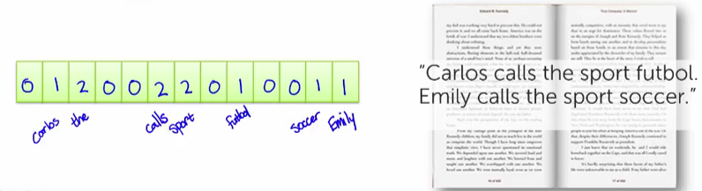
  - Zeroes for every other possible word in the vocabulary.
    - Vector is very long and sparse
  - If have 2 different documents and associated vectors, look at an element-wise product of the vectors
    - Two articles about soccer might look like this:
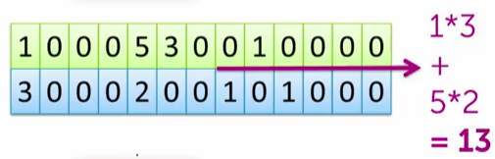

    - Two dissimilar articles might look like this:
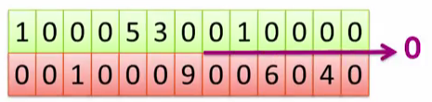

  - Issues with Word counts:
    - Document length.
      - If have 2 documents about soccer with a given similarity value of 13 are doubled in length, might get a new similarity value of 52
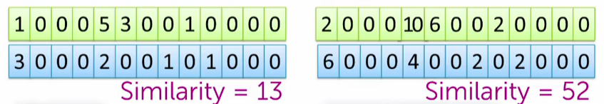
      - By this measure, the longer document is a lot more similar, even though it is just simply longer.
      - This measure has a bias towards longer documents
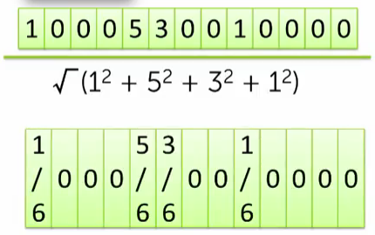

      - One solution - normalize the vector - add squares of each value in the vector, and take square root

      - Use the result to divide every value in the vector before measuring similarity
- Prioritizing important words with Term Frequency - Inverse Document Frequency (tf-idf)
  - Issues with word counts - rare words
    - Common words (eg. “the”, “player”, “goal” ...) dominate the similarity measure when compare against other documents
    - Rare words get overwhelmed in the measurement. Want to increase the importance of these words
      - Rare words:
        - Appear infrequently in the corpus - want to up-weight these words
        - Equivalently - want to discount a word w, based on the number of containing documents in the corpus
      - Important words:
        - Do we really only want to up-weight the rare words?
        - Want to include words that are relevant for a document (eg. ”soccer”, “field”, “goal”)
        - What characterizes important words?
          - Appears frequently in the document (common locally)
          - Appears rarely in the corpus (rare globally)
        - Importance involves some trade-off between local frequency and global rarity
11/13/2016
- Calculating tf-idf vectors
  - Look locally for term frequency (same word count)
    - Down-weight this WC vector by the Inverse Document Frequency
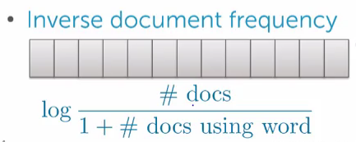

  - For words that are frequent in a document (large number of docs, large number of docs with the word):

  - For a rare word (large number of docs, small number of docs with this word)

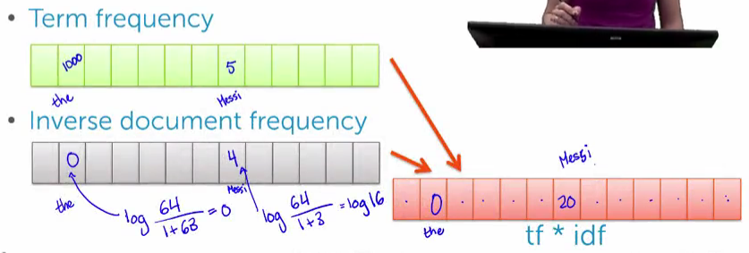
  - Note - add one in the denominator to avoid dividing by zero for words that don’t appear in the corpus anywhere.
  - tf-idf is the vector product of the tf and idf vectors

  - (note in this example to the right, the prof is off by 1 cell in the tf-idf vector)

- Retrieving documents with nearest-neighbor search
  - Algorithm:
    - Input: query article
    - Output: most similar article
    - Search over each article in the corpus
      - Compute s = similarity(query article, this article)
      - If s > Best_s,
        - record this article as the current best match
        - Best_s = s
  - k-nearest neighbor search is a variant of this:
    - Input: query article
    - Output: list of k similar articles (priority queue of top K articles)
- Clustering documents
  - Structure the corpus so that similar articles are nearby
  - Challenge - articles won’t have labels. Need to discover the groups that represent clusters

  - For now, assume that we have labels for our clusters
    - Multi-class classification problem
      - Assign a query document to one or more of the pre-defined cluster labels
      - This is an example of supervised learning

  - Clustering when no labels provided - need to discover clustering groups from the corpus
    - No labels provided
    - Need to uncover cluster structure
    - Input: docs as vectors (word count vector)
      - 1 dimension for each word in the vector (len of WC vector is the dimension of the space)
    - Output: cluster labels
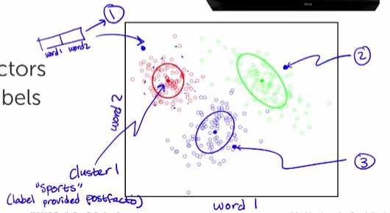

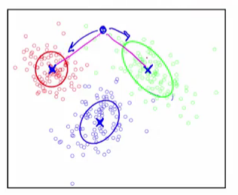
      - Note that labels like “sports” are provided to clusters 1, 2, and 3 from a post-processing analysis of the docs in each cluster (post facto)
      - This is an example of unsupervised learning
    - Cluster is defined by a center and shape/spread
    - Assign an observation (query doc) to a cluster (topic label)
      - Score every observation based on its similarity to a cluster, based on the cluster’s center and shape
      - Often, we just look at cluster centers when determining similarity, and shape isn’t important
        - Distance between query document and center document of a cluster (s)
- K-means clustering
  - Assume:
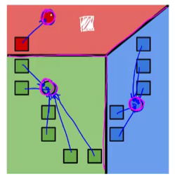
    - Similarity metric = distance between a query document and the center of a document cluster (smaller is better)
  - Initialize cluster centers
    - Choosing initial cluster centers is some work, but for now just assume that we randomly assign them
  - Assign every observation in the corpus to the closest cluster center
    - Use a Voronoi Tessellation
    - Define regions for each cluster. Any new observations in a given region are assigned to the cluster of the region

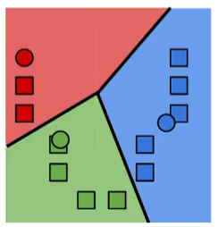
    - Now we have a new set of cluster centers
  - Revise cluster centers as the mean of assigned observations
    - Repeat steps 1 & 2 until we reach convergence
- Other clustering examples
  - Clustering images
  - Grouping patients by medical condition
    - Grouping by seizure patterns from their brain images
  - Product recommendations
    - Discover groups of related products
    - Discover groups of related users/customers
  - Structuring search results
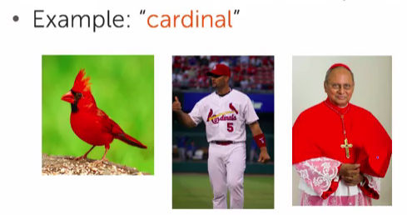

  - Discovering similar neighborhoods
    - Estimating price at a local level
      - Often small number of, or no existing sales prices
      - Knowing a neighborhood can help with price prediction
      - Cluster regions with similar trends and share information within a cluster
    - Forecast violent crimes
      - Better task police forces
- Clustering and similarity ML block diagram

11/28/2016
- Workflow, k-means algorithm:
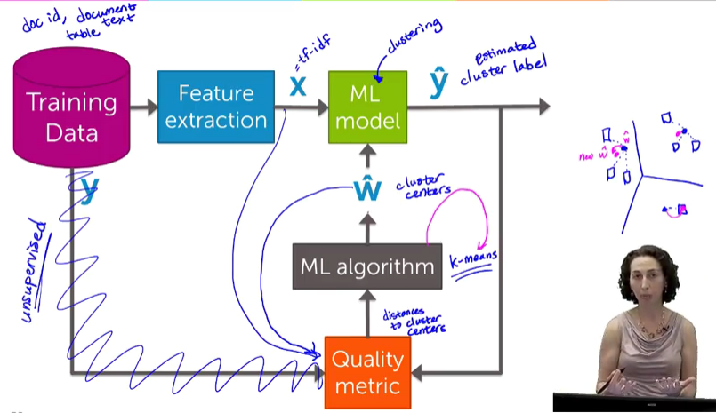
- Goal: minimize distances from actual word in a document to a cluster center
  - To measure accuracy (distance of word from cluster label), need:
    - tf-idf vectors (the data, documeent representations)
    - The cluster centers
  - Generatedistances to cluster centers
- Center of mass for cluster centers shifts over time
- Loop through cluster center calculations

12/12/2016
- Notebook: document retrieval
- obama_word_count_table = obama[['word_count']].stack('word_count', new_column_name = ['word','count'])
  - Note that the “[[...]]” above selects the word_count column from the Obama document, since this document is itself a row/column table.

