Introduction to Data Science in Python

https://www.coursera.org/learn/python-data-analysis/home/welcome

Python 3 and associated documentation:
- https://docs.python.org/3/
- http://planetpython.org/
- https://stackoverflow.com/questions/tagged/pandas
- https://dataskeptic.com/podcast

Course downloads:
- https://drive.google.com/drive/folders/0B7Tj31nhk4BANnZ2bnBrZnJESlk

Week 1
05/25/2017
05/28/2017
05/29/2017
Basics:
- Optional arguments to a function have to come at the end of the function definition
  - def add_numbers(x, y, z=None, flag=False):
    - z and flag are optional, and have default values
- Optional arguments can be passed in with explicit values
  - print(add_numbers(1, 2, flag=True))
- Tuples are immutable objects, while lists are mutable
- Strings are just lists of characters, so they can be sliced using list operations
- Arrays are indexed from zero
- Use split to make parsing of tokens from a string easier
  - firstname = 'Christopher Arthur Hansen Brooks'.split(' ')[0]
- You can specify more than 1 variable (key in this case) in a for statement
  - for name, email in x.items():
- UTF == Unicode Transformation Format
- Python uses unicode for strings
- Can use ‘{}’ for string formatting so that values can be substituted in from variables
  - sales_statement = '{} bought {} item(s) at a price of {} each for a total of {}'

print(sales_statement.format(sales_record['person'],
sales_record['num_items'],
sales_record['price'],
sales_record['num_items']*sales_record['price']))
  - This is a whole string formatting language within Python
- The Epoch == Jan 1st, 1970
- Classes and objects
  - Generally names using CamelCase
  - Class variables are declared within a class, and are shared across all instances
  - Objects don’t have private and protected members.
    - If you instantiate an object, you have full access to any of the members of that object
  - No need for an explicit constructor in Python
    - Can create one if wanted through __init__
  - Map function is one of the bases for functional programming in Python
    - Functional programming - a programming paradigm in which you declare all parameters which could change through execution for a given function
      - Referred to as being side-effect free, since there is a software contract that declares what can change
    - Python isn’t a pure functional programming language
      - Side-effects are allowed
      - You don’t have to include all parameters when calling a function
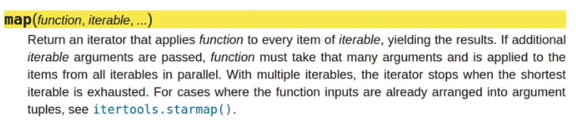
    - Map function returns a mapped object.
      - Lazy evaluation - doesn’t actually do the work
      - Allows for very efficient memory management
- Lambda functions
  - Lambda is Python’s way of creating anonymous functions
  - Only 1 expression to be evaluated in a lambda
  - Return of a lambda statement is a function reference (lazy evaluation)
  - No default values for lambda functions
  - Useful for simple data cleaning tasks
  - Example:
people = ['Dr. Christopher Brooks', 'Dr. Kevyn Collins-Thompson', 'Dr. VG Vinod Vydiswaran', 'Dr. Daniel Romero']

def split_title_and_name(person):
return person.split()[0] + ' ' + person.split()[-1]

#option 1
for person in people:
print(split_title_and_name(person) == (lambda x: x.split()[0] + ' ' + x.split()[-1])(person))

#option 2
list(map(split_title_and_name, people)) == list(map(lambda person: person.split()[0] + ' ' + person.split()[-1], people))

- List comprehensions
  - Example:
    - Regular for loop:
my_list = []
for number in range(0, 1000):
if number % 2 == 0:
my_list.append(number)
my_list
    - List comprehension:
my_list = [number for number in range(0,1000) if number % 2 == 0]
my_list
  - Comprehensions are more compact, and tends to run faster
  - Example:
    - Regular for loop:
def times_tables():
lst = []
for i in range(10):
for j in range (10):
lst.append(i*j)
return lst
    - List comprehension:
times_tables() == [j*i for i in range(10) for j in range(10)]
  - Example:
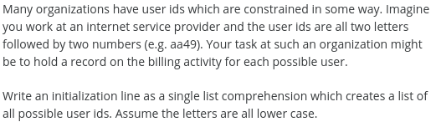
lowercase = 'abcdefghijklmnopqrstuvwxyz'
digits = '0123456789'

correct_answer = [a+b+c+d for a in lowercase for b in lowercase for c in digits for d in digits]

correct_answer[:50] # Display first 50 ids
- Numpy
  - Lets us work efficiently with arrays and matrices in Python
  - See the notebook for examples.
  - When working with arrays, remember that assigning one array to another simply creates a reference, not a copy. Use the copy method to create a copy before working.
r_copy = r.copy()

Week 2
05/29/2017
- The Series is a core data construct in Python
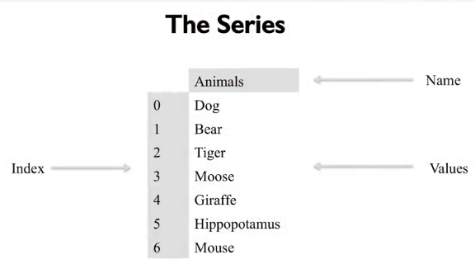
  - Cross between a list and a dictionary
  - Items are stored in an order
  - Labels are associated with the items
  - Underneath, Pandas stores series values in a typed array using Numpy library
    - Significantly better performance over Python lists
  - Pandas + Numpy handles missing data for typed lists differently than a Python list, where missing values have are None
    - Strings are considered to be of type object
    - If creating a series from a number list with a None, it keeps the underlying type for the series (int64, float, ...), but the missing value is NaN (not a number)
    - NaN is not None (NaN is actually a number)
    - NaN is not equivalent to itself either
    - Need to use a library method like Numpy isan( )
  - What happens if the list of values in the index object are not aligned with keys in the dictionary for creating the series?
    - Pandas overrides automatic creation to favor only an all-of-the-indices value provides
      - Will ignore from the dictionary all keys which are not in the index provided, and will assign Nonetype or NaN values for every index value from the dictionary which is not also in the index key list:
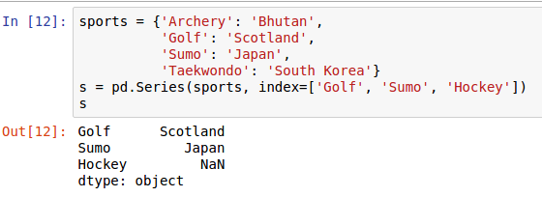
06/05/2017
- Suffix a method call with ‘?’ to see a signature and explanation of the method
- Pandas series can be queried by either the index position or the index label
  - index - iloc
  - position - loc
  - These are attributes, not methods. Use [ ] as the index operator
  - These can be omitted for simple values as a shorthand, but use the operators explicitly if using complex types as index or position for clarity
  - Note: to get the index of a dataframe:
    - points = pd.Series(0, index=df.index.values)
- “%” starts a magic function
- “%%” starts a cellular magic function
- Pandas and numpy support vectorization
  - Example: summing items in a series using numpy sum
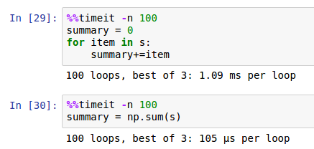
  - Mixed types in a series are allowed
  - If you reference an index that doesn’t exist when assigning a value to a series, the index will be added as well.
  - Indexes don’t have to be unique in a series
  - Series can be appended
  - Append operator doesn’t alter a series. It creates a new series with the appended results
- The Pandas Dataframe
  - Heart of the Pandas library
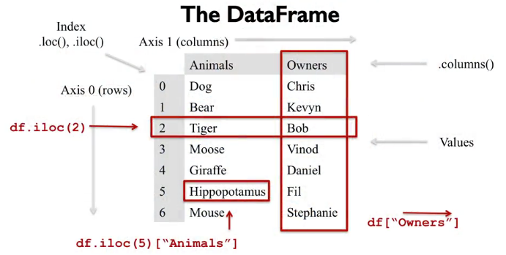
  - Distinction between rows and columns is really only conceptual.
    - Can think of the dataframe itself as a 2-axis labeled array
  - Can create a dataframe in several different ways
    - From a set of series, where each series is a row of the frame
    - From a set of dictionaries, where each is a row from the frame
  - Indices and column names along either axis can be non-unique
  - loc and iloc perform row selection
  - Could transpose rows and columns to use loc/iloc for column selections using the T operator
    - Kind of ugly
  - Chaining of indexes and columns has a cost, and should be avoided
    - Causes Pandas to return a copy of a dataframe rather than a view on it
    - If retrieving data it’s slow, but not a problem. If changing data in a frame, it can be a source of error.
  - loc/iloc supports slicing using ‘:’
  - Data can be dropped using drop( )
    - Returns a new df, unless using ‘inplace’ option
    - Axes parameter used to drop a whole column
    - Del operator works directly on the dataframe

06/06/2017
- Common workflow - read data into a dataframe, then reduce it to the columns & rows of interest
  - Pandas tried to provide views on data rather than create new dataframes
    - Faster
    - More memory efficient
  - If you make updates to the data it may affect the contents of the base dataframe
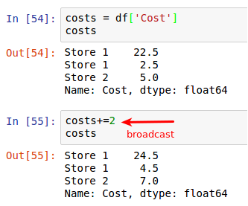
- Applying an operation to all members of a dataframe is called broadcasting:
- ‘!’ at the beginning of a line in a Jupyter notebook cell passes the rest of the line to the platform shell for processing.
- Dataframes can be constructed from CSV files using the read_csv method
- Boolean masking
  - Heart of fast,efficient querying in numpy and pandas
  - A 1 or 2 dimensional array, each of the values are true or false
  - Overlayed on the dataframe, and any cell with a True value is emitted to the final result
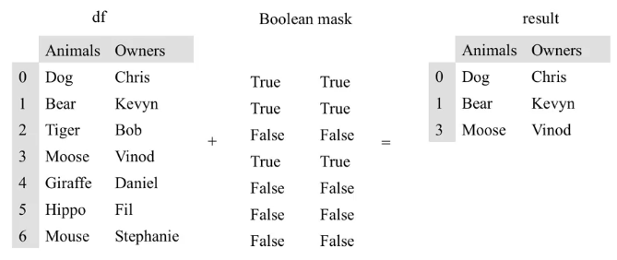
  - Boolean masks are created by applying operators to the pandas series or dataframe object
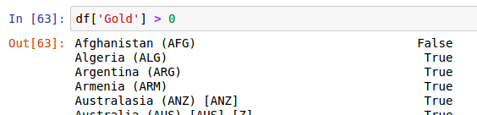
    - Here we are broadcasting the ‘>’ operation, resulting in the boolean mask as a series
  - Now overlay this on the dataframe using the ‘where’ function
    - Where function applies a mask to a dataframe and returns a new dataframe
  - NaN value is usually ignored by operators and functions
  - Often want to drop rows from a dataframe that are empty. Use ‘dropna’
  - Can create more complex queries using boolean operators to combine masks
    - Each boolean mask needs parens because of the order of operations

06/10/2017
- Index of data dataframe is essentially a row level lable
  - Rows correspond to axis 0
- Can use the set_index(...) function to promote a column to be the index
  - Is a destructive process
  - If want to keep the current index, need to create a new column and copy the index into it.
- Can also use reset_index(...) to create a default-numbered column, and promote the current index into a column

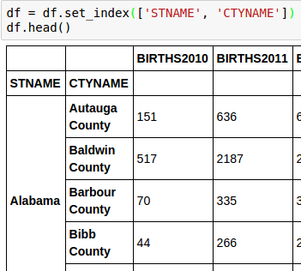
- Pandas can do multi-level indexing
  - Use set_index(...) with a list of column names to use for the multi-index:

- Often want to find the unique values in a column.
  - Use the unique(...) function
  - Similar to SQL distinct operator
- How to query a multi-indexed dataframe?
  - With a multi-index, must specify arguments in order by the level you wish to query
  - Inside of the index, each column is called a level, and the outer-most column is level zero
  - These are called hierarchical indices
    - Can also transpose this dataframe, and use this kind of indexing for columns

06/11/2017
- na_values_list - list other strings which could refer to missing values
- na_filter - to turn off white space filtering
- Sometimes useful to think of missing values as actually having information
  - Analyzing logs from online learning systems - video use from lecture playback systems
    - Common for video player to have a heartbeat function - kept in la log file
    - Since the heartbeat info for a user sometimes doesn’t change over time, rather than send the whole unchanged file for logging, will just insert null values if a given user’s state is the same
- fillna function - put a value in for each NaN value
  - ffill and bfill args used to give a direction to the fill from a given location
    - Need to have your data in sorted order when you use this function for things to work well
- Can sort by index or values
  - In log data, time is not a unique index, since 2 users can be at the same place in a given video.
    - Make userid a secondary field for a multi-index
  - Once the multi-index is built properly, can sort, and use fill to replace None/NaN values
- Statistical functions typically ignore missing values
  - Usually what we want, but need to be aware of this

Week 3
10/31/2017
Merging Dataframes
- Dataframe and Series querying:
  - loc, iloc used for row-based querying
  - [ ] used for column-based querying
- Can use Boolean masking and broadcasting to refine a query
- If adding a column, can pass in a scalar value to be the default for all of the row values
- If adding a column with a list of values, the list must be long enough to hold a value for each row
  - This means we have to input None values for the rows where we have no value
  - Can assign an index using a range of values and specifying the beginning and ending row indexes
- More often we want to joint 2 dataframes together
- Relational concepts:
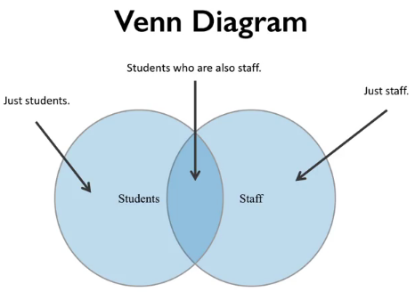

  - Think of these populations as indices in separate dataframes, maybe with label of PERSON_NAME
  - Maybe we want all people in both populations (full outer join)
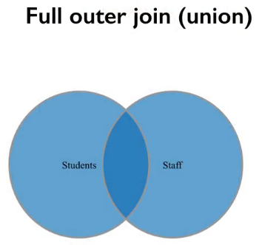

  - Maybe we want people who are both students and staff (inner join)
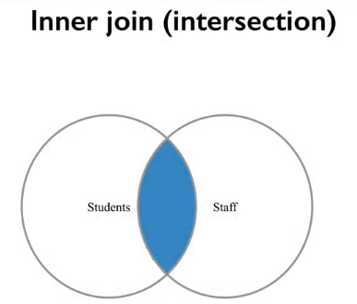

  - Use Pandas merge method for these two dataframes
    - Can specify the type of join to perform
  - 2 other types of merging that implement set addition
    - Left merge gives all staff, regardless of whether they were students or not
      - Left because the staff df is listed first in the merge request
      - If they are students, we want their details
    - Similarly, a right joint gives all students, and if they are staff, give those details too.
- Other interesting features of merge:
  - Don’t have to use indices to merge on
    - Can use columns as well
- What happens when there are conflicts between dataframes?
  - A column that is not the index of the join is present in both dataframes
    - An _x and _y suffix is appended to the column name in the joined dataframe
      - _x is always from the left dataframe, and _y is always from the right dataframe
      - Can control these suffixes with parameters on the merge request
- Multi-indexing and multiple columns
  - E.g. - possible that first names of students might be the same, but last names aren’t
    - Specify multiple keys in left_on and right_on parameters (‘First_name’, ‘Last_name’)
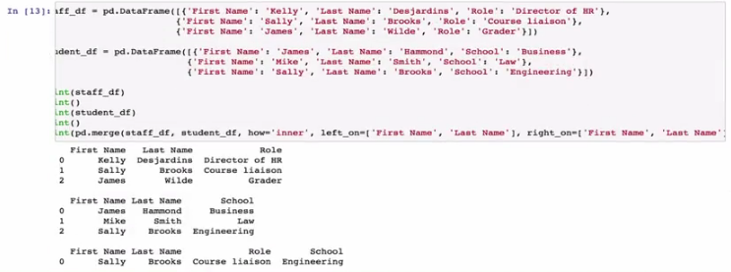
  - In this example, James Hammond, and James Wilde don’t match on both keys, so neither is included in the inner join
Pandas Idioms
- Idiomatic solutions usually have high performance, and high readability
  - Kind of an accepted best practice - “pandorable”
  - E.g. - use vectorization whenever possible, and avoid iterative loops
- Chain indexing
  - E.g. df.loc[‘Washtenaw’][‘Total Population’]
    - Generally a bad practice - pandas could be returning a copy of a view, depending on the numpy implementation
    - Code smell - if you see “][“, you should think carefully about what you are doing
- Method chaining - generally good
  - Every method on an object returns a reference on that object
- Apply(...) (rows), and applymap(...) (columns)
  - Apply is generally more useful to work across rows rather than columns
  - Apply is often not used much within large subroutines, but is included a lot in lambdas

11/04/2017
Group By
- Takes a column name or names, and splits the dataframe up into chunks
  - Returns a dataframe groupby object
  - Can be iterated upon to return a tuple which contains group condition, dataframe reduce by that grouping
- Most of the time use groupby on one or more columns
  - Can provide a function to groupby that segments the data
  - Need to set the index of the dataframe to be the column you want to groupby first
  - This is a kind of lightweight hashing
    - Used to distribute a tasks across multiple workers, cores, nodes
      - Split your data, apply some function, combine results - split/apply/combine method (e.g. mapreduce)
- Groupby object has a method called agg
  - Applies a function to the column or columns of data in the group, and returns the result
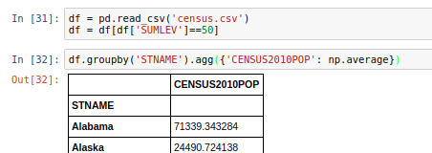

    - With agg, pass in a dictionary of the column names you want, and the function to apply
    - When pass in a dictionary to agg, can be used to either identify the columns to apply a function on, or to name an output column if there are multiple functions to run
      - Difference depends on the keys passed in from the dictionary, and how they are named.
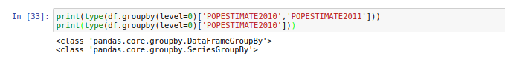
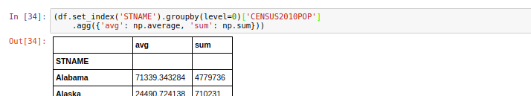

Scales
- 4 scales worth knowing as a data scientist
  - Ratio scale
    - Units equally spaced
    - Mathematical operations of +-/* are all valid
    - e.g. height and weight
  - Interval scale
    - Units are equally spaced, but there is no true zero
    - e.g. temperature in C or F. There is no such thing as absolute zero.
    - e.g. compass direction - zero degrees doesn’t indicate a lack of direction
  - Ordinal scale
    - Very common in ML, sometimes difficult to work with
    - The order of the units is important, but the intervals are not evenly spaced
    - Letter grates like A, A+ are a good example
  - Nominal scale
    - Often called categorical data
    - Categories of data, but the categories have no order with respect to one another
    - e.g. Teams of a sport
- Pandas has a number of functions to convert between scales
  - Pandas has a categorical data type.
    - Can set a data type using the astype method
  - Can change data to an ordinal type by passing in ‘ordered’ to astype(), and passing in the categories in an ordered fashion
- Ordered data has ordering, so it can help with boolean masking
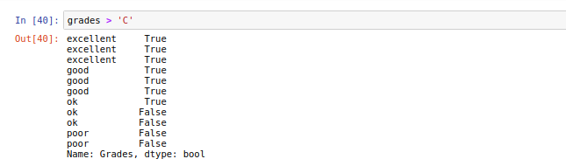
- Casting a series to order values by category
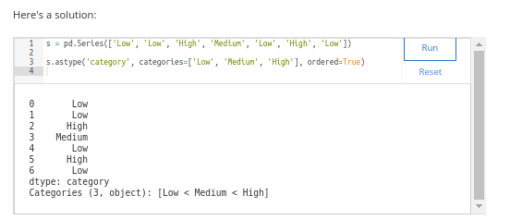
- Sometimes useful to represent categorical values as each being a column with a value of True or False as to whether that category applies
  - Very common in feature extraction
  - Variables with a boolean value typically called dummy variables
  - Pandas has a function called getdummies that will convert values of a single column into zeroes and ones indicating the presence of a dummy variable
- Pandas has a function to reduce a value on the interval or ratio scale to one that is categorical (e.g. letter grade)
  - Very useful to visualize the frequency of categories (e.g. in a histogram)
  - If using an ML classification approach to the data, need to categorize things (reduce the dimensionality of the data)
  - Pandas cut function takes an array-like structure of a column, or a dataframe, or a series, and a number of bins to be used
    - Bins are spaced equally
    - This puts data into categories
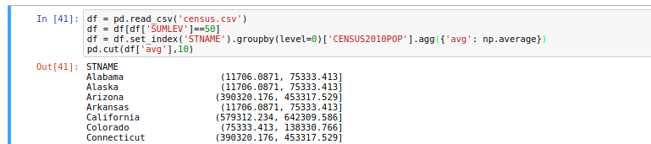

- Cut a series of jacket wearer’s heights into 3 categories (small, med, large)
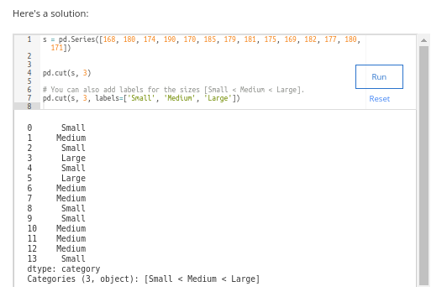
  - There are many other ways to create categorical data from values
    - Cut creates categories of equal size based on values acted upon
    - Sometimes want categories based on the frequency of the values

Pivot Tables
- A way of summarizing data in a df for a particular purpose
- Makes heavy use of agg function
- Pivot table is a df where the rows represent one variable you’re interested in, and the columns another.
  - The values in the cells are some aggregate value
  - Also tends to include marginal values as well
    - The sums for each column and row
  - Allows you to see the relationship between 2 variables at a glance.
- Here we want to see the relationship between model year and make of an electric car, and the values are the numpy mean of all electric car battery capacities for the models that manufacturer produces
  - Original data:
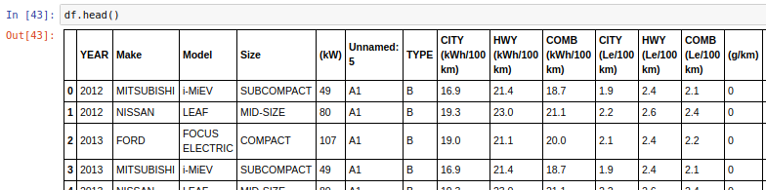
  - Pivot table:
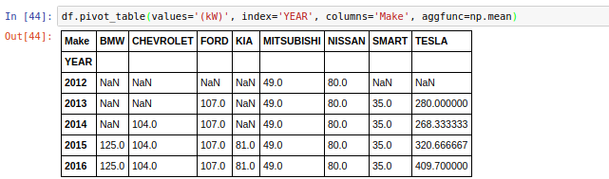
- Can pass aggfunc a list of functions, or user-defined functions

Date Functionality
- 4 main time related classes
  - Timestamp
    - Associates single values with points in time
    - Interchangeable with Python’s Datetime in most cases
  - Period
    - Represents a span of time
  - DatetimeIndex
    - The index of a Datetime
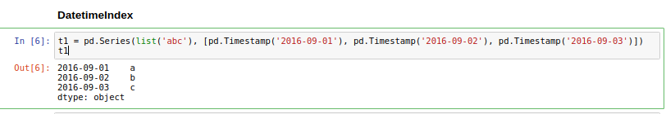
    - Note the values associated with each Datetime that came from list(‘abc’)
  - PeriodIndex
    - Very similar to DatetimeIndex, only for periods
- See the workbook for this week for more examples

Goodhart’s law discussion: https://dataskeptic.com/blog/episodes/2016/goodharts-law
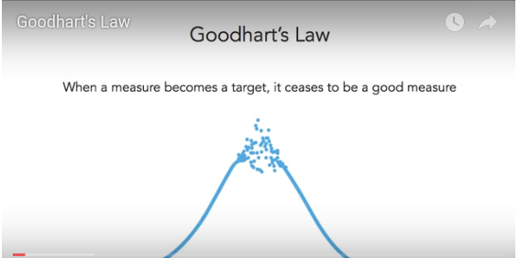

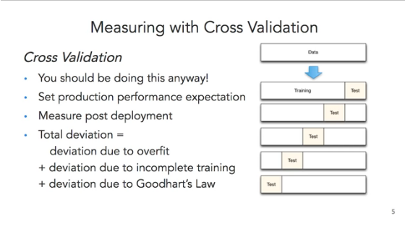
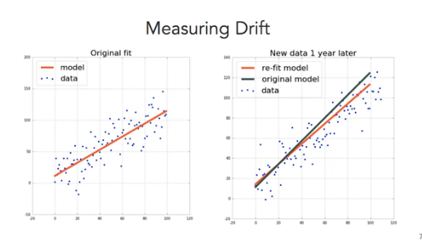
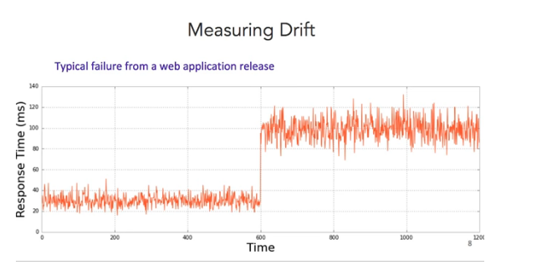
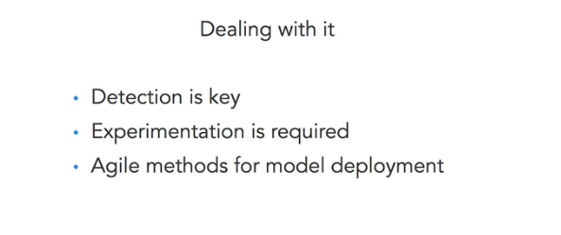
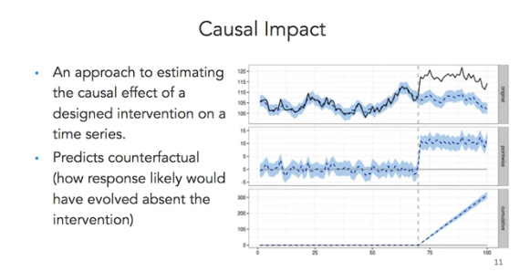
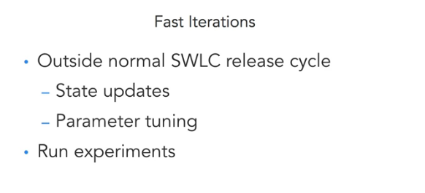
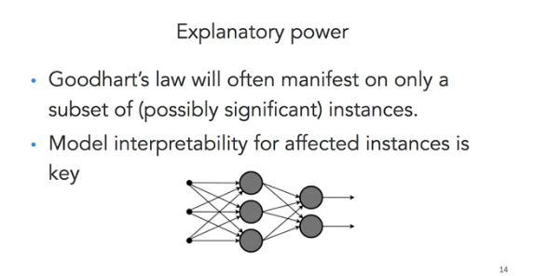

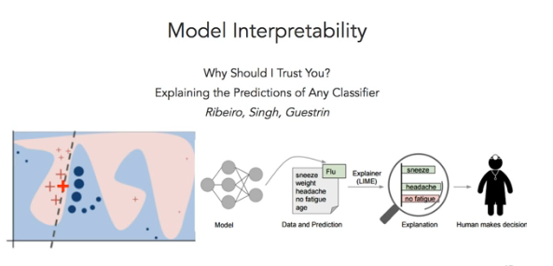
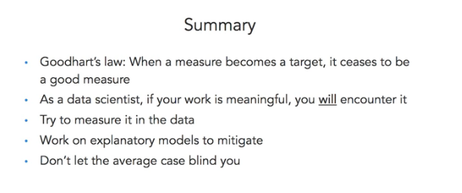
04/01/2018
Got stuck on question 2 of assignment 3 for a looong time. This discussion post was key to understanding exactly how they wanted the data cleaned. I had cleaned the data in a way that I thought met the requirements, and ultimately was even better than required, but that isn’t what makes the autograder happy.

https://www.coursera.org/learn/python-data-analysis/discussions/weeks/3/threads/xogZbrMWEee0mQrUfDuicA

