Using Git with projects hosted on Github





Juan Antonio Breña Moral

Introduction

GIT Clients / Source Tree

- Install SourceTree & Install
http://www.sourcetreeapp.com/

Clone a project

- Download a GIT project
  - Open the tool Source tree to see bookmark window. This window will help you to link your computer with your GIT project in order to work with it.

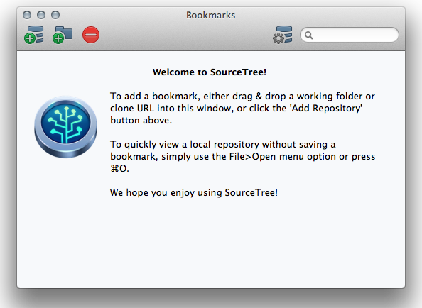
Click in the first icon to see the following window:

https://github.com/jabrena/OpenCVLab.git

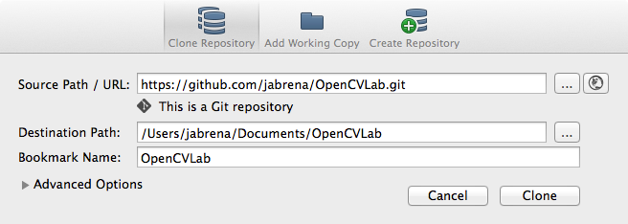

And click in clone button to download the repository.

Once you have cloned the project, click on it to see the timeline:

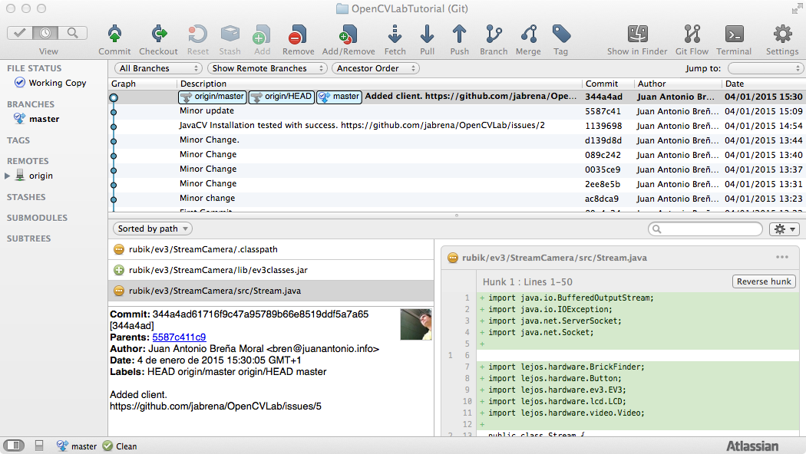
Besides you can check the project in your hard disk.

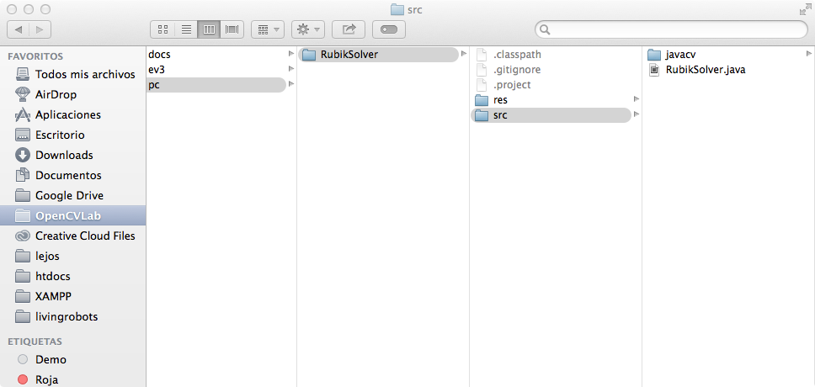

Intalling the project
The project is based on Java, so a good IDE is Eclipse.
Download Eclipse from:
http://eclipse.org/downloads/

Once, you have installed eclipse, import a project.

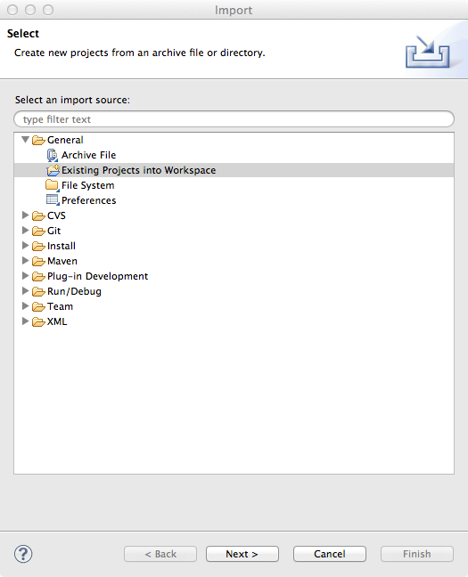

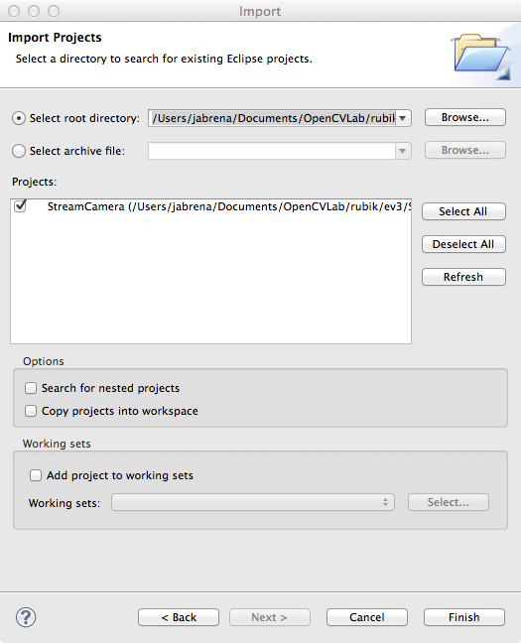

Updating the project in GIT.
When you have stable code about a feature described in a issue:
https://github.com/jabrena/OpenCVLab/issues

You could update that changes.

Open Sourcetree to see what files changes to commit in the repository.

Example:
In this case, we updated the file Stream.java adding a javadoc comment:

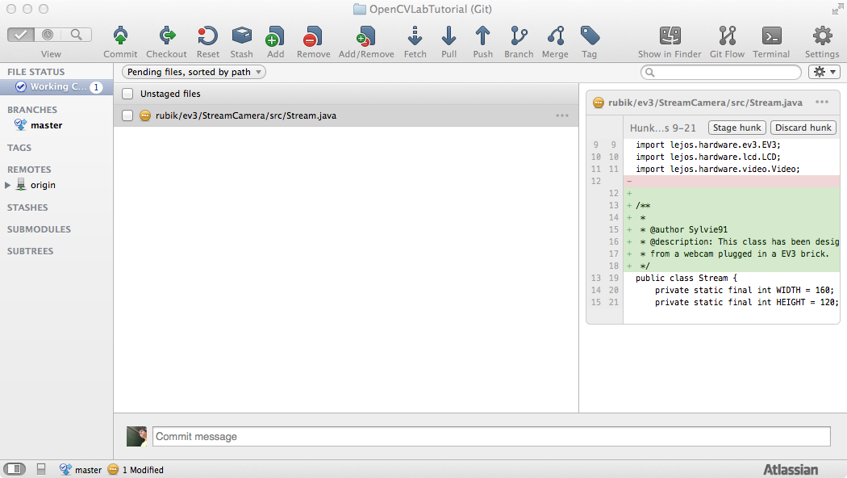
To commit, click in the file to upload and type a comment.
It is very important to associate a commit in git with a issue in github to link the commit with a issue (Good practice)

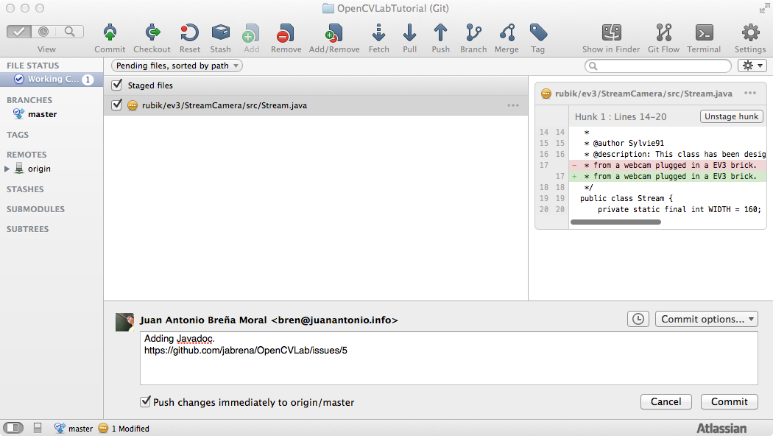

Updating your working copy with changes from other mates.
Every day try to execute a pull operation to refresh your project:

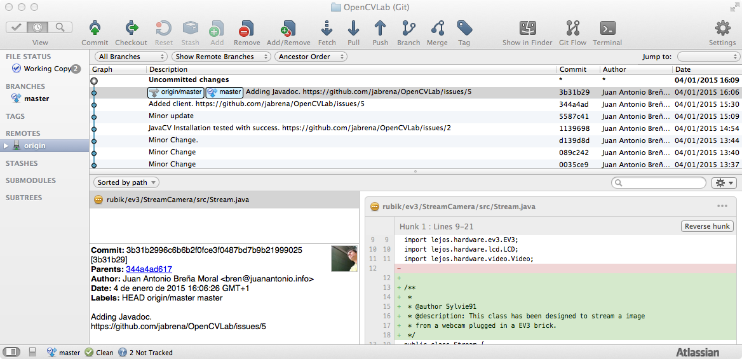
and click in pull button:
