How to reinstall LeJOS 0.9 in a system with LeJOS 0.85
Juan Antonio Breña Moral

Prerrequisites
Connect a NXT brick in your system and type:

lsusb

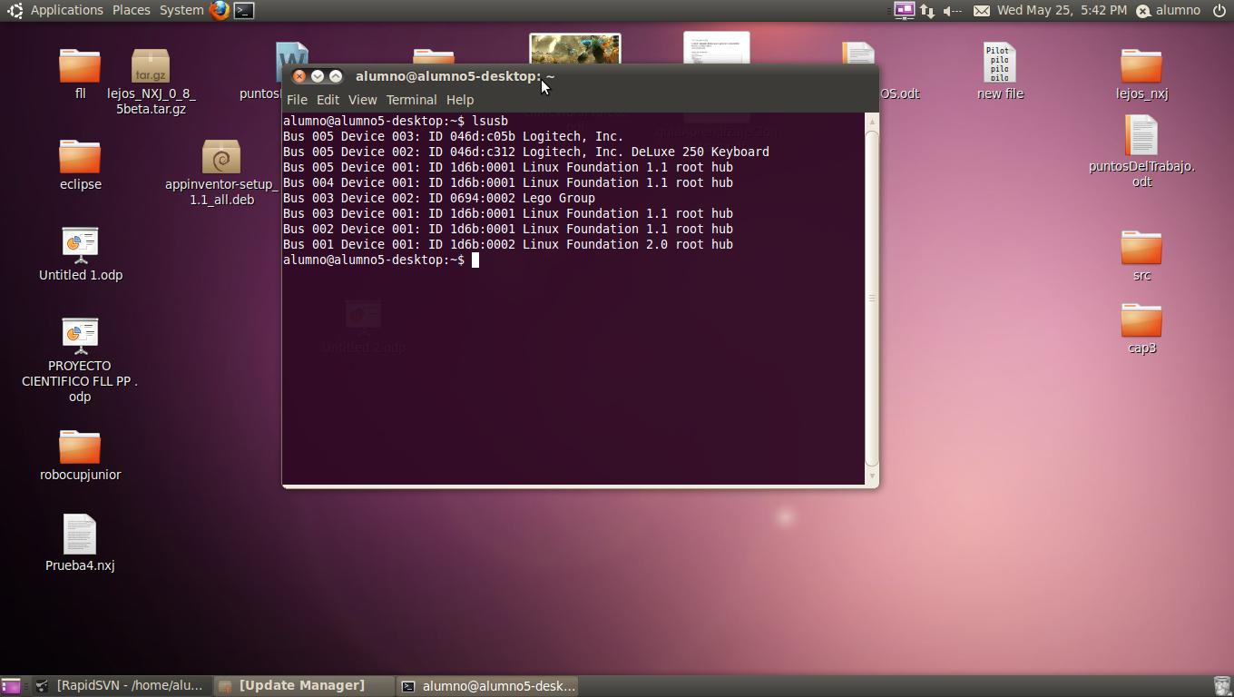
check your lejos installation with the command:

nxj

http://lejos.sourceforge.net/
http://sourceforge.net/projects/lejos/files/lejos-NXJ/0.9.0beta/

sudo cp lejos_NXJ_0_9_0beta.tar.gz /usr/local/

alumno@alumno5-desktop:/usr/local$ ls
bin include lejos_NXJ_0_9_0beta.tar.gz sbin
etc lejos lib share
games lejos_NXJ_0_8_5beta.tar.gz man src

sudo mv lejos lejos_085
sudo su
tar -xvf lejos_NXJ_0_9_0beta.tar.gz
mv lejos_nxj lejos
cd lejos
chmod +x bin/*

root@alumnlo5-desktop:/usr/local/lejos/build# ant
Buildfile: build.xml

jlibnxt:

clean:

jlibnxt:
[cc] 1 total files to be compiled.
[cc] Starting link

make:
[copy] Copying 1 file to /usr/local/lejos/lib/pc/native/linux/x86
[echo]
[echo] *** SUCCESS: jlibnxt was installed correctly ***
[echo]

all:
[echo] Done.

BUILD SUCCESSFUL
Total time: 2 seconds

sudo rmmod cdc_acm
sudo -s
echo "" >> /etc/modprobe.d/blacklist.conf
echo "blacklist cdc_adm" >> /etc/modprobe.d/blacklist.conf

