**ACHIEVEMENTS**

**First Aider**

Provided first aid and maintain safety to the entire student body during school events.

* + - General Assembly (June 14, 2012)
    - Acquaintance party (June 15, 2012)
    - CNSM Days (September 19 – 21, 2012)
    - Sports fest (February – March 2013)

**Blood Letting**

This is a joint project of LINGAHP, Nursing College Assembly and GEAMH-Cavite Blood Council that happened last September 09, 2012. Materials and facilities for the blood donation are brought by the personnel from the GEAMH-Cavite Blood Council. Every individual who voluntarily donated blood was given an Identification card which will serve as a guarantee that they will receive assistance in case the need for blood arises.

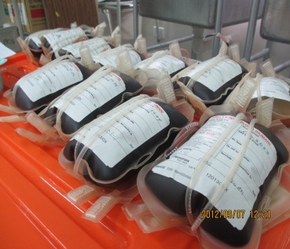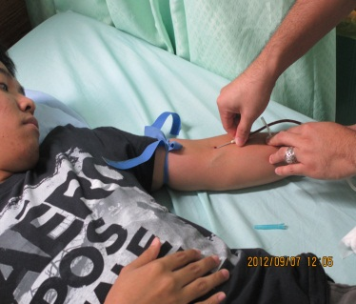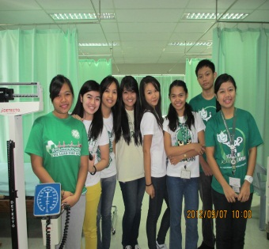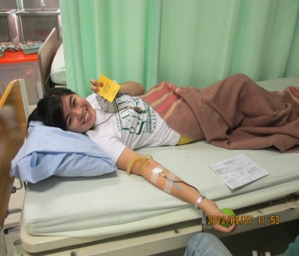

**Basic Life Support Training**

In cooperation of College assembly and AHMCS Training Center, LINGAHP was able to provide their selected members to have free Basic Life Support Training. Everyone who joints this activity was able to get their own Healthcare provider card which is an American Heart Association (AHA). (October 10, 2012 at chapel Rm 1)

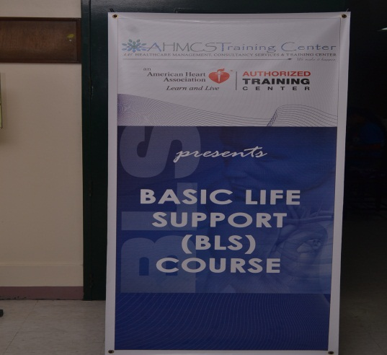

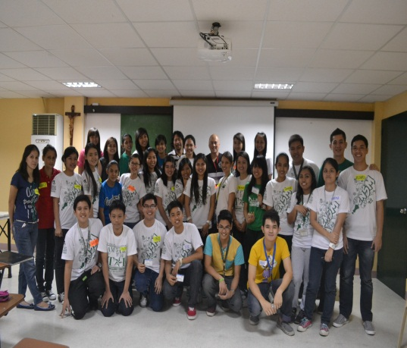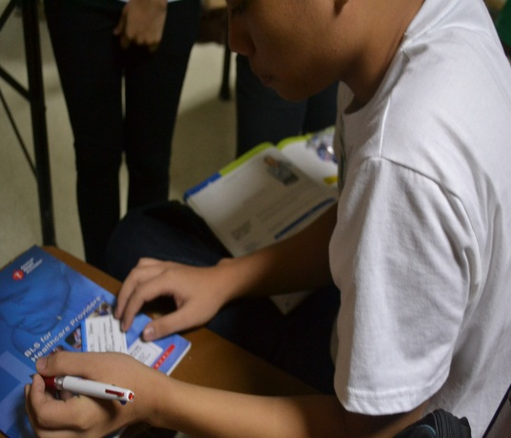

OPTULI

Members of LINGAHP volunteered to the school’s annual OPTULI last May 04, 2013 at DLS HIS Chapel rooms. More than 200 boys were circumcised. This project became successful because of the students, doctors and nurses who volunteered.

