# **SLO Manual Annotation Instructions**

## Equipment check

1. You will need a mouse and mouse pad for selecting/editing the pixels for segmentation.
2. You will also need a large monitor, and preferable be able to perform manual segmentation **not** on a laptop screen but a typical desktop monitor.

## ITK-SNAP setup

1. Go to [ITK-SNAP Version 4.x Downloads](http://www.itksnap.org/pmwiki/pmwiki.php?n=Downloads.SNAP4) and click the link for ITK-SNAP 4.2.0 (stable version) windows Self-Install Package (64-bit).
2. Fill in the form and select next. On the next page and select the download. It will take you to another page and the download should start.
3. Navigate to the downloaded .exe file and double click to begin install process.
4. Select next, agree to the terms and conditions and select next. Tick the box next to ‘Do not add SNAP to the system PATH’, keep selecting next until the setup is complete, press finish.
5. Navigate to the SNAP program and open, it will prompt you if you would like to enable automatic updates, select yes.
6. **(OPTIONAL)** Go to [RSNA 2016 ITK-SNAP Training - Intro & Manual Segmentation - YouTube](https://www.youtube.com/watch?v=-tjVN5GwjKg&feature=youtu.be) and watch the ~15min video. This is a training video to learn how to use SNAP, they give an example in 3D but we will be annotating in 2D. The slides for the training video can be found here: [RSNA-manual-Guido-2.key (itksnap.org)](http://www.itksnap.org/pmwiki/uploads/Train/RSNA2016-Manual-Guido-Final.pdf).

## Load in image, label properties, main tools

1. Go to File > Open Main Image. Use the browse button to navigate to the image. Under File Format select ‘Generic ITK image’. Select Next and Finish.
2. Click the ‘A’ in the top right corner of the top left window in it to expand the view to full size and set the window to full screen (*below*).
3. Go to Segmentation > Open Segmentation and select browse to navigate to the corresponding binary vessel mask. Under File Format select ‘Generic ITK image’. Select Next and Finish.
4. Next, we need to set up some labels. Click Segmentation > Import Label Descriptions and select browse to navigate to a text file whose name begin with *LabelProperties*.
   1. If correcting the artery-vein-optic disc segmentation map, upload *LabelProperties_AVOD.txt.*
   2. If correcting the binary vessel segmentation map, upload *LabelProperties_Binary.txt.*

Once selected for upload, the file will be automatically detect it as a text file. Click Ok.

1. Using *LabelProperties_AVOD.txt,* your Segmentation Labels toolbar you will now see different colour labels for:
   1. Clear Label (Black), which is your “rubber”
   2. Artery (Red)
   3. Vein (Blue)
   4. Green (Optic disc)

For *LabelProperties_Binary.txt* there is just the Clear Label (Black) and Vessel (Red).

1. Your window should look something like below.

Selecting this tick-box can make a label disappear which can be useful.

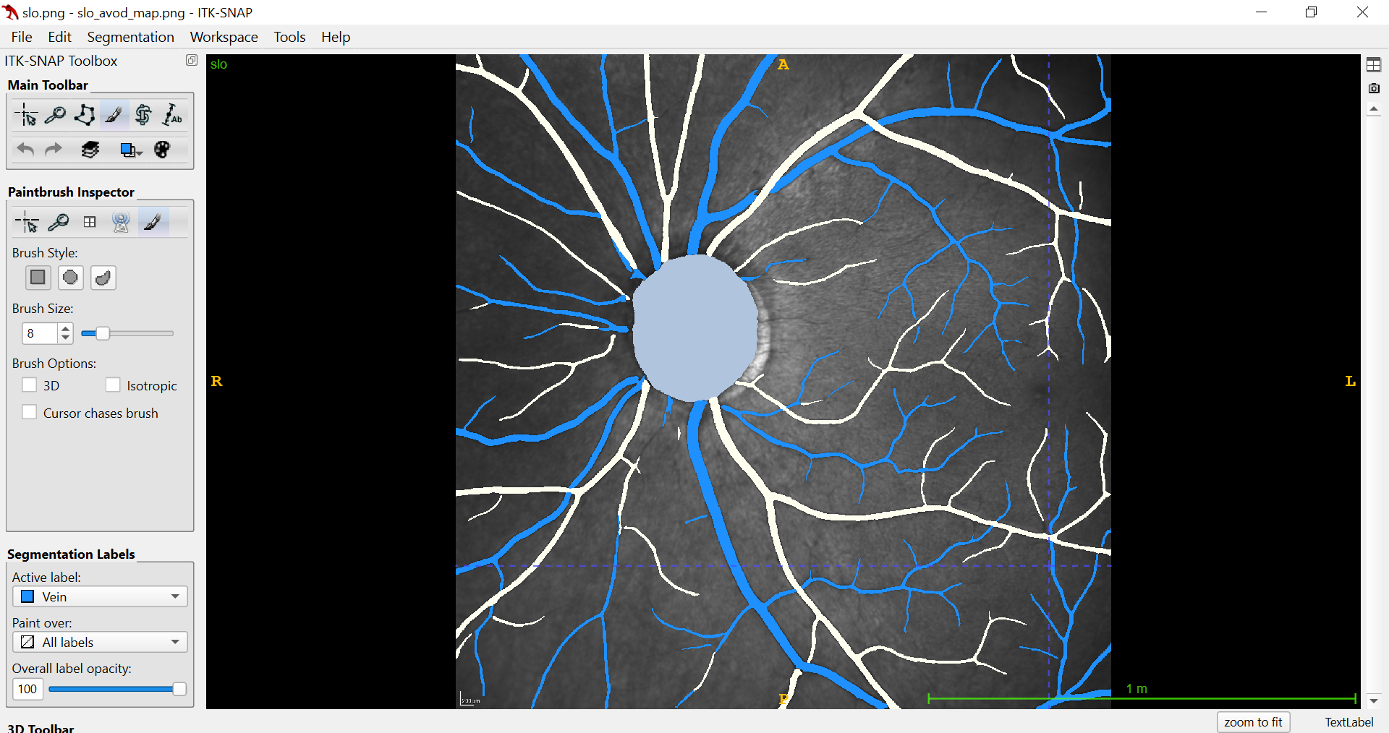

Label editor

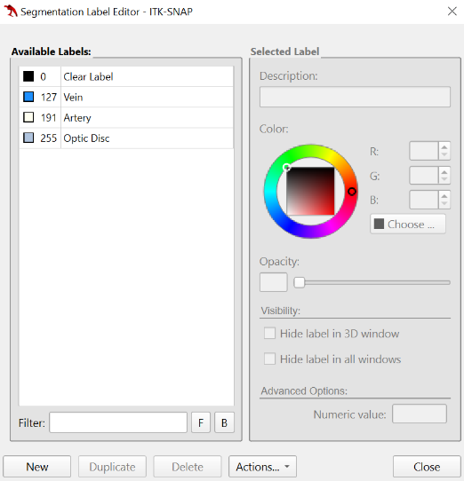

Paint brush

Magnifying glass

Paintbrush size/shape options

Label selector

## Main tools

1. Note, on this toolbar there is also an opacity option to change the transparency of the labelling which can be helpful for manual segmentation. Use your mouse scroll to toggle quickly between opacity levels.
2. On the Main Toolbar, the magnifying glass can be used to zoom into the portion of the image you would like to annotate. If you hover your mouse over this icon it provides instructions on how to do that.
3. We recommend all annotating is done using the Paintbrush tool, seen on the Main Toolbar

## Segmentation

1. Optic disc:
   1. Select the Paintbrush tool. This is a paint brush that allows you to ‘colour in’ pixels. You can change the size and shape of the brush.
   2. Select the “Optic disc” segmentation label and make sure you are painting over All Labels (as the optic disc isn’t current yellow (an unknown vessel).
   3. You may use the magnifying glass freely. Holding the right mouse-click will zoom in and out for you.
   4. You may alter the opacity to aid segmentation.
   5. You can select a Paintbrush Brush size freely, and you may want to start with a large size to cover the core region of the optic disc.
   6. I would recommend selecting the circular Brush Style, which is helpful for annotating edges.
   7. Annotate the optic disc including the optic disc cup and rim (see below).
   8. If you over-annotate, you can select “Clear Label” as the active label and “Optic Disc” as the label to Paint Over. This prevents you from rubbing out any vessels, and only rubbing out optic disc labels.
2. Artery-vein segmentation:
   1. Select the Paintbrush tool. This is a paint brush that allows you to ‘colour in’ pixels. You can change the size and shape of the brush.
   2. Select one of “Artery” or “Vein” as the Active Label and you can select “All Labels” as the Paint Over label, or select the other vessel type to paint over for more controlled corrections.
      1. In the former, this lets you colour new pixels as artery/vein which is helpful for fixing disconnected vessels/false negatives.
      2. The latter is helpful to speed up the annotation process – you can select a large Brush Size for large vessels and paint over them freely without worrying about annotating any of the fundus tissue adjacent to them.
   3. You can use the magnifying glass freely. Holding the right mouse-click will zoom in and out for you.
   4. Use the “Clear Label” to correct false positives, i.e. rub these pixels out.
   5. You can select a Paintbrush Brush size freely, and you may want to start with a large size to cover the larger vessels more quickly.
   6. I would recommend selecting the circular Brush Style, which is helpful for annotating edges.
   7. You can alter the opacity to aid segmentation.
3. Fovea
   1. Select the Paintbrush tool. This is a paint brush that allows you to ‘colour in’ pixels. You can change the size and shape of the brush.
   2. (**Optional**) Depending on the state of the predicted fovea segmentation mask, you may want to remove all the predicted areas by using the “Clear Label”, i.e. rub these pixels out.
      1. Use a large Paint Brush size to do this easily and quickly.
   3. Select the “Fovea” as the Active Label and you can select “All Labels” as the Paint Over label.
   4. You can use the magnifying glass freely. Holding the right mouse-click will zoom in and out for you.
   5. You can select a Paintbrush Brush size freely, and alter the opacity to aid in your segmentation.
   6. Select a **single** area as the foveola centralis to the best of your ability.
      1. (**Important**) When re-inputted into OCTolyzer, the mask will be processed to find the centroid of the largest object.
4. Some tips:
   1. You can select the “Clear label” as a “rubber”, in case you label parts of the image mistakenly. This can also be done with the right mouse-click.
   2. Ctrl+Z will undo the most recent Paintbrush annotation.
   3. Press 2 or 4 to toggle between pan/zoom (2) and brush tool (4)
   4. Regularly reduce the “Overall label opacity” on the Segmentation Labels” toolbar to sanity check any selected regions to make sure you are happy with your selections.
5. Some rules we follow for artery-vein classification
   1. Alternating rule: It is common for the distribution between arterial and venule retinal vasculature to appear on the fundus in an alternating like fashion (see left-hand image).
   2. Thickness rule: It is generally observed that veins are thicker than arteries (see left-hand image).
   3. Brightness rule: It is also generally observed that veins are darker than arteries (see left-hand image)
   4. Intersection/junction rule: It’s rare for arteries or veins to cross each other. If it appears that retinal vessels are intersecting (and forming at least a 4-ended junction), it’s very likely that an artery and vein are crossing (see right-hand image).

## Saving segmentations

1. Once you’re are happy with your annotation, save the segmentation into the “annotations” folder by going to **Segmentation > Save Segmentation Image** and **do not change the filename, and only change the file format from “.png” to “.nii.gz**”, saving the file format as NiFTI. **This is crucial for SLOctolyzer to identify a manual annotation**. Select Finish.
2. You can do step 2 & 3 as you go along. If you need to finish an annotation later follow step 2 and 3 and close SNAP. When you want to come back to it, load the image as in (1) described earlier in this document and load the segmentation by going to Segmentation > Open Segmentation and select the file to open and go to Segmentation > Import Label Descriptions and select the .txt file to open and continue annotating where you left off.