AP SETUP

Know how to create AP SETUP
- AP Setup is where we setup payables. To create new AP Setup, click the CREATE button to proceed.
- Upon creating new AP Setup transaction, a dialog box will pop out with list of supplier. Type the supplier in the search bar and it will automatically sort out. Then click the selected supplier.
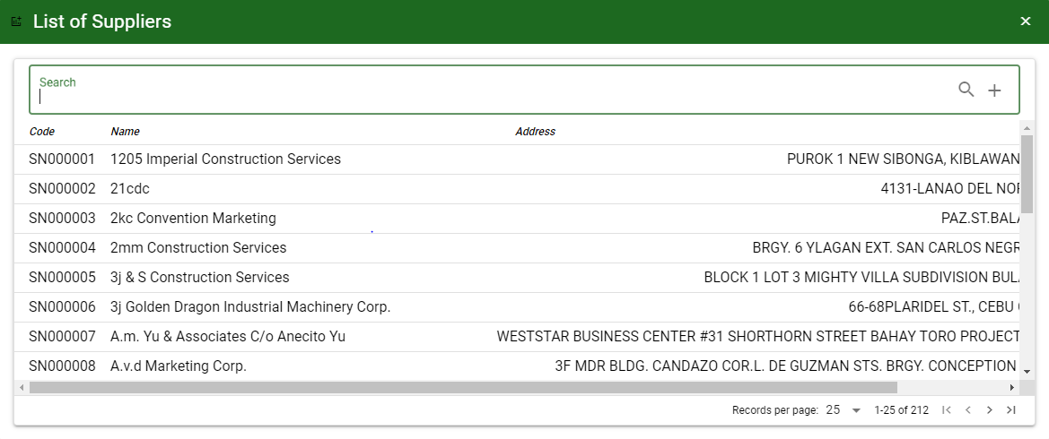
- 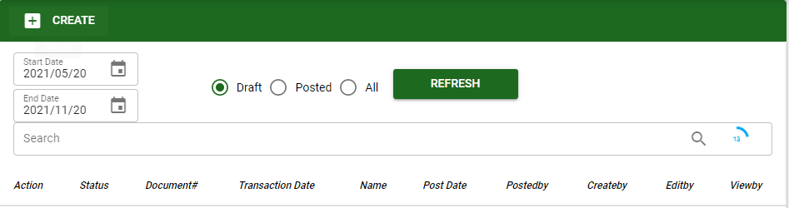

Know how to SELECT ACCOUNT IN AP SETUP
- To select account/s in AP Setup, click ADD ACCOUNT button then ENTER in Search bar to load all accounts.
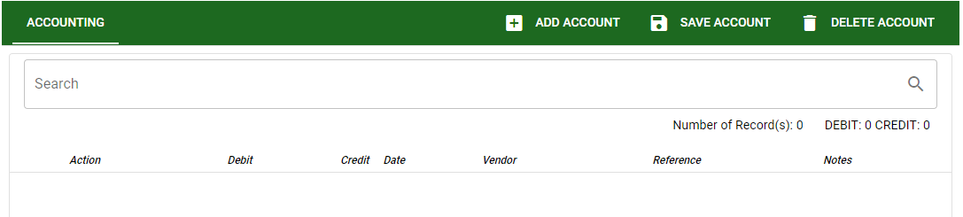

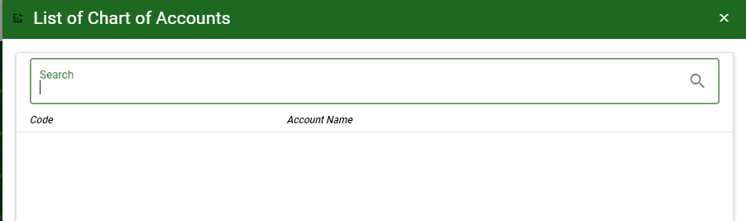

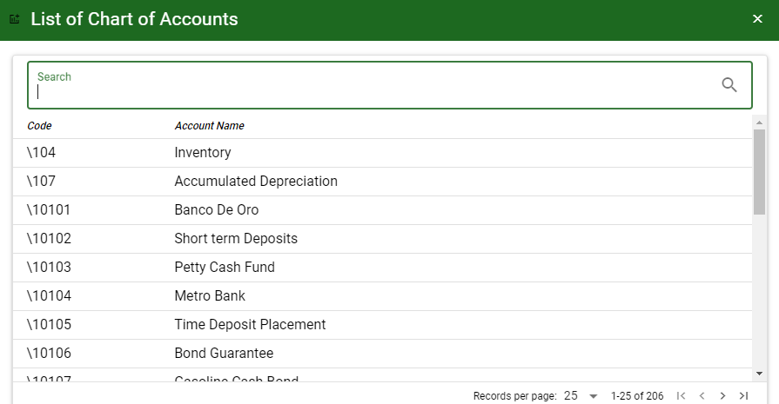

- SAVE ACCOUNT: To save the accounts and to proceed.
- DELETE ACCOUNT: To delete all accounts for the specific transaction.

Know how to USE THE FUNCTION BUTTONS IN AP Setup
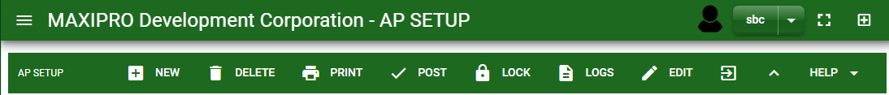

 | FULL SCREEN Button  Use to allow the AP Setup – main form to full screen. |  | NEW Button  Use to create new transaction. |  | LOCK Button  Use to lock the transaction to refrain from changing the details in the transaction.
 | OPEN NEW TAB Button  Use to open new tab module you currently using. |  | DELETE Button  Use to delete created transaction that doesn’t have yet previous transaction. |  | LOGS Button  Use to monitor the activities made in the AP Setup.
 | BACK TO LISTING Button  Use to go back from AP Setup – main form to AP Setup main window. |  | PRINT Button  Use to print AP Setup printout. |  | EDIT Button  Use to modify the transaction.
 | HIDE HEAD Button  Use to minimize the AP Setup – main form. |  | POST/UNPOST Button  Use to post the transaction if it is finalized and to unpost if there is modification with the transaction.

