AR SETUP

Know how to create AR SETUP
- AR Setup is where we setup receivables. To create new AR Setup, click the CREATE button to proceed.
- Upon creating new AR Setup transaction, a dialog box will pop out with list of customer. Type the customer in the search bar and it will automatically sort out. Then click the selected customer.
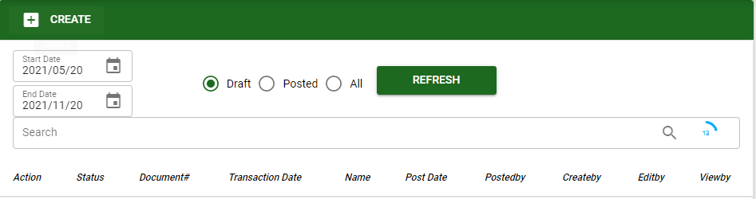
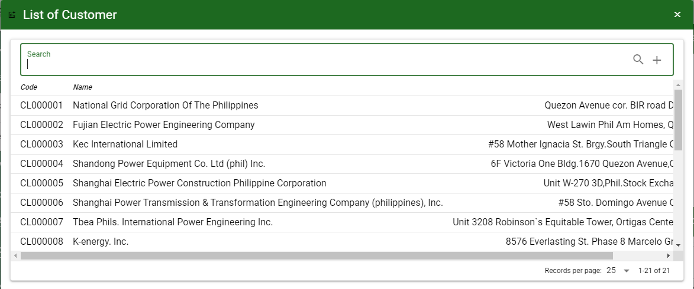

Know how to SELECT ACCOUNT IN ar SETUP
- To select account/s in AR Setup, click ADD ACCOUNT button then ENTER in Search bar to load all accounts.

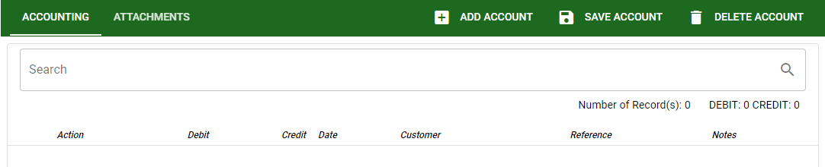

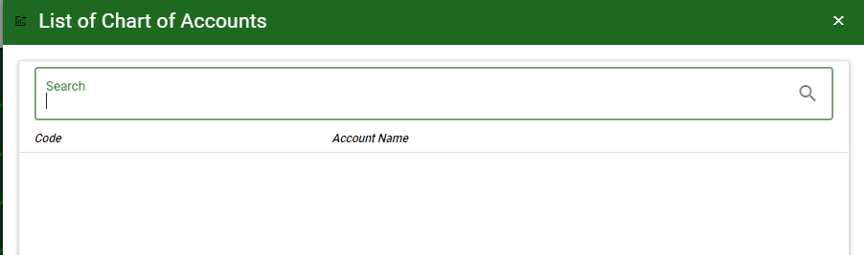

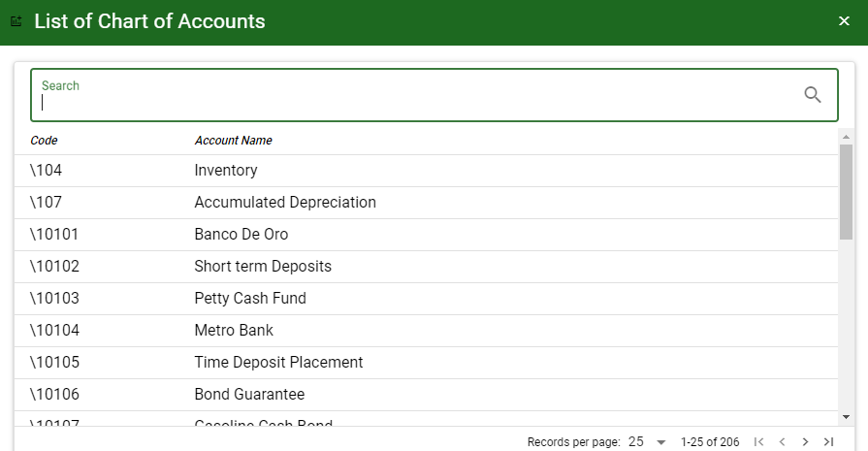

- SAVE ACCOUNT: To save the accounts and to proceed.
- DELETE ACCOUNT: To delete all accounts for the specific transaction.
- ATTACHMENTS: Upon clicking ATTACHMENTS tab, the user can add documents.


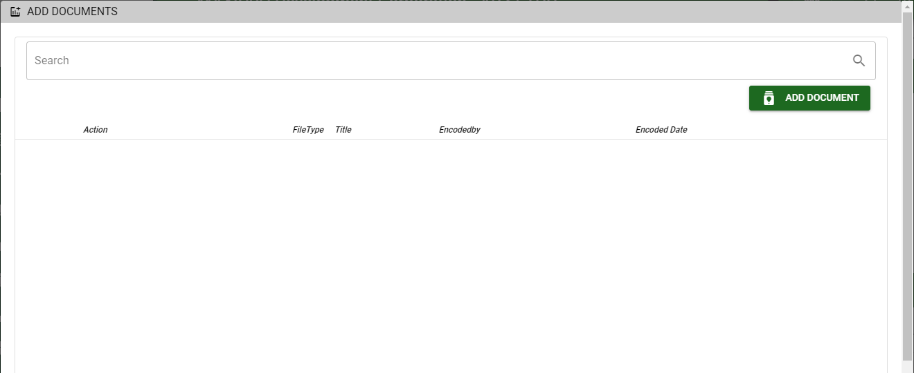

Know how to USE THE FUNCTION BUTTONS IN AR Setup
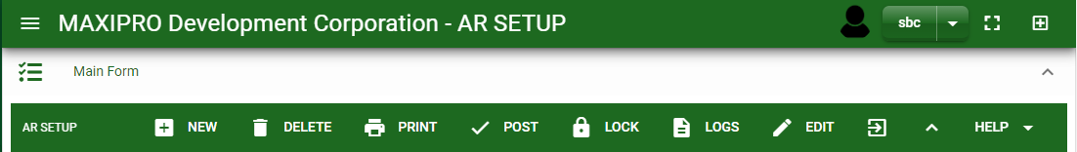

 | FULL SCREEN Button  Use to allow the AR Setup – main form to full screen. |  | NEW Button  Use to create new transaction. |  | LOCK Button  Use to lock the transaction to refrain from changing the details in the transaction.
 | OPEN NEW TAB Button  Use to open new tab module you currently using. |  | DELETE Button  Use to delete created transaction that doesn’t have yet previous transaction. |  | LOGS Button  Use to monitor the activities made in the AR Setup.
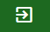 | BACK TO LISTING Button  Use to go back from AR Setup – main form to AR Setup main window. |  | PRINT Button  Use to print AR Setup printout. |  | EDIT Button  Use to modify the transaction.
 | HIDE HEAD Button  Use to minimize the AR Setup – main form. |  | POST/UNPOST Button  Use to post the transaction if it is finalized and to unpost if there is modification with the transaction.

