Construction System

Billing Accomplishment

Know how to create Billing Accomplishment
- To create Billing Accomplishment, click CREATE to proceed.
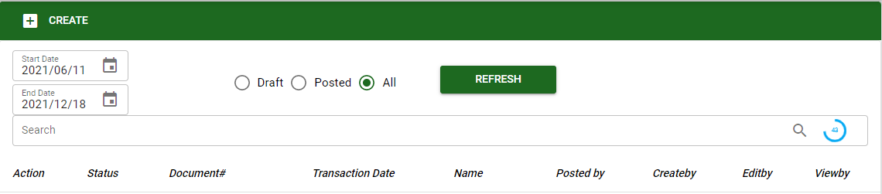
- In creating Billing Accomplishment, the user must select customer and project.
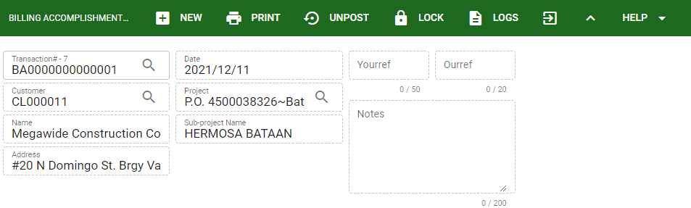
- Upon creating Billing Accomplishment, the user will input the quantity accomplished per sub-activity of each stage of the project.

Know how to add per subactivity in billing accomplishment
- To sub-activity of each stage of the project in Billing Accomplishment, click the STAGE button to view all stages created and have completed based from the project selected in the transaction.
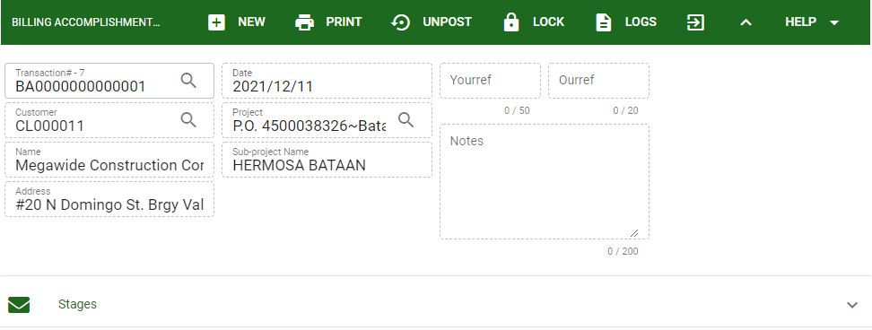
- Upon clicking the STAGES, it will show the list of stages under that particular project.
- The user must click the PLUS sign button to proceed in the sub activity of the stage.
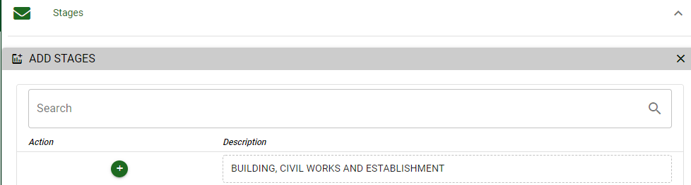
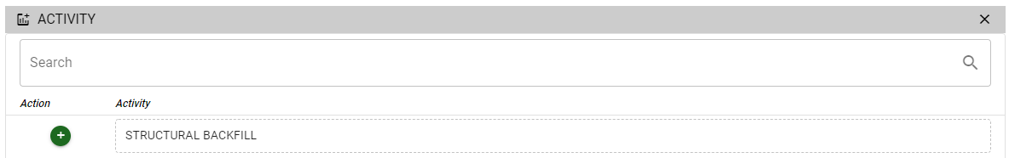

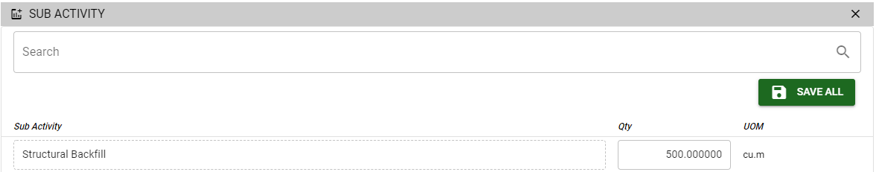
- The user will input the quantity used to accomplished the sub-activity, click the SAVE ALL to proceed.
- If the billing transaction of per project is finalized the user can POST the transaction to proceed in Progress Billing.

Know how to post transaction in Billing accomplishment
- If the transaction is final and ready for posting. Click the POST button.
- The posted transaction can be unposted as long as it’s not yet created in the progress billing and paid.
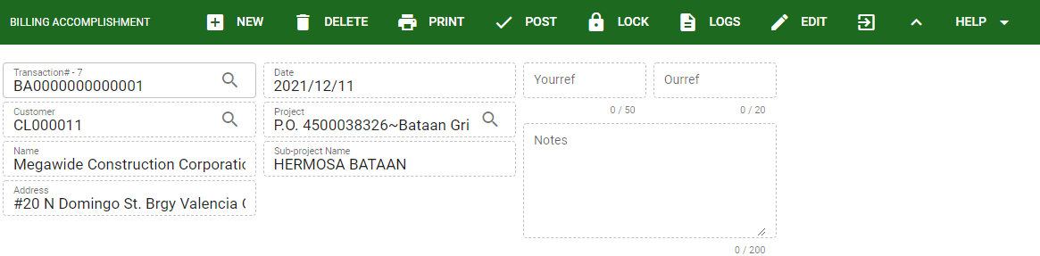
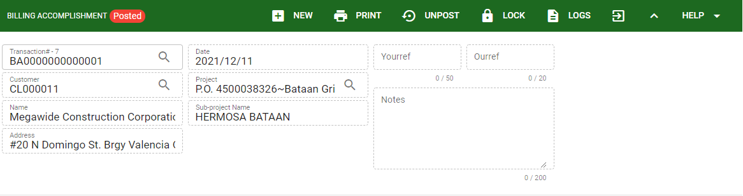
All posted billing accomplishment transaction will be related in creating Progress Billing.

