CONSTRUCTION SYSTEM

Budget Liquidation

Know how to create Budget Liquidation
- Budget Liquidation is related to the created Budget Request from the site. Once the Budget Request is approved and posted, then it will proceed in Budget Liquidation.
- To create new Budget Liquidation, click the CREATE to proceed.
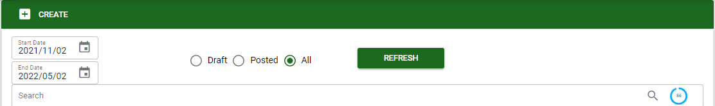
- The user may use the filters for the type of transaction and date range to search specific transaction.
- Upon creation of Budget Liquidation, the user must select the project, sub-project and the BR# (approved budget request for reference) then SAVE.
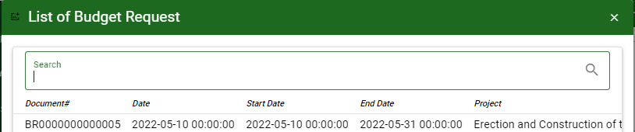
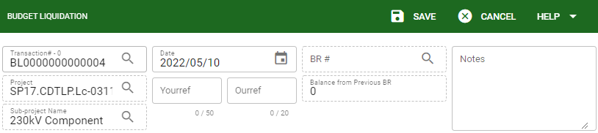

- If the selected reference BR# have balance that not use yet in the liquidation it will show in the header.
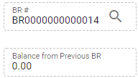

Know how to add particulars in Budget Liquidation
- Click the BR button to select a particular budget request reference, then click ACCEPT to proceed.
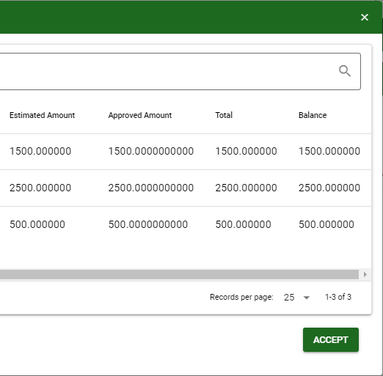
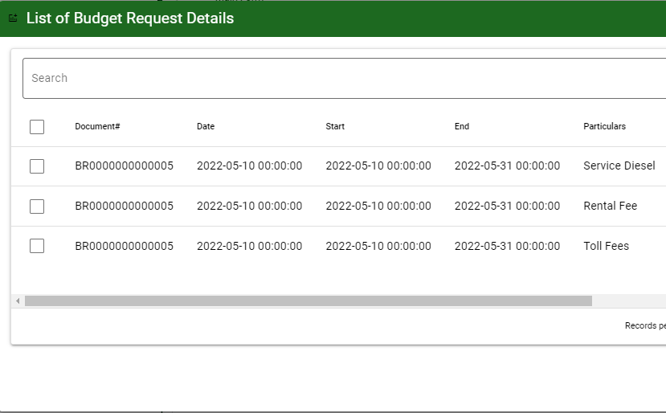

Note: In BR button the user can monitor the available balance per particulars based from the approved budget amount.
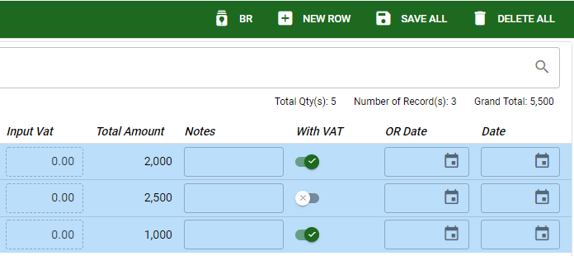
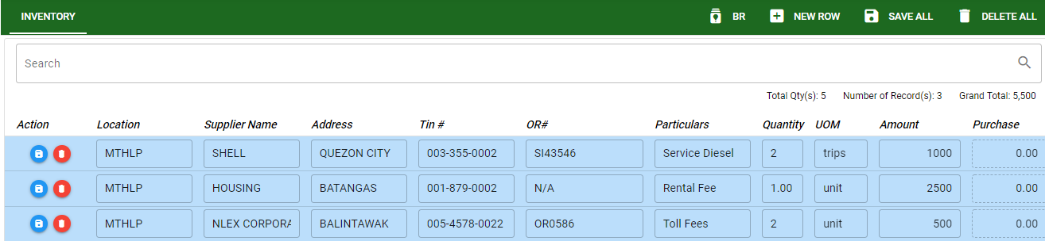
- The user will manually encode the details of the liquidation based from the approved budget request.

- Click SAVE to proceed on Posting the transaction.

Know how to post Budget Liquidation
- To post the Budget Liquidation transaction, Click the POST button.
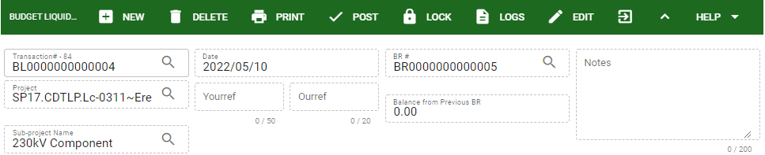
- Budget Liquidation function keys:
- New: To create new Budget Liquidation click this NEW button.
- Delete: This will delete the transaction if there it is not yet posted and does not have particulars.
- Print: The user can use this PRINT button to generate and print the Budget Liquidation in two (2) formats (BRUR and Liquidation).
- Post: The user will click this if the transaction is finalized.
- Lock: The user can use this to avoid accidentally modifying or deleting unposted transaction.
- Logs: This will help to monitor and check on what are the actions applied and done in a particular transaction.
- Edit: The user can modify/ revised the transaction as long as it is not yet posted.

