Bill of Quantity (BOQ)

Know how to create BOQ
There are two ways to create BOQ:
- The user can create BOQ which is the materials and services are automatically plotted based from the Stages Setup and Project Management, then the user will just input the correct quantity and amount that needed for that particular materials and services after selecting specific project, subproject and stage.
- Click the CREATE button.
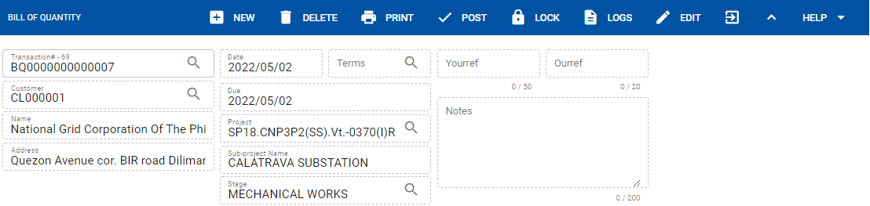
- Select the specific Project, Sub-project and Stages, then click SAVE.
- After saving, it will automatically display/plot the material and services based from the setup of project, sub-project and stages.
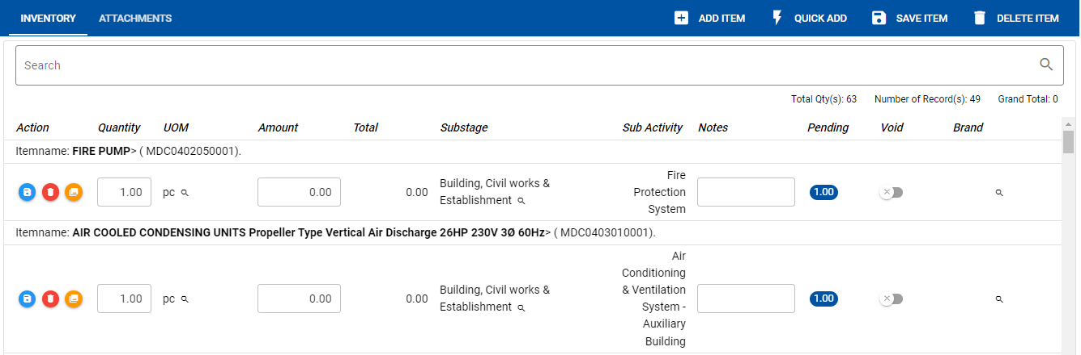
- The user can also create BOQ manually even without the setup of materials and services from the Stages Setup. To know how to create manually BOQ proceed from below procedures:

- Click the CREATE button.
- The user can also browse other created transaction. Depends on the filter set-up.
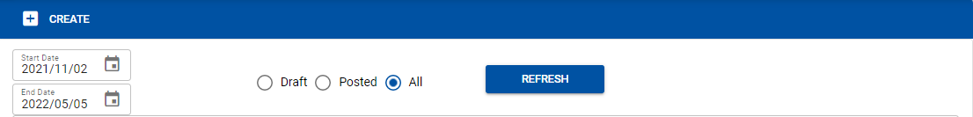

The user must set-up the start and end date and select what type of transaction to be search. Draft is for not yet finalize transaction and posted transaction is for finalized transaction.

- In creating BOQ the user must select the allotted materials and services for that particular project, subproject and stage.



- After selecting project, subproject and stage for BOQ the user can add the material and labor for that transaction. Click ADD ITEM to select from the list of products.
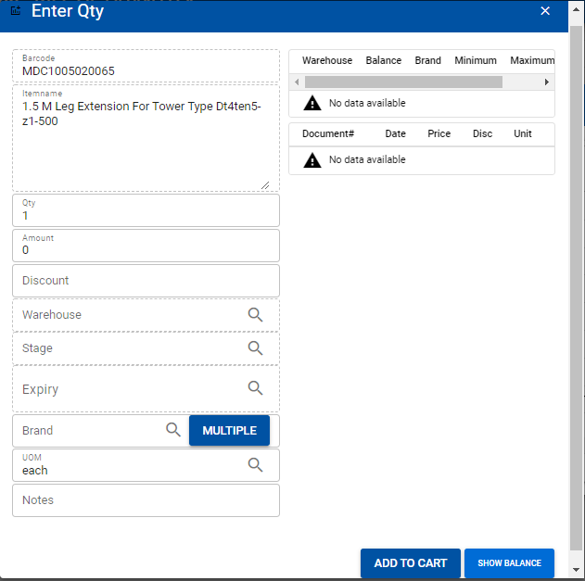
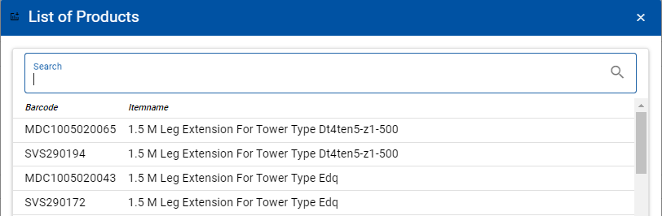

- Upon selecting materials and services from the list of products the user must enter the quantity and select the specific stages.
- SHOW BALANCE button is to view available stocks in warehouse.
- After entering the quantity click the ADD TO CART to select more material that is required in the transaction.

Know how to add item in BOQ
- All selected materials and services from the list of products will be added in the CART.
- To proceed, the user must click the CART icon to review and accept the material and services.
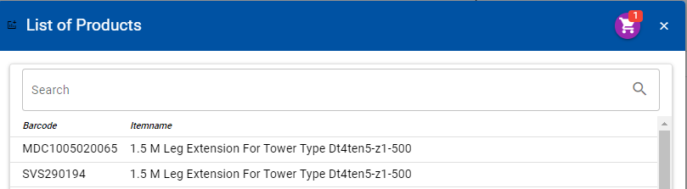
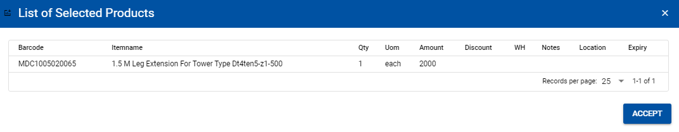

- Click the ACCEPT button to proceed in the transaction. Make sure before posting, the selected items/services are saved.

Know how to post transaction in BOQ
- After selecting materials and services in BOQ, the user must post the transaction once it is finalized.
- To post the transaction. Click the POST button.
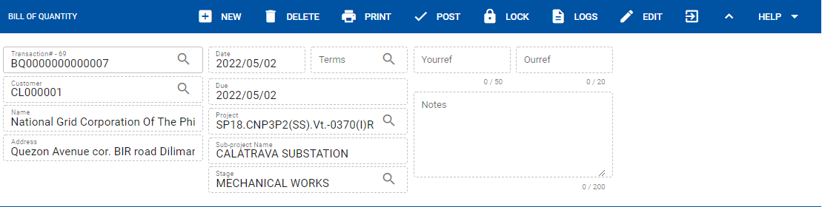
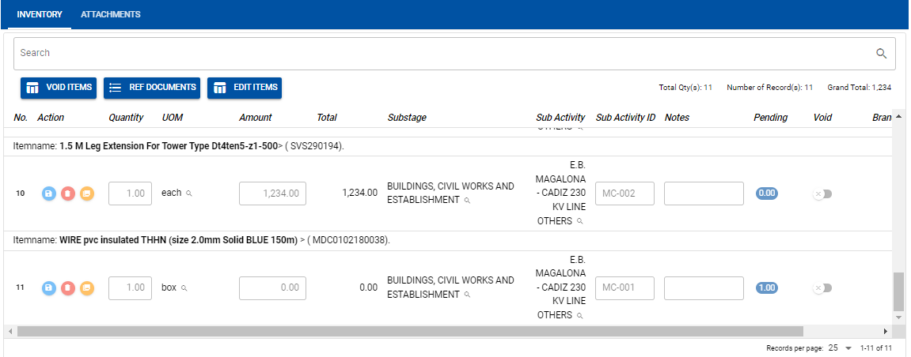

- After posting, the transaction is finalized. The user cannot revise once it is posted. In case the user has something to revised from the transaction as long as the material or services are not yet served the user can still un-post the transaction. Click the UNPOST to proceed revising the transaction.
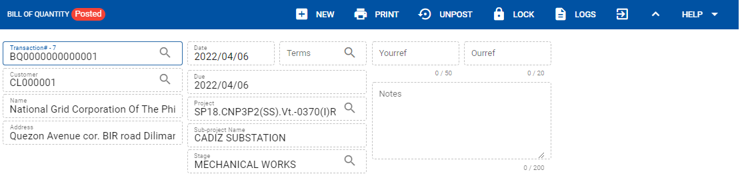

Know how to void in BOQ
- In BOQ the user can void transaction in the given options:
- If the materials or services in the transaction have quantity/amount served the user can void only the remaining quantity/amount.
- If the materials or services in the transaction are not yet served, the user can still void the whole quantity and amount of the material or services.
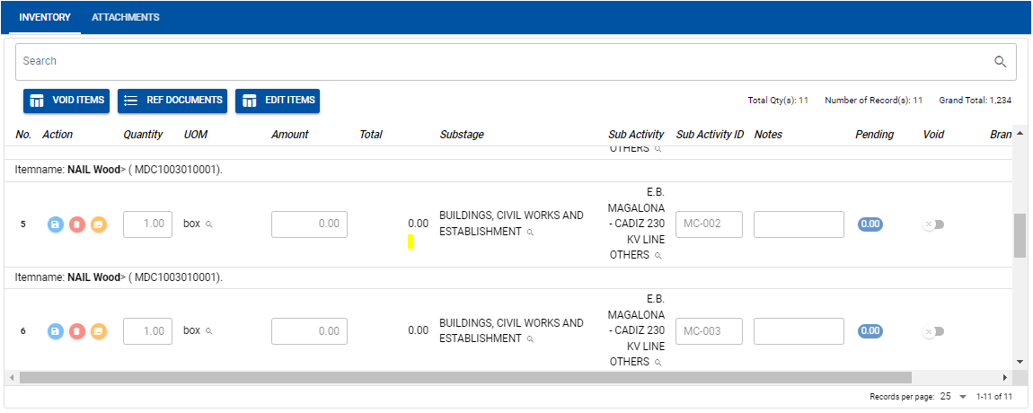
- If the user can also delete the transaction as long as the materials or services it is not yet serve.

