Construction System

Budget Request

Know how to create Budget REquest
- Click the CREATE button to create new budget request. See image below.
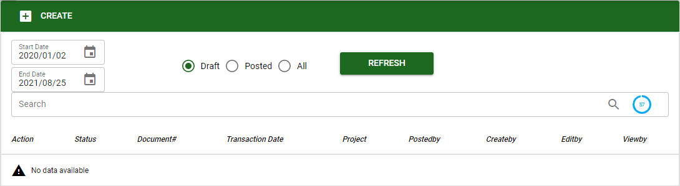
- In creating new Budget Request, the user must select specific project and subproject and other details of the transaction. After filling-in the information in the header, click SAVE to proceed.
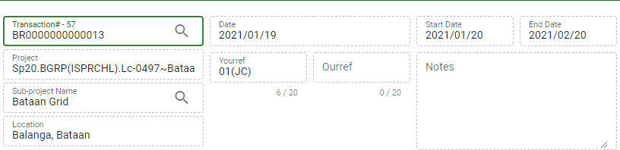
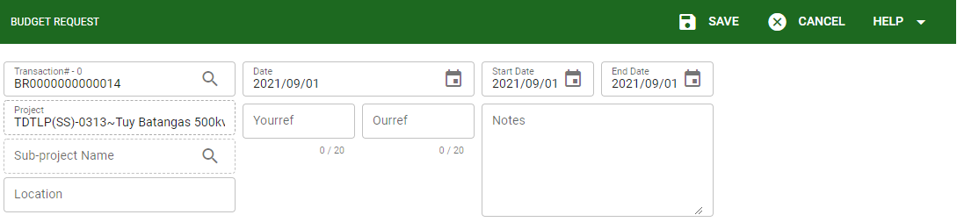

- The user will encode manually the details of the budget. Click NEW ROW to add new row for the information. Click SAVE after encoding the details to proceed.
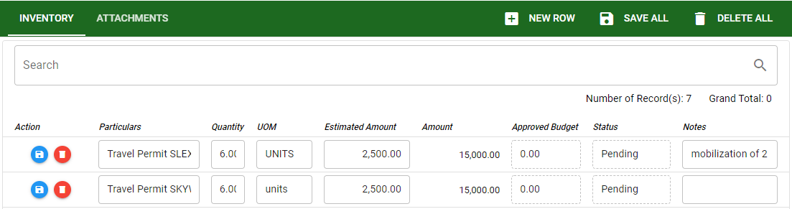
- The user can also attach supporting documents related to the budget request. Click the ATTACHMENTS to add document.
- Click ADD DOCUMENT to select item to be uploaded.
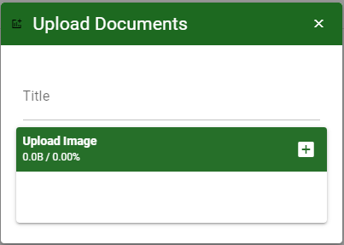
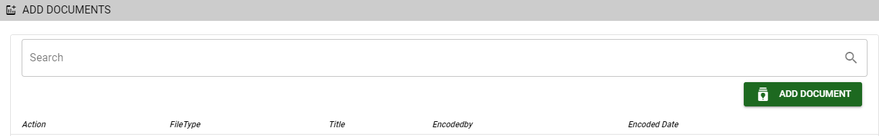

Know how to Post the created Budget Request
- To post the created budget request, click the POST button this means the transaction is finalize or approved. Once the transaction is posted it cannot be modified.

Know how to use the function button in budget request
- Functions buttons are used for creating and revising transactions.
- New: This allows the user to create new transaction under budget request.
- Delete: This allows the user to delete the whole transaction as long as it’s not finalized or posted.
- Print: This allows the user to print the details of the transaction.
- Post: This allows the user to post or finalized the transaction.
- Lock: This allows the user to lock particular transaction to avoid unnecessary changes in the transaction.
- Logs: This allows the user to view all activity applied in the particular transaction.

