RECEIVED PAYMENT

Know how to RECEIVED PAYMENT
- Received Payment is where we record collection we received. To create new Received Payment, click the CREATE button to proceed.
- Upon creating new received payment transaction, a dialog box will pop out with list of customer. Type the customer in the search bar and it will automatically sort out. Then click the selected customer.
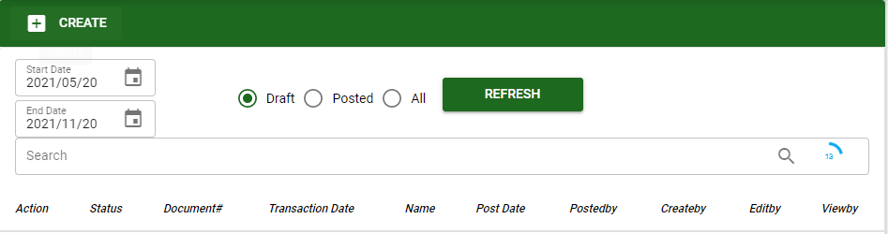

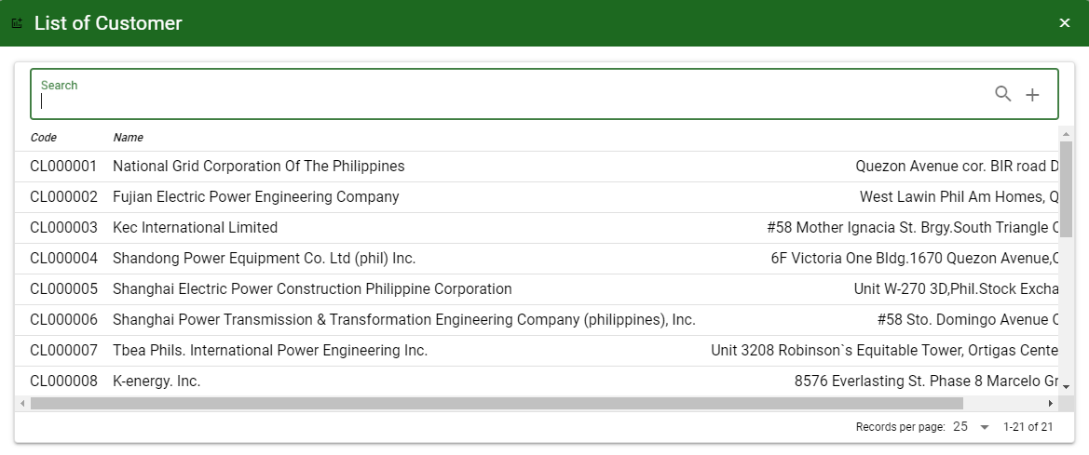

Know how to SELECT ACCOUNT IN RECEIVED PAYMENT
- To select account/s in Received Payment, the user can proceed with the following:
a.1. UNPAID: After saving the header, the user may now select the receivable account that the user will record. Click UNPAID button to view all the A/R account to the customer and select it by ticking the check box. Click Accept, if done.
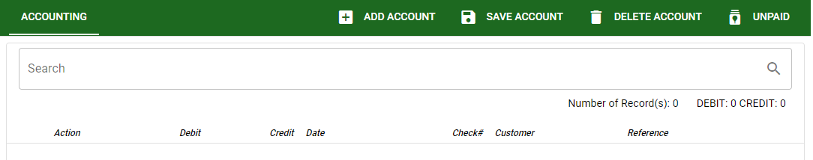

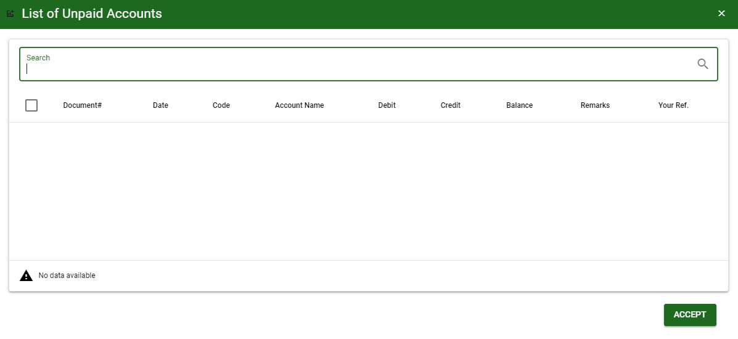

a.2. ADD ACCOUNT: This will allow the user to manually select an account. Click ADD ACCOUNT button then ENTER in Search bar to load all accounts.
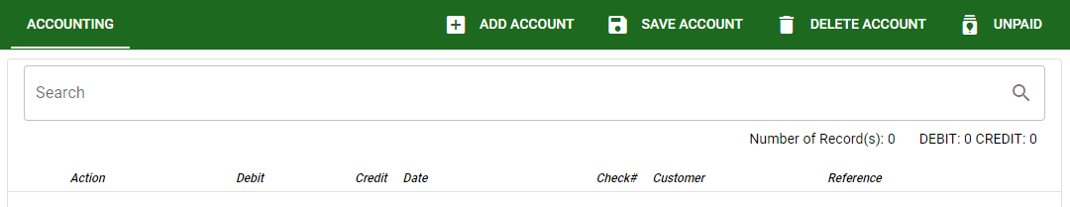

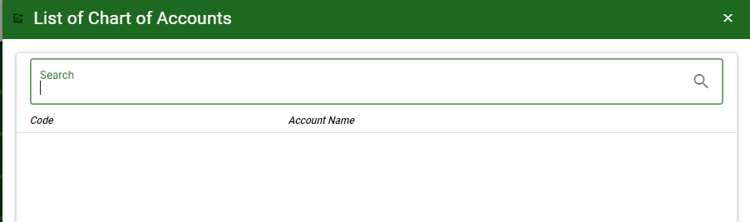
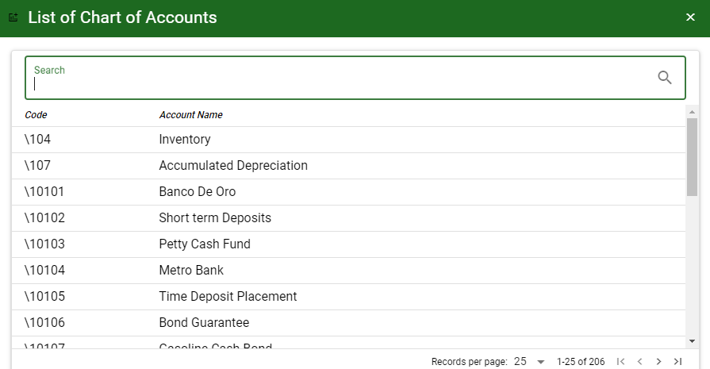

- SAVE ACCOUNT: To save the accounts and to proceed.
- DELETE ACCOUNT: To delete all accounts for the specific transaction.

Know how to USE THE FUNCTION BUTTONS IN received payment
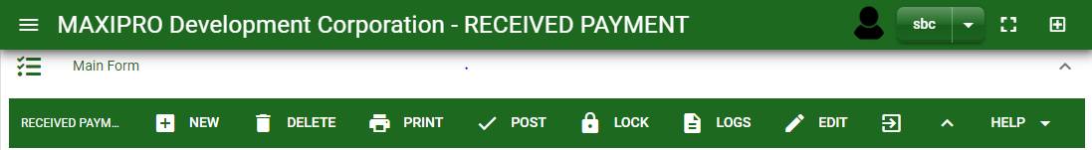

 | FULL SCREEN Button  Use to allow the Received Payment – main form to full screen. |  | NEW Button  Use to create new transaction. | 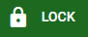 | LOCK Button  Use to lock the transaction to refrain from changing the details in the transaction.
 | OPEN NEW TAB Button  Use to open new tab module you currently using. | 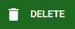 | DELETE Button  Use to delete created transaction that doesn’t have yet previous transaction. |  | LOGS Button  Use to monitor the activities made in the Received Payment.
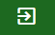 | BACK TO LISTING Button  Use to go back from Received Payment – main form to Received Payment main window. | 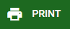 | PRINT Button  Use to print Received Payment printout. |  | EDIT Button  Use to modify the transaction.
 | HIDE HEAD Button  Use to minimize the Received Payment – main form. |  | POST/UNPOST Button  Use to post the transaction if it is finalized and to unpost if there is modification with the transaction.

