Customer ledger

Know how to create new customer
- Click the CREATE button to create new customer. See image below.
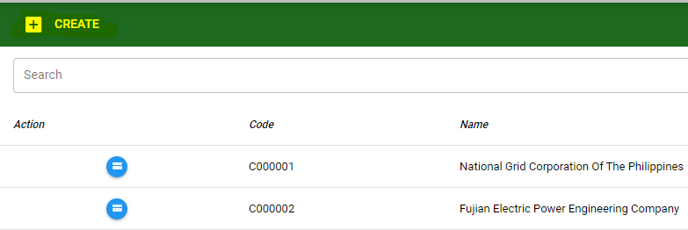
Customer Tagging
In the customer ledger, customer can be tag also from the following for example customer and supplier/warehouse at the same time.
Note:
- If the customer is tag from any of the following, the customer and details will be displayed on the ledger which the customer is tagged.
- If the customer is not active anymore and has history transaction, it’s not allowed to delete customer. The user can INACTIVE the customer.

- The user will encode the information details of the customer then click SAVE button. See image below.

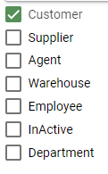
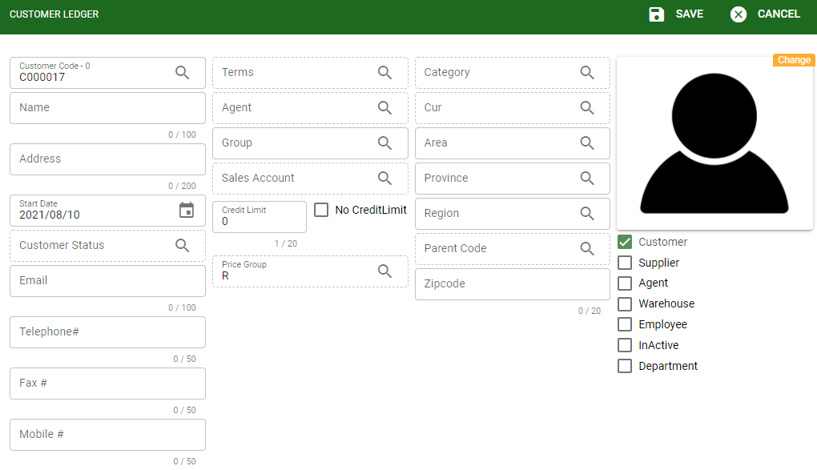
- The user can also view different transactions history that is related from the existing customer.
- Account Receivable History: It will display the account receivable of the customer based from the filtered date.
- Account Payable History: It will display the account payables of the customer based from the filtered date.
- Posted Checks History: It will display posted checks under particular customer and based from the filtered date.
- Returned Checks History: It will display returned checks under particular customer and based from the filtered date.
- Inventory History: It will display transacted items/inventory under particular customer and based from the filtered date.

Know how to generate transaction history

To filter history transaction, the user must select start date then click the REFRESH button to view the transaction list. See image below.
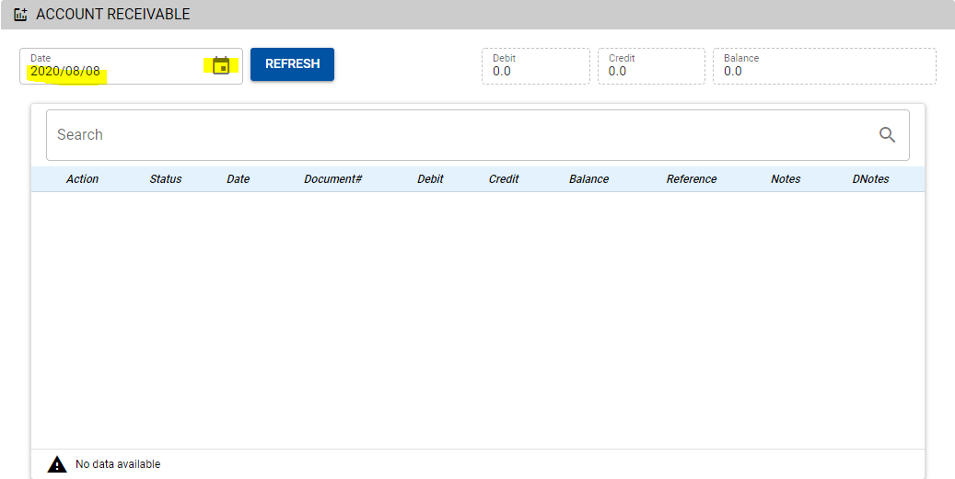

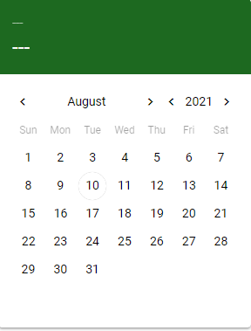
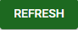

Know how to use the customer ledger functions buttons

- New: Use this to create a new customer
- Delete: Use this to delete customer (allowed to delete if the customer doesn’t have history transaction)
- Print: Use this to print out the details of the customer
- Logs: Use this to check the last user modified the customer details or to see the last user activity
- Edit: To modify customer details such as address, email, and other info
- Back: Use this to go back in the customer listing

Know how to search existing customer

Use the SEARCH field to enter the customer’s specific name or keyword then click the search icon. After searching it will show all the customer that is related from the keyword entered from the search field.Click the VIEW button to check the details of the customer. See image below

