CASH/CHECK voucher

Know how to create CASH/check voucher
- Cash/Check Voucher is where payment whether it is in cash or in check is recorded. It is where we also disburse the APV document we made in Accounts Payable Voucher. To create new Cash/Check Voucher, click the CREATE button to proceed.
- Upon creating new cash/check voucher transaction, a dialog box will pop out with list of supplier. Type the supplier in the search bar and it will automatically sort out. Then click the selected supplier.
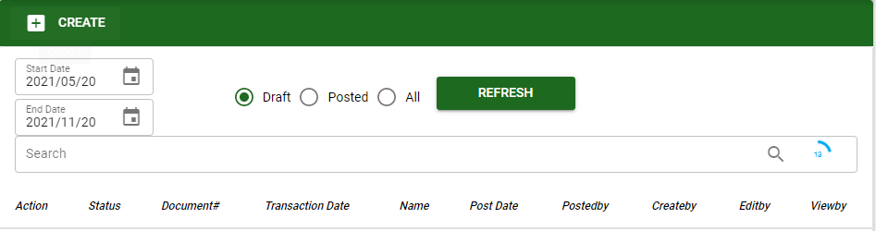
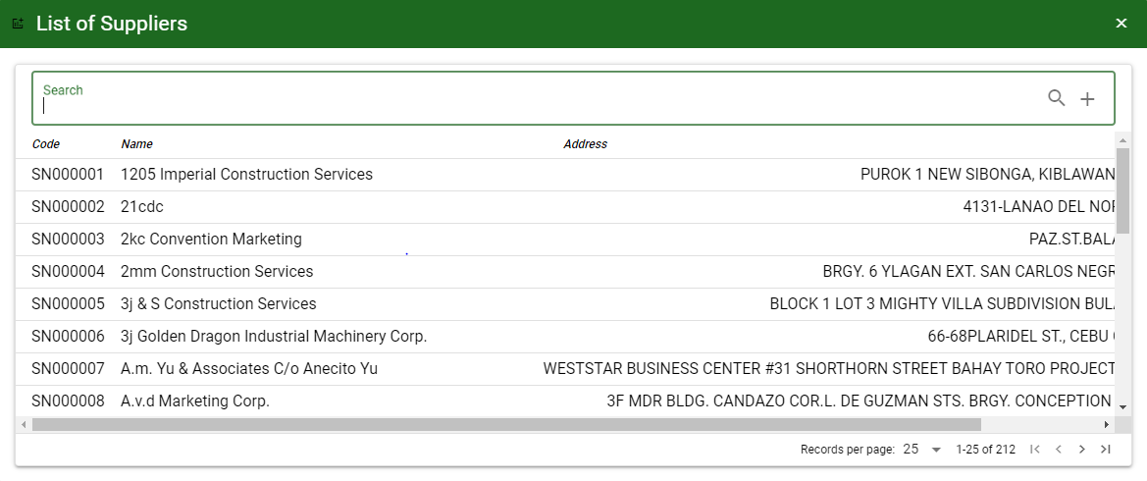

Know how to SELECT ACCOUNT IN cash/check voucher
- To select account/s in Payable Voucher, the user can proceed with the following:
a.1. UNPAID: This will show all unpaid payables of the supplier and select it by ticking the checkbox. Click ACCEPT, if done.

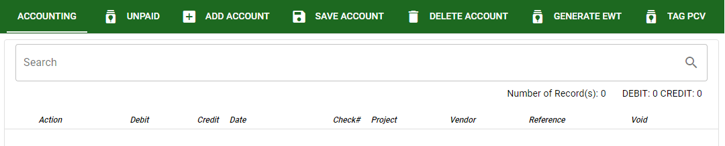

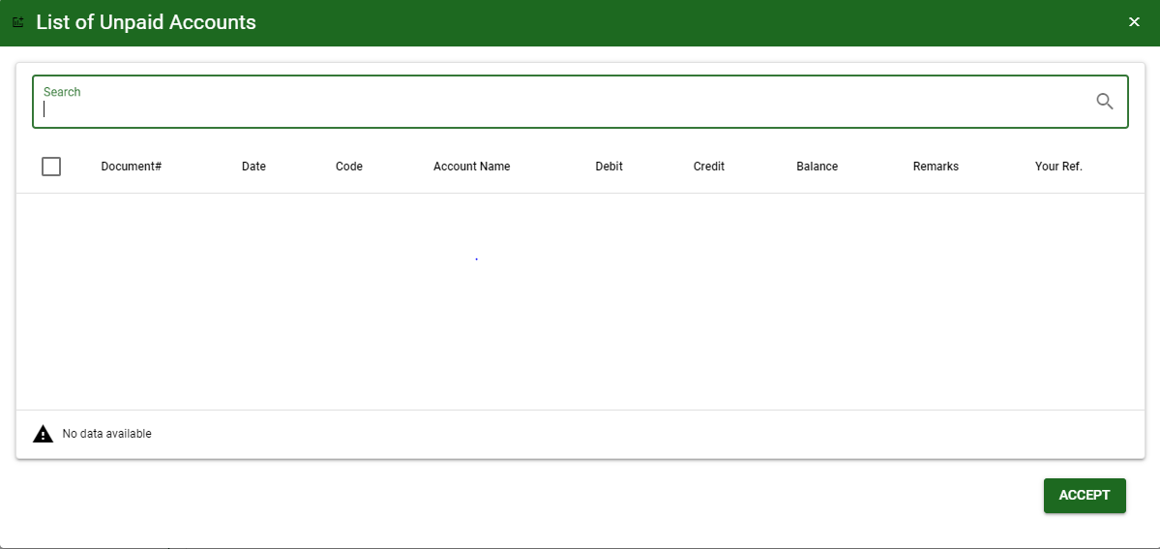

a.2. ADD ACCOUNT: This will allow the user to manually select an account. Click ADD ACCOUNT button then ENTER in Search bar to load all accounts.

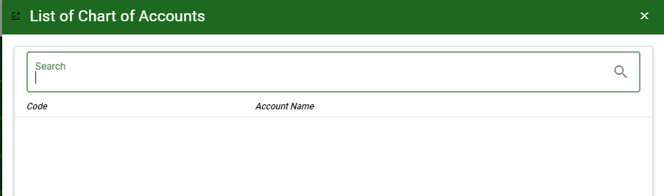
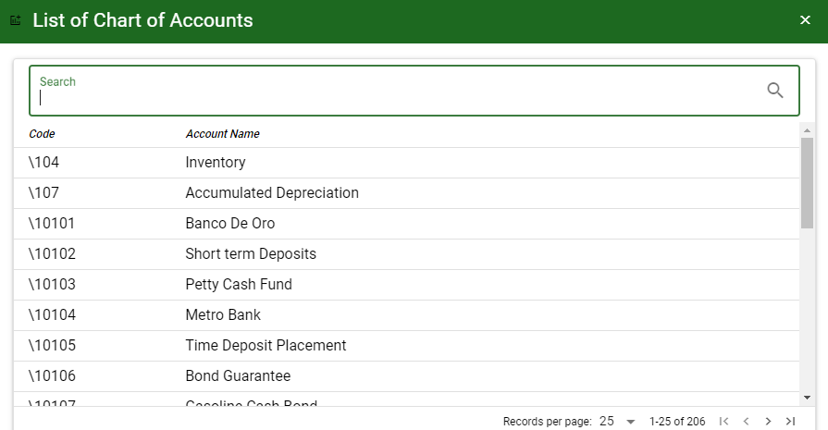

- SAVE ACCOUNT: To save the accounts and to proceed.
- DELETE ACCOUNT: To delete all accounts for the specific transaction.
- GENERATE EWT: This will generate EWT percentage based from EWT Setup under TRANSACTION UTILITIES.

Know how to USE THE FUNCTION BUTTONS IN CASH/CHECK VOUCHER
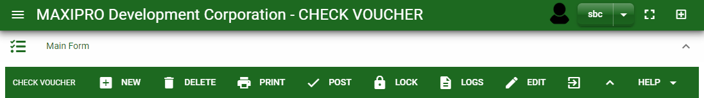

 | FULL SCREEN Button  Use to allow the Cash/Check Voucher – main form to full screen. |  | NEW Button  Use to create new transaction. |  | LOCK Button  Use to lock the transaction to refrain from changing the details in the transaction.
 | OPEN NEW TAB Button  Use to open new tab module you currently using. |  | DELETE Button  Use to delete created transaction that doesn’t have yet previous transaction. |  | LOGS Button  Use to monitor the activities made in the Cash/Check Voucher.
 | BACK TO LISTING Button  Use to go back from Cash/Check Voucher – main form to Cash/Check Voucher main window. |  | PRINT Button  Use to print Cash/Check Voucher printout. |  | EDIT Button  Use to modify the transaction.
 | HIDE HEAD Button  Use to minimize the Cash/Check Voucher – main form. |  | POST/UNPOST Button  Use to post the transaction if it is finalized and to unpost if there is modification with the transaction.

