Purchase Return

Know how to Set-up new Purchase Return
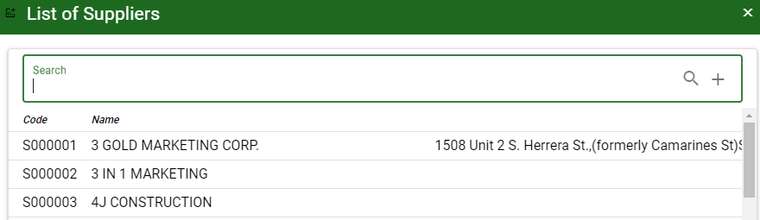
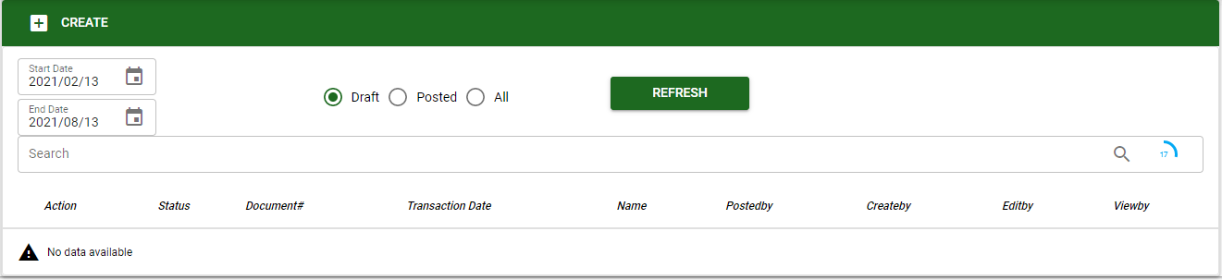

- Click the CREATE button to create new purchase return transaction.
- Select the supplier to be transact in purchase return.

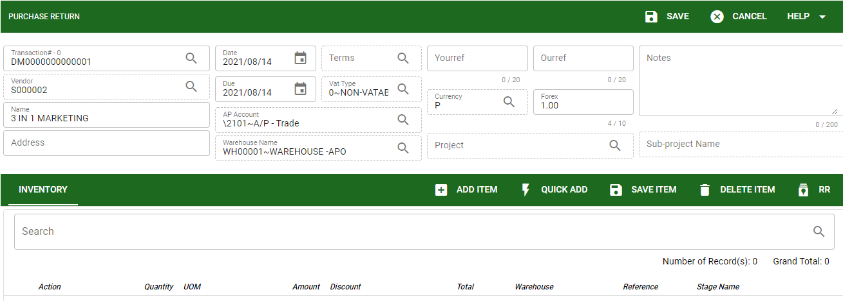
- The user will select also the warehouse where the inventory will be deducted as return to the supplier.
- If the transaction is also per project and subproject the user needs to select particular project and subproject.

Know how to add items in Purchase Return
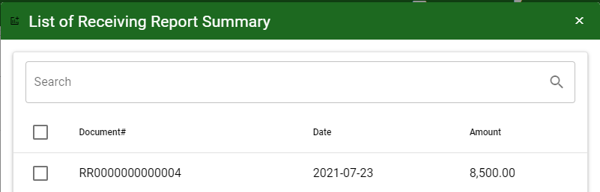

- In adding item to be return to the supplier the user can use the RR (Receiving report) button to view all the posted receiving report created and need to be transact as purchase return.
- Using ADD ITEM same procedure with other modules it allows the user to manually select item to return.
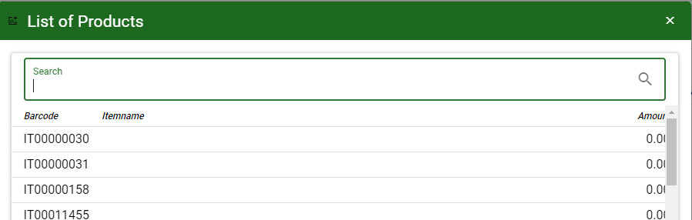
- Using QUICK ADD is to manually encode item by entering barcode of the item.
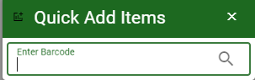

- SAVE item to proceed the transaction.
- DELETE item to delete item that not necessary in the return transaction or accidentally added.

Know how to use the function buttons
- To use the following function button in receiving report click this link Functions.

