Fixed Asset Card

Know how to create fixed asset card
- Click the CREATE button to create new fixed asset item. All fixed asset items should be encoded in this module to enable generating depreciation.
- To set-up the details of the fixed asset item see the example image below.
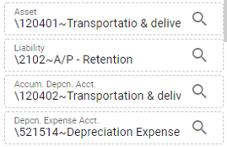
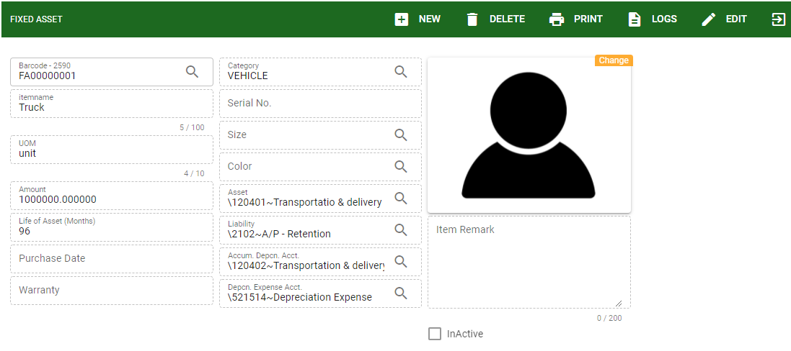
In the Fixed Asset Card, it is required to set-up particular accounting entries per fixed asset item.
These accounting entries set-up will default entries for the transaction of fixed asset item in the accounting side.

- Barcode: Enter the barcode for every fixed asset item.
- Item name: Item name or description of the fixed asset item.
- UOM: The unit of measurement of the fixed asset item
- Amount: The amount of the fixed asset item
- Life of Asset: The life span of the fixed asset item to determine the depreciation.
- Purchase Date: Date when the fixed asset bought.
- Warranty: For recording of fixed asset warranty
- Category: To categorize the fixed asset like vehicle, equipment, machine and etc.
- Serial No.: Monitoring of serial per fixed asset item.
- Size and color: For other details of the fixed asset item.
- Inactive: If the fixed asset item is not being active or used but had a previous transaction the user can inactive.

Know how to USE FUNCTION BUTTONS AND SEARCH EXISTING FIXED ASSET ITEM
- To use the function buttons and search existing fixed asset item.
Link to Know how to use the customer ledger functions buttons
And Know how to search existing customer

Know how to view history transaction in FIXED ASSET card
- To view history transaction from the following: Link to Know how to view transaction history of the item
- History: To view transaction history related to the fixed asset item.
- In- History: To view receiving transaction only related to the fixed asset item.
- UOM: To view or add another unit of measurement to be use for the fixed asset item.
- Warehouse (WH): To view available balance of fixed asset item per warehouse.
- Purchase Order (PO): To view PO transaction created under particular fixed asset item.

