Job Completion

Know how to create job Completion
- If the JOB ORDER is completed the user must proceed in creating JOB COMPLETION.
- In creating JOB COMPLETION, the user will click the CREATE to proceed.
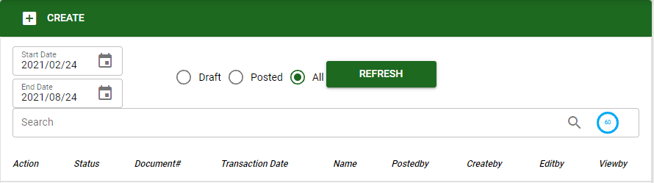
- The user can also search specific existing transactions by using the date range and type of transaction.
- The user needs to enter the information for the JOB COMPLETION then click SAVE to proceed.
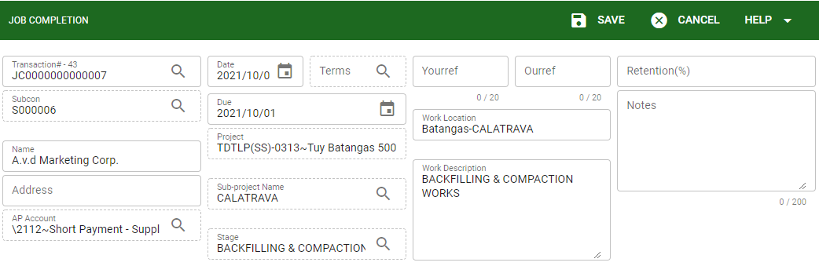
- Same with the JOB ORDER upon adding labor/services in JOB COMPLETION the user can only add using the JO button which display all posted job order and under that particular subcontractor.
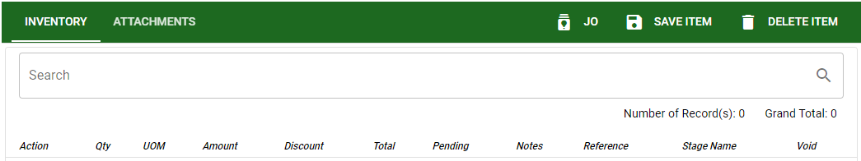
- The user must select the JO that need to be process in JOB COMPLETION, then click ACCEPT to proceed.
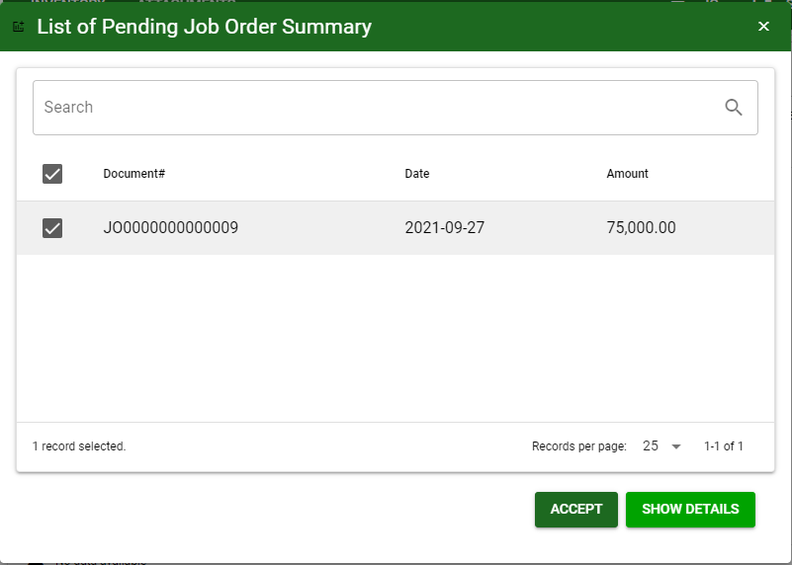
- After adding labor/services from job order for completion, click the SAVE ITEM to proceed in posting the transaction
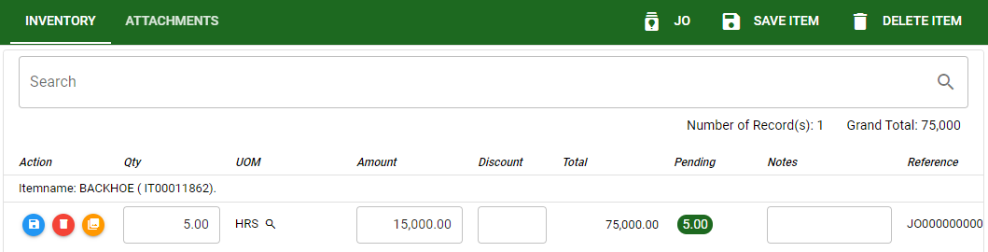

Know how to post transaction in job Completion
- If the transaction in job completion is finalize. Then user can post the transaction.
- Click the POST button to finalize the transaction.
