Job Order

Know how to create job order
- JOB ORDER is related to the created job request from the site. Once the job request is approved and posted then it will proceed in job order.
- To create new job order, click the CREATE to proceed.
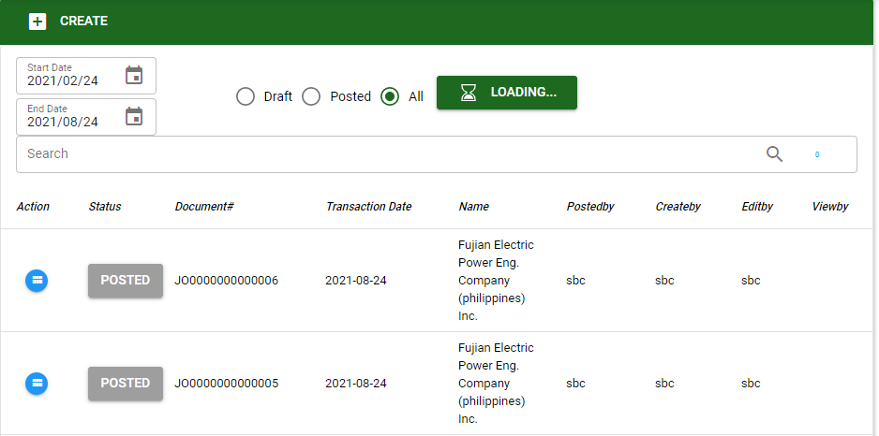
- The user may use the filters for the type of transaction and date range to search specific transaction.
- The user must select particular subcontractor, project, subproject, stage, work location and work description for the job order.
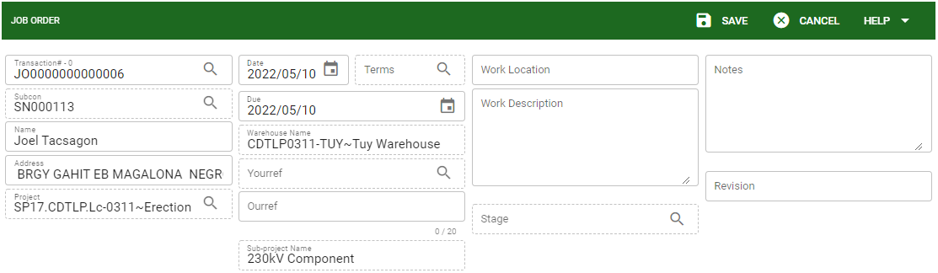
- Subcontractor: The user must select a specific contractor based from the job request.
- Project: The user must select specific project related to the job order.
- Sub-project: The user must select specific sub-project related to the job order.
- Yourref: The user must select specific Job request document to be tag for the job order.
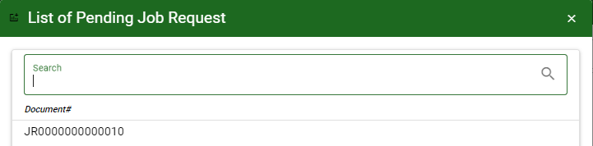
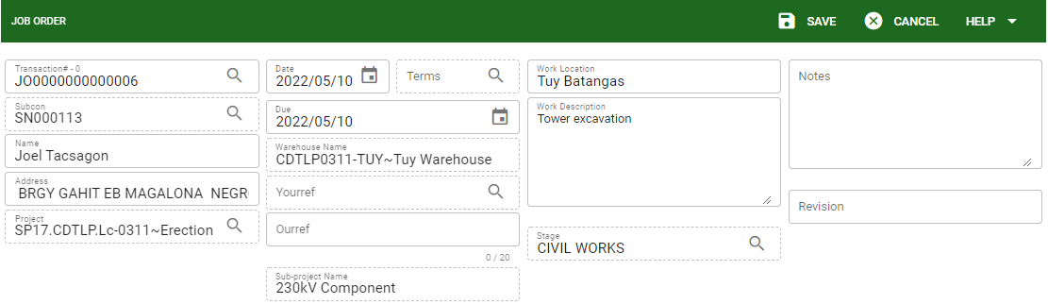

- Work Location: The user is required to encode the work location of the job order.
- Work Description: The user is required to encode the work description of the job order.
- Revision: The user can encode manually the number of revision for a particular job order.

- After encoding specific details for the job order, click SAVE to proceed.

Know how to add labor/services in job order
- The procedure of adding labor/services in job order is same of the job request.
- Click the JR button to show all services under the selected JR# and based from the selected project, subproject and stage in the header setup.
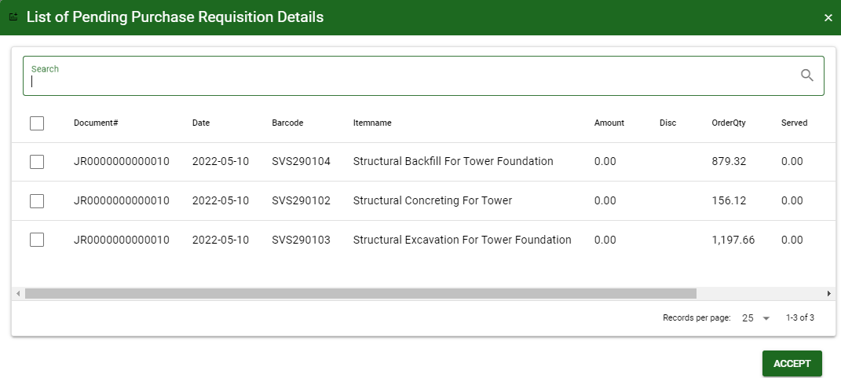
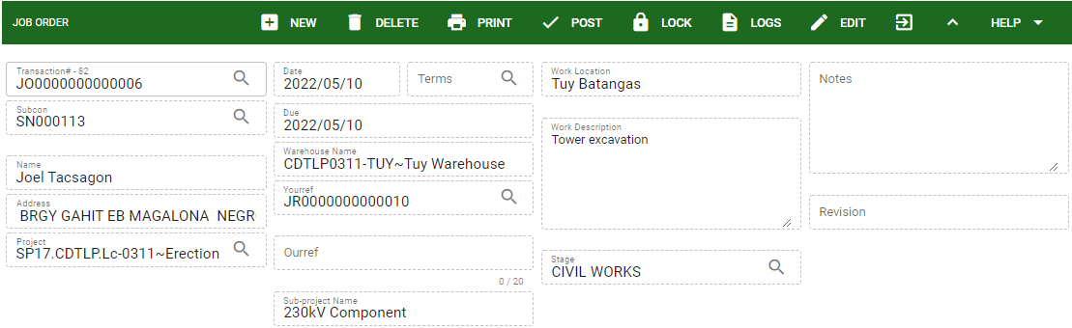
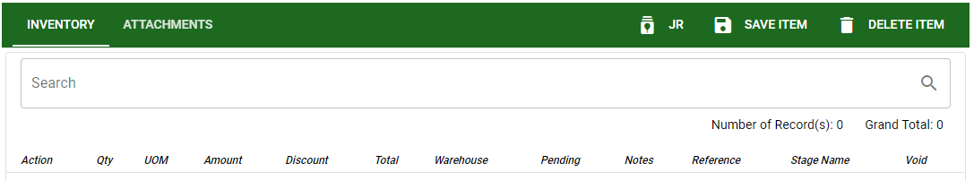

- Select the particular job request that is related to the job order transaction, then click the ACCEPT button to proceed.
- After selecting the labor/services for job order the user must SAVE it first then proceed in posting.
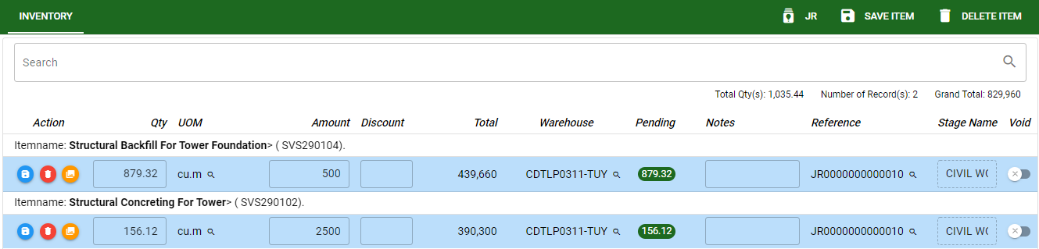

Know how to post transaction in job order
- To post the transaction, click the POST button to finalize the transaction.


