Job Request

Know how to create transaction in Job Request
- In JOB REQUEST this is the same as with purchase requisition, it is also a request from the site with regards of labor/services only.
- The labor/services requested from the site must also from the created and posted BOQ.
- Click CREATE to proceed with new transaction.
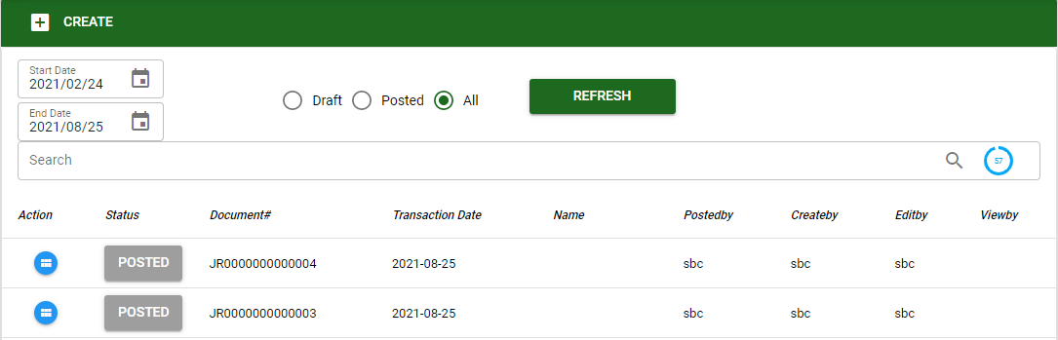
The user can also search existing transaction by using the filters to select particular type of transaction and date coverage under JOB REQUEST.
- The user must select the project for the job request. Then click SAVE to proceed.
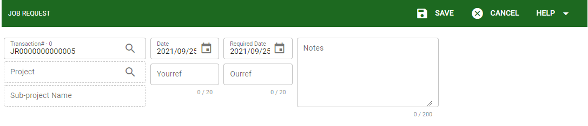
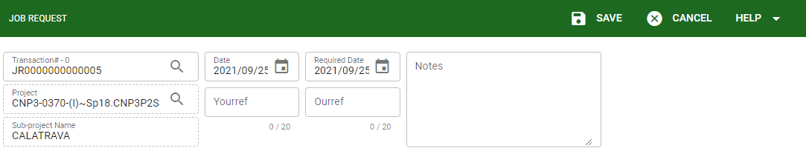

Know how to add service/labor in Job Request
- To add labor/services make sure that the BOQ related to the request is already posted.
- Click the BOQ button to view all available BOQ transaction that are posted and under the selected project.
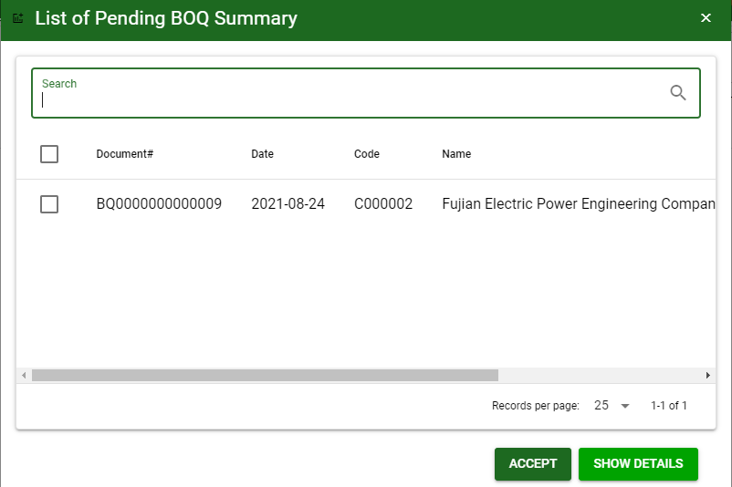
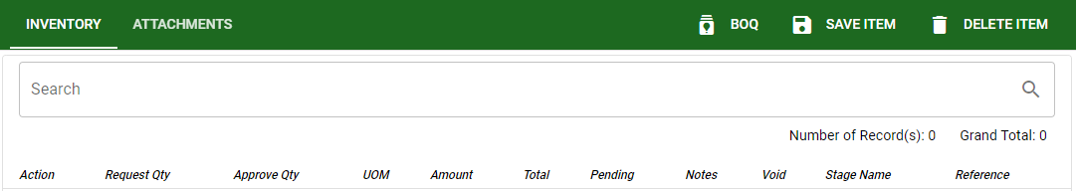
ACCEPT: To accept and proceed the selected BOQ#.
SHOW DETAILES: To show the list of labor/services under the selected BOQ#

- Same with the purchase requisition in the job request the user must wait for the approval of the request from the head office.

- To proceed with the approval the user must click the LOCK button.
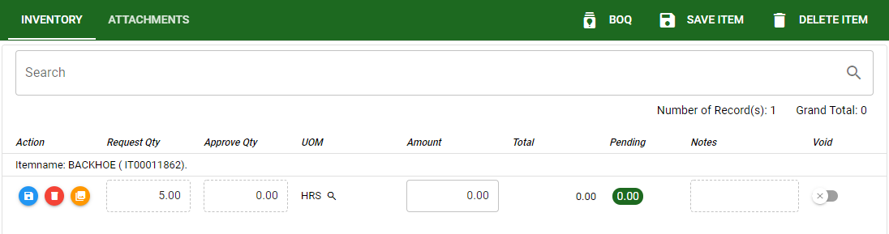
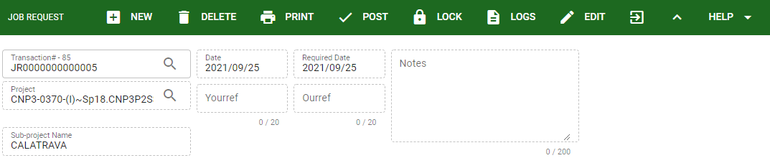
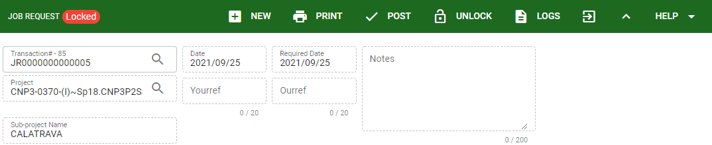

- Once the transaction is lock it will proceed in the APPROVAL LIST.
- After the approval of the request the site can proceed with posting the transaction.

Know how to post transaction in Job Request
- To POST the transaction make sure that the request is already approves.
- Click the POST button to finalized.
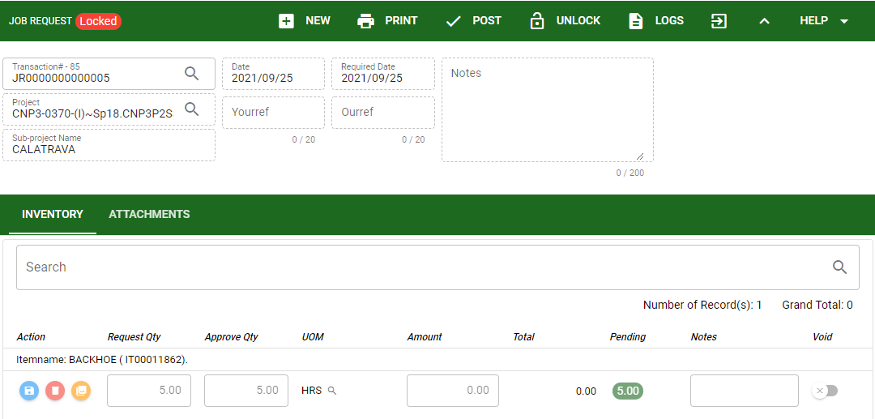
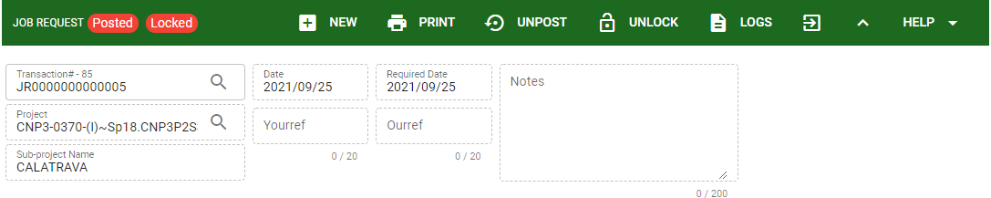
- After posting the request the user can proceed to the job order.

