Material Issuance

Know how to create material Issuance
- In creating material issuance, it will relate from the purchase requisition created from the site.
- If the purchase requisition is already approved and posted it will proceed here in material issuance.
- Click CREATE to proceed in creating new transaction in material issuance.
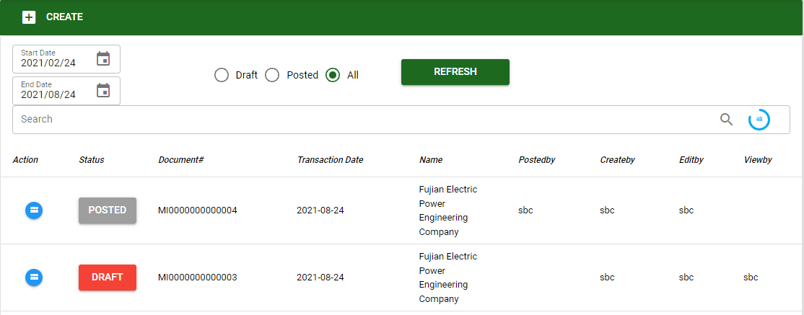
- In material issuance the user can search existing transactions by using the filters:
- Date range
- Type of transaction (posted, draft and all)
- Material Issuance is related from the purchase requisition. If the purchased requisition is approved and posted the head office can issue the materials based from the approved transaction in purchase requisition. In material issuance after selecting the customer’s name, warehouse to be release the material, project and, subproject, click SAVE to proceed.
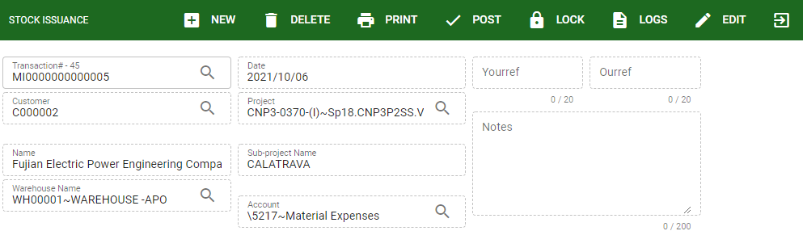

Know how to add item in material Issuance
- To add item in material issuance the user can use two option the ADD ITEM where the user can search manually the item by using the search bar.
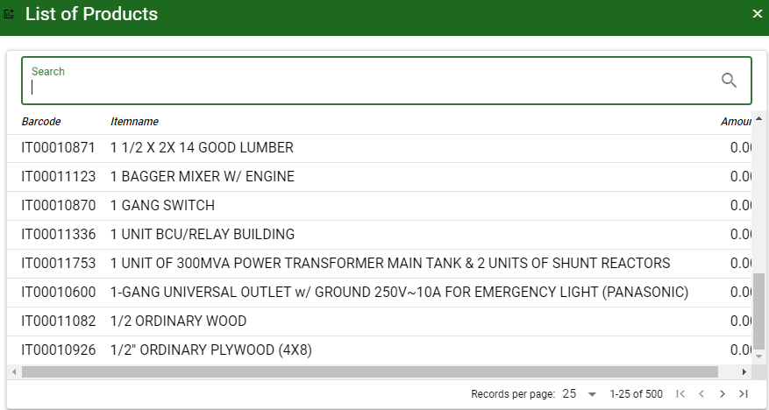
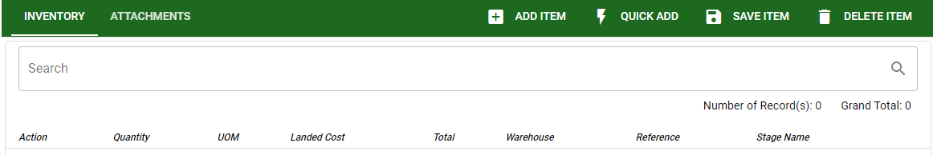

- The other way of adding item in material issuance is by using QUICK ADD, the user will enter only the barcode of the item then it will automatically display.
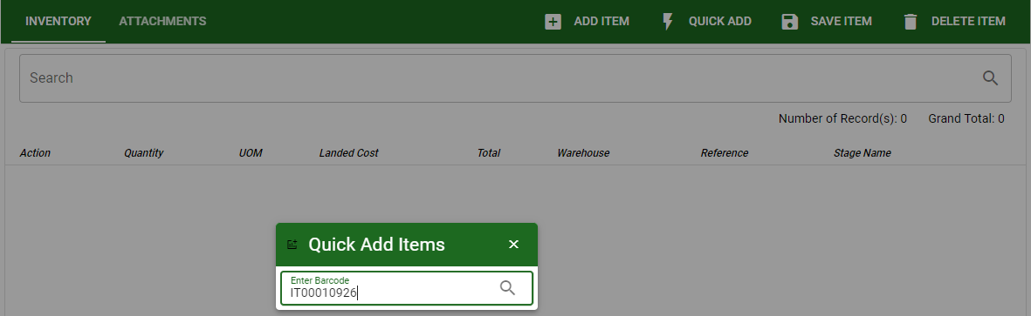

Know how to save item in material Issuance
- Upon adding items to be use in material issuance the user must enter the quantity required for issuance based from the requisition from the site.
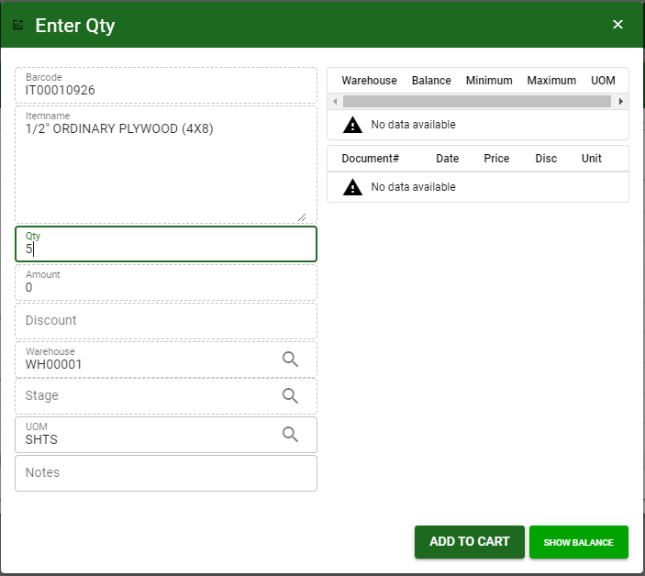
The user can use the SHOW BALANCE to view the available balance in warehouses.
- Click ADD TO CART after entering the required quantity to proceed.
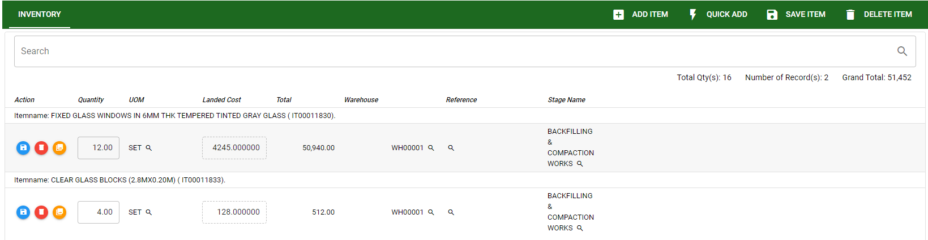
- Click the SAVE ITEM to save all the items and to proceed on posting transaction.

Know how to Post transaction in material Issuance
- If the transaction is final the user can post the transaction.
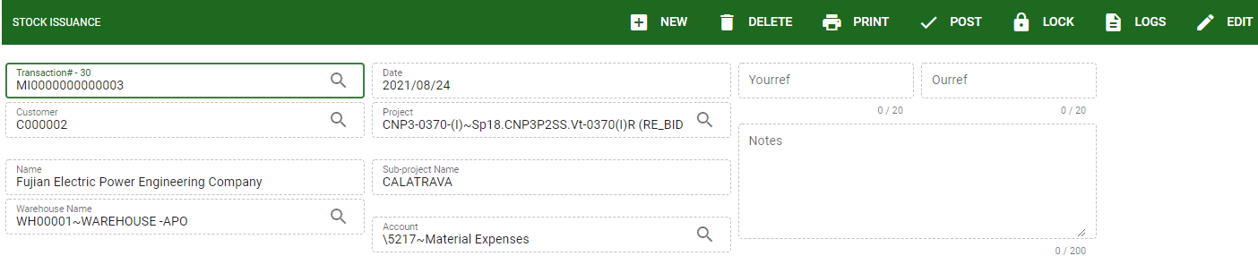
- Click the POST button to finalize the transaction. Once the transaction is posted the user can still unposted it as long as the issued quantity are not yet used. If the quantity is already used or serve the transaction is cannot be unposted.

