Stock Transfer

Know how to create Stock Transfer
- To create stock transfer, click CREATE to proceed.
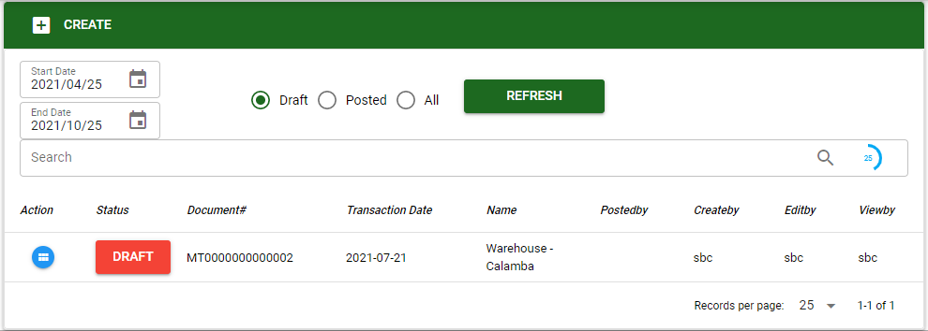
In creating stock transfer the user can transfer stock from particular warehouse to another warehouse.
- The user must select particular project warehouse source where the stock will be deducted and project warehouse destination to transfer the stock.
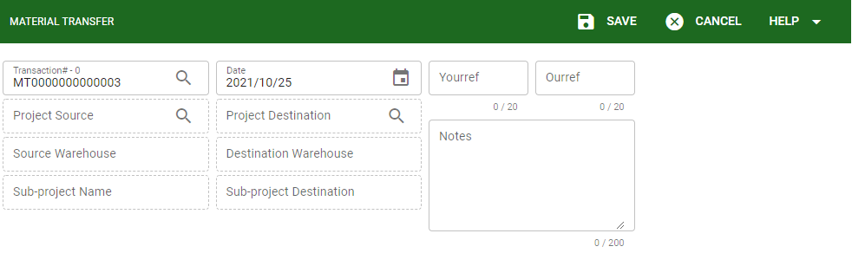
- After selecting warehouses for the transaction, the user can proceed in saving the transaction.

Know how to add item in Stock Transfer
- After saving the created transaction the user now can proceed to selecting item to be transferred.
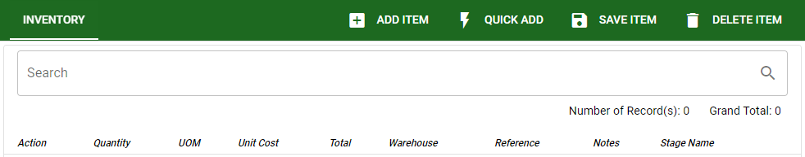
The user can use ADD ITEM or QUICK ADD upon selecting item to be transacted in stock transfer.
- Upon selecting items, the user needs to encode the required quantity to be transferred.
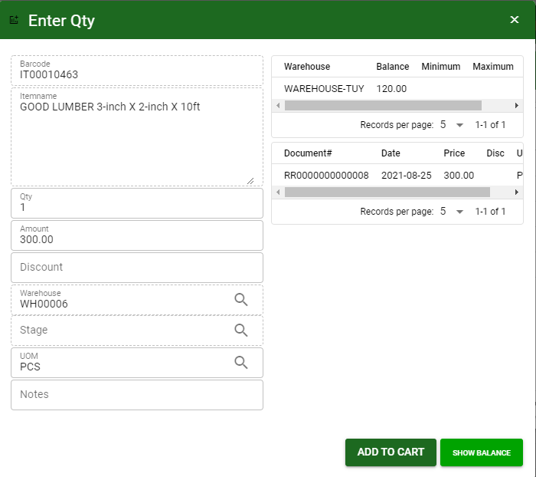
The user can also view available stocks in warehouses and also the current transaction under that particular item.
- After enter the required quantity to be transferred the user can click the ADD TO CART to proceed adding another item.
- After the user done selecting items to be transferred, the user must click the CART icon to finalize the list of items.
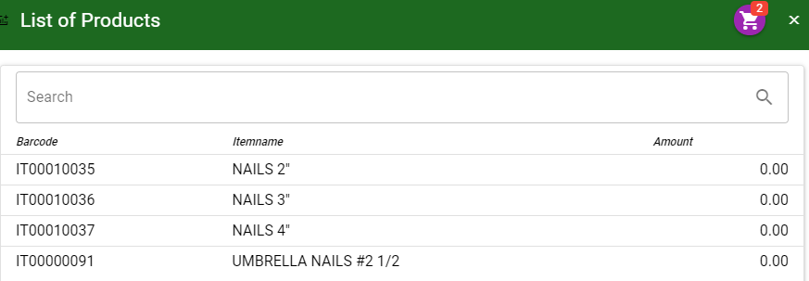
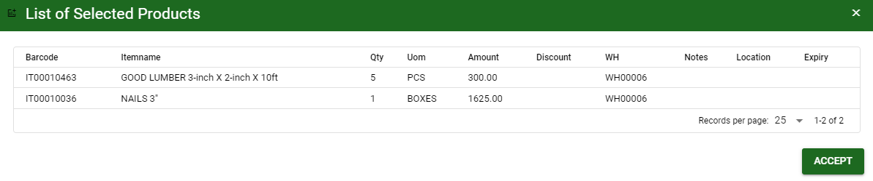
If the item in the CART is finalize the user can click the ACCEPT to proceed the transaction.
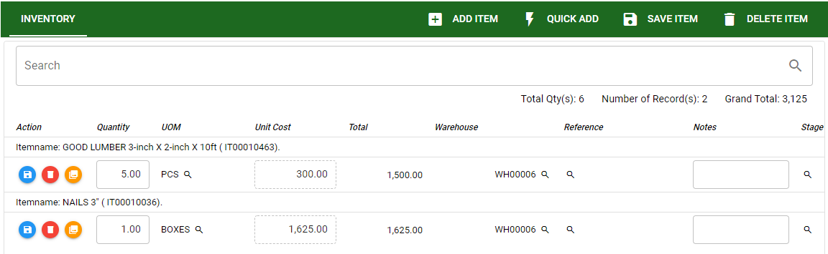
Click SAVE ITEM if the items are finalized to proceed in posting the transaction.

Know how to post transaction in Stock Transfer
- If the transaction is finalized the user can post the transaction.
- Click the POST for posting the transaction.
