Progress Billing

Know how to create Progress Billing
- To create Progress Billing, click CREATE to proceed.
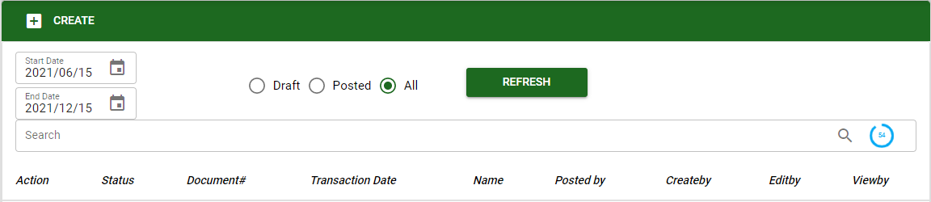
The user can use the Progress Billing to create billings to the customer once there is accomplishment in the project.
- The user must select specific customer and project for creating progress billing. Click SAVE to proceed.
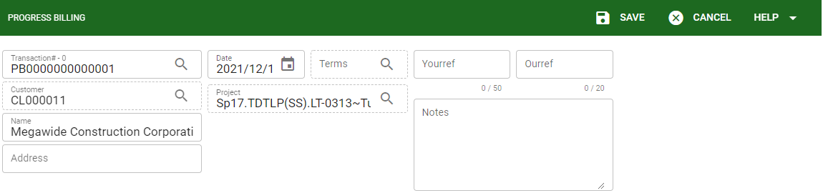

Know how to add Billing accomplishment in Progress Billing
- In creating progress billing, the user can only create billing under the same customer and project. The billing accomplishment can only be created in progress billing once it is posted.
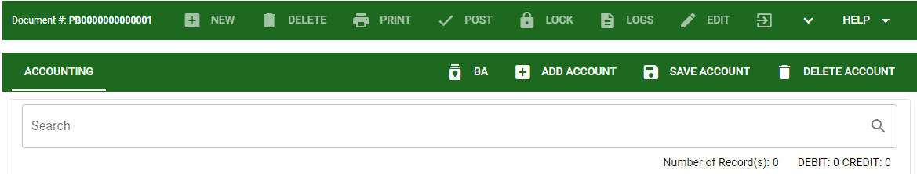

- Click the BA button to view all posted and unbilled billing accomplishment related to the selected customer and project.
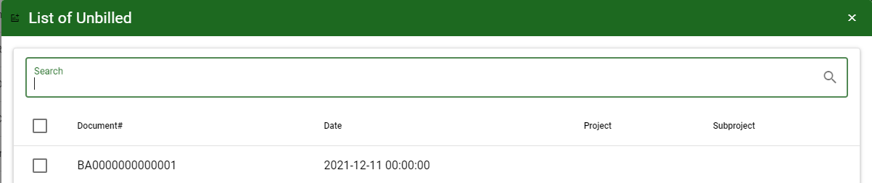
- After selecting specific billing accomplishment, click ACCEPT to proceed.
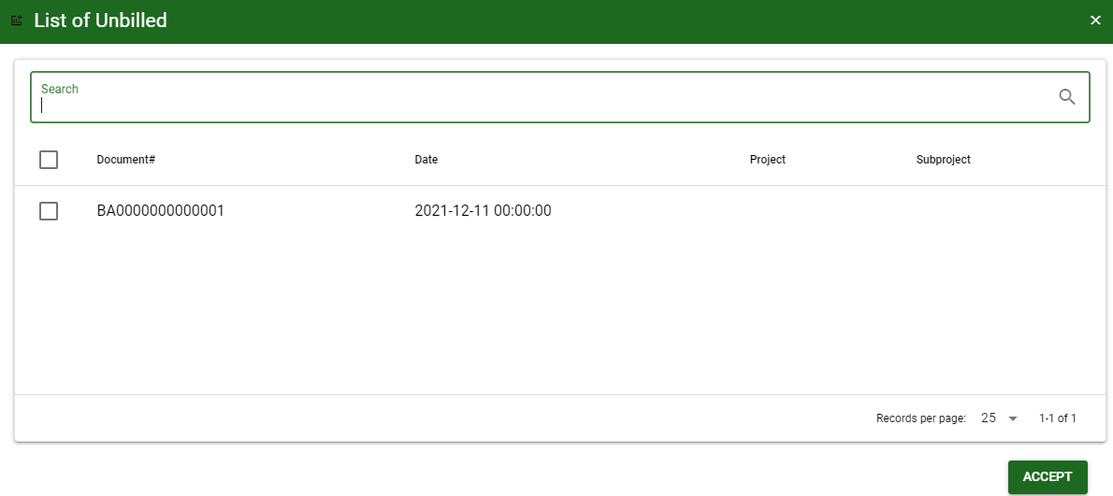

- After selecting unbilled BA it will display all the accounting entries for that transaction. Click SAVE ACCOUNT to proceed.
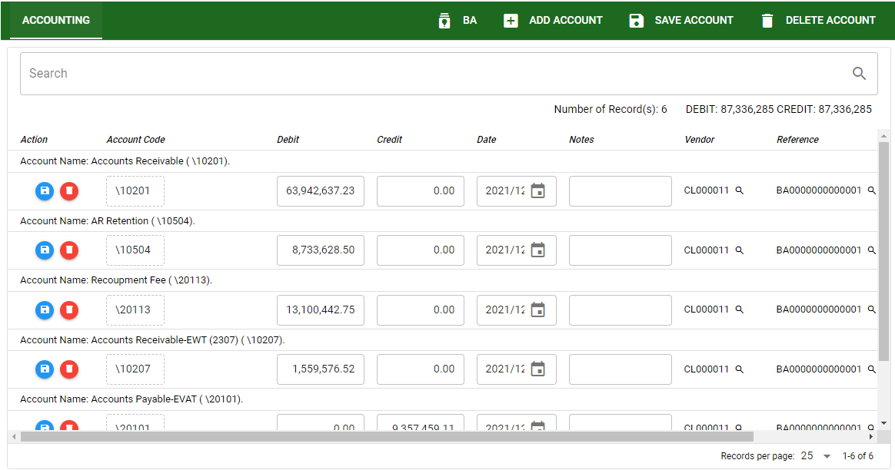

Know how to post transaction in Progress Billing
- To post progress billing transaction, click the POST button. All posted progress billing can be pickup for collection.
