Project Management

Know how to set-up Project management
- Click CREATE for creating new Project Management set-up.
- Then it will require the user to select a particular customer to be set-up for project management.


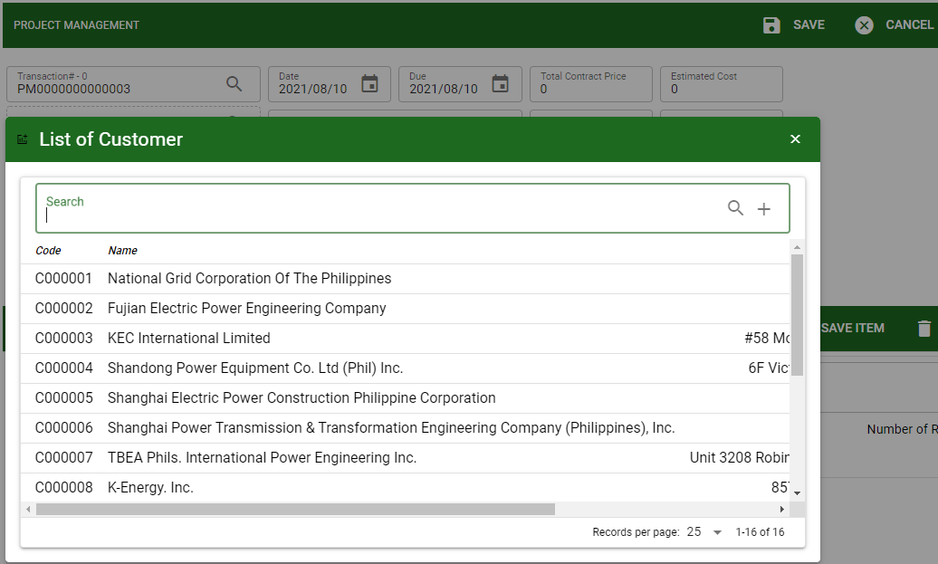

- After selecting a particular customer, the user will continue to fill-out the header details. See image below.
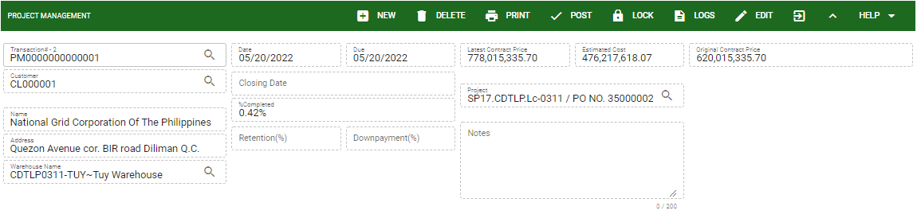

- Transaction#: Indicate the auto-generated transaction# to monitor the transaction per project.
- Customer code: Indicate the designated code for the customer.
- Customer Name: Indicate the customer’s name encoded from the customer ledger.
- Address: Indicate the customer’s address encoded from the customer ledger.
- Date and Due: Indicate the date and due of the transaction.
- Closing Date: Indicate the date of closing the project of the transaction.
- Completed %: This is an automatic computation for the completion of the project based from the percentage completion per sub-project.
- Retention %: Manual encoding of the percentage of retention of the project
- Down payment %: Manual encoding of the percentage of down payment of the project
- Project: Select specific project encoded from Project Master.
- Notes: Indicate the remarks of the transaction.
- Latest Contract Price: Manual encoding for record purposes of Total Contract Price (Original Contract Price of the project) or the Revised Contract Price.
- Estimated Cost: Manual encoding for record purposes of estimated cost in the project.
- Original Contract Price: If the project has revised contract price, the user must input the original contract price here. Then, the user must input the revised contract price in Latest Contract Price field.

Know how to select project in project managEment
- For creating project management, it requires to select specific project which is created from Project Master.
- Click the search icon in the project field.
- The user can use the search bar to search specific project.
- The user can also use the PLUS action button indicated in the search bar that directly access to the project master to create new project.
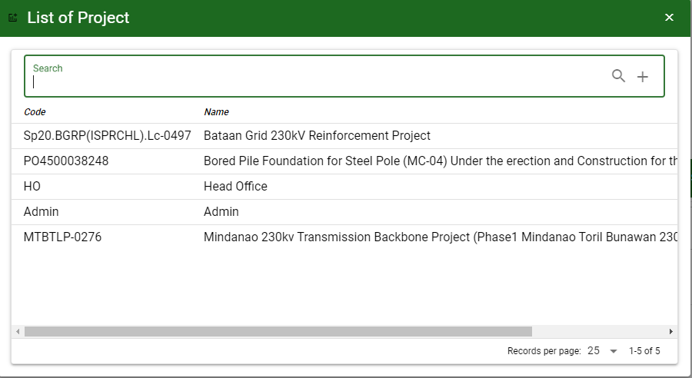
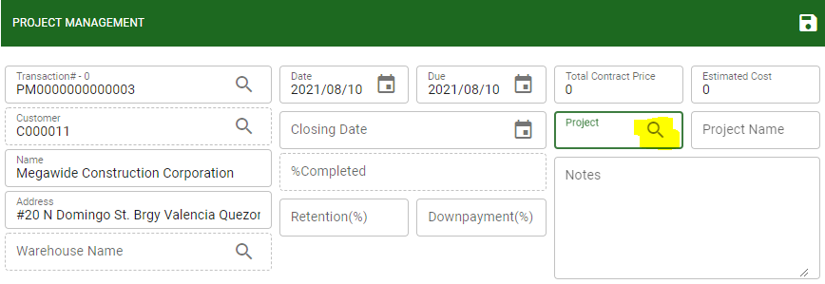

- Select the project to be set-up in project management, then click SAVE to proceed.
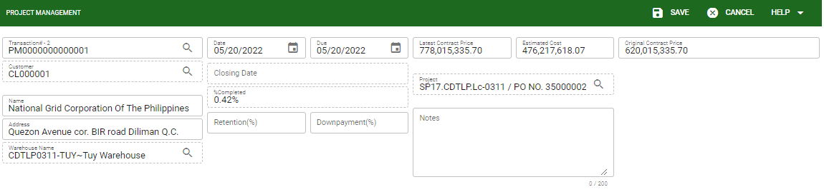

Know how to Setup Sub-project in project management
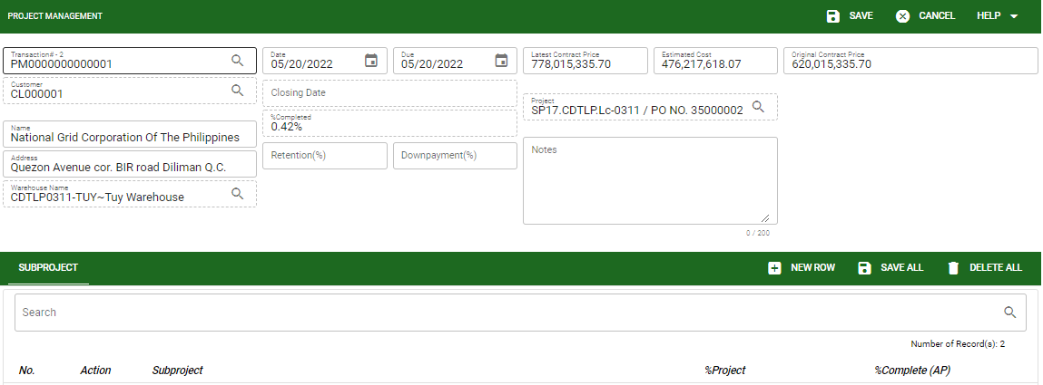

- Click the NEW ROW to manually add new subproject then click SAVE ALL to proceed.
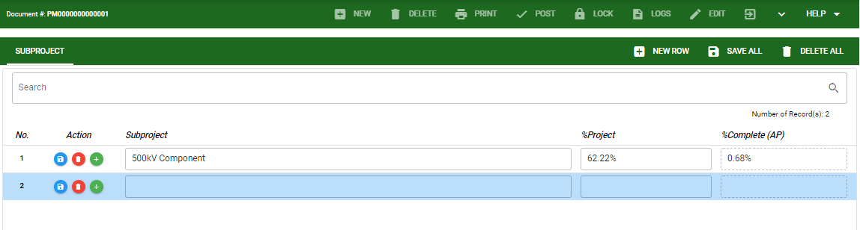

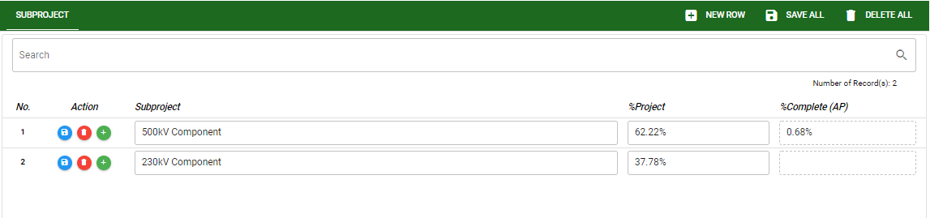

Know how to Setup Stages per Sub-project in project management
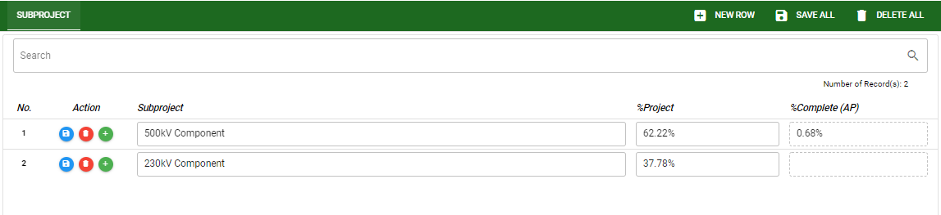

- Subproject: This indicates the subproject under particular project.
- Percentage of the Project: This indicates the percentage of the subproject for the whole project.
- Percentage of Completion: This indicates the computed percentage accomplished of the stages for the whole subproject.
- To add stages under subproject, click the PLUS sign button.
- Click the ADD STAGES button to proceed. Then select stages to be added under particular sub-project.
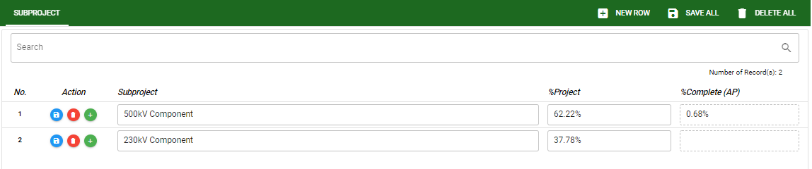

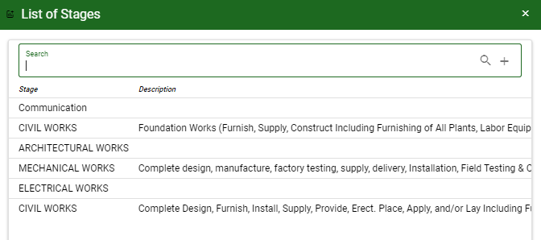

- The user can directly access the Stages Set-up by clicking the ADD/PLUS sign action from the search bar.
- The selected stages will be added in the list under subproject.
- Per stages will have percentage completion setup for the whole percentage of the sub-project.
- The user will encode manually the estimated cost and percentage per stages, then click SAVE/SAVE ALL to proceed.

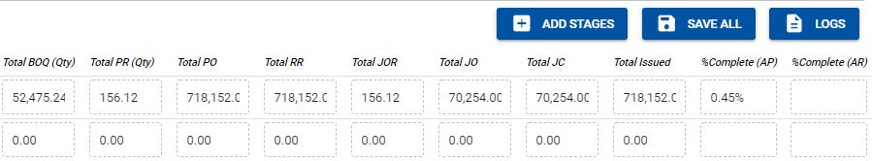
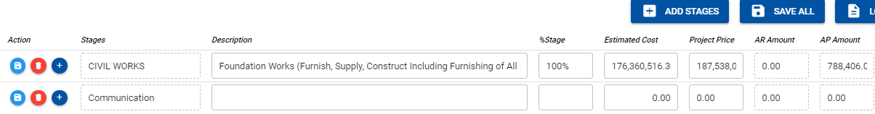

Know how to Add Activity and Sub-activity in Stages per Sub-project in project management


- Click the PLUS sign in the stage to add activity.

- Click ADD ACTIVITY to select specific activity to be added under that particular stage.
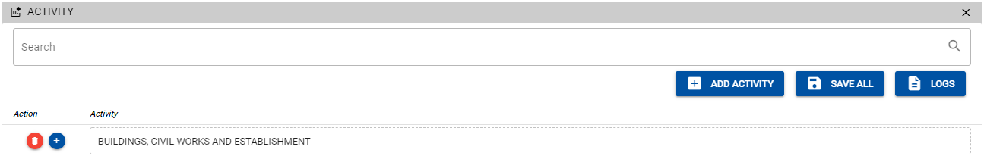
- After adding Activity, the user must also need to add the sub-activity. To add click again the ADD sign to proceed.


- Click the ADD SUBACTIVITY to select specific sub-activity under that particular activity.

- After selecting sub-activity, the user will enter the quantity and amount.

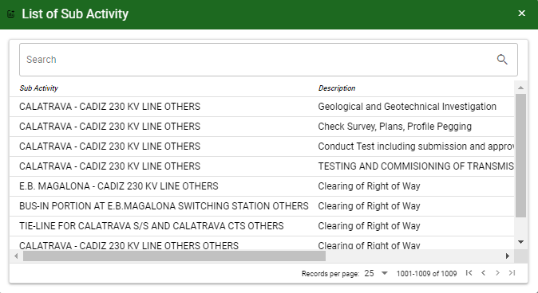

- After selecting the specific sub activity, the user must input the Sub Activity ID, contract quantity, estimated quantity, unit contract price and unit estimated cost.
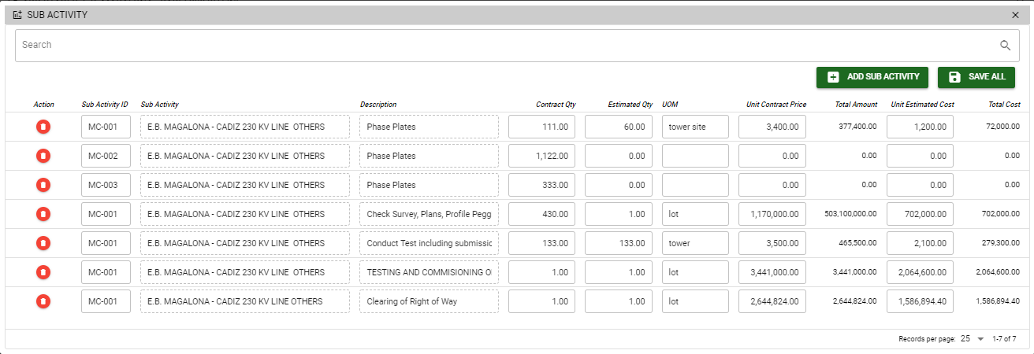

Note: All the stages, activity and sub-activity that will be viewed from the selection in project management is based from the setup in the Stages Set-up module.

Know how to view reference and add attachment in project management
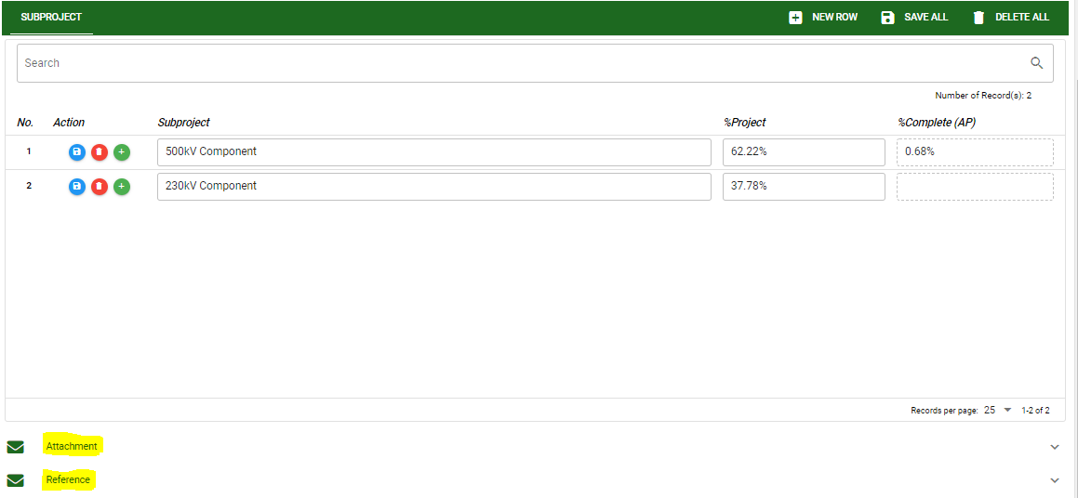

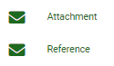

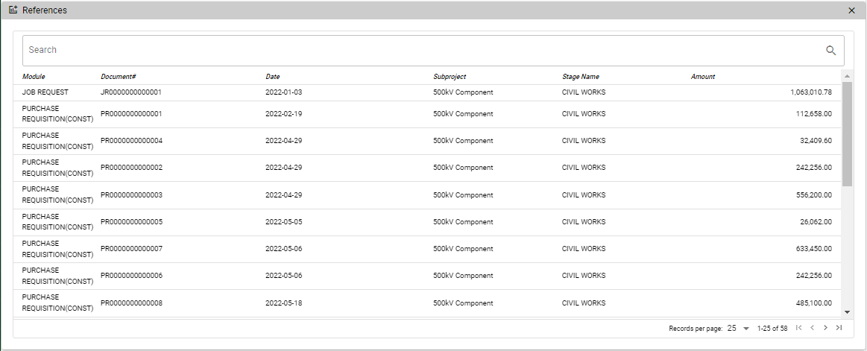
- All created transactions related to the project, sub-project and stages can be view in the REFERENCE tab and these transactions also determine the percentage of the completion for the whole project.

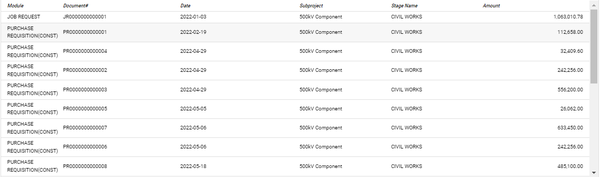

- The user may use the ATTACHMENT to upload supporting documents related to the project. Click the ADD DOCUMENT to upload documents.
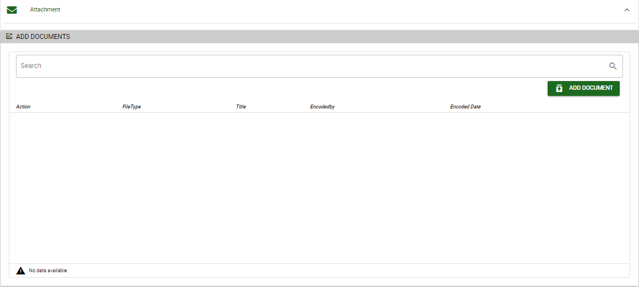

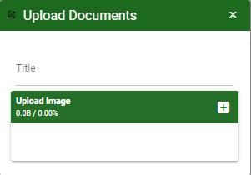

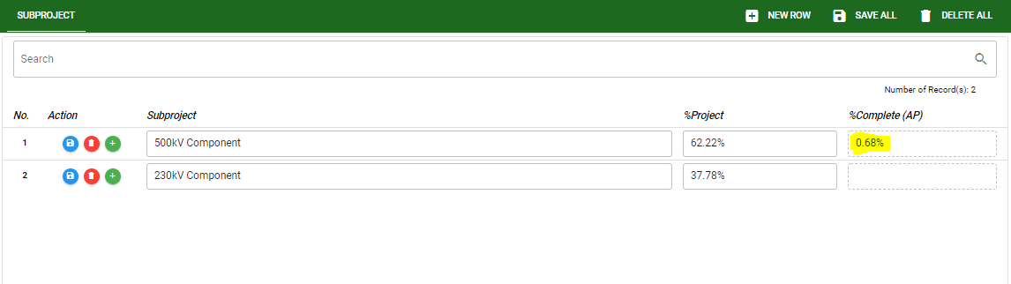
- Example below is the presented percentage accomplished from stages and also the equivalent of the percentage of the subproject to the whole project.

Know how to view all the created project in project management
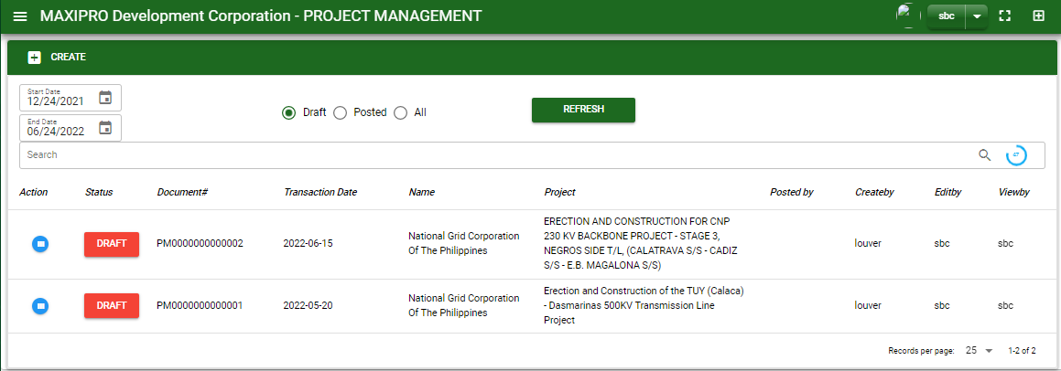
A

C
B



- The user can view the created project by using the date filter. The user must select the start and end date.
- The user can use filter to view the unposted, posted and all the transactions.
- After the user set-up the filter, click the REFRESH button to view the transaction based from the filter.

Know how to used the function button in project management
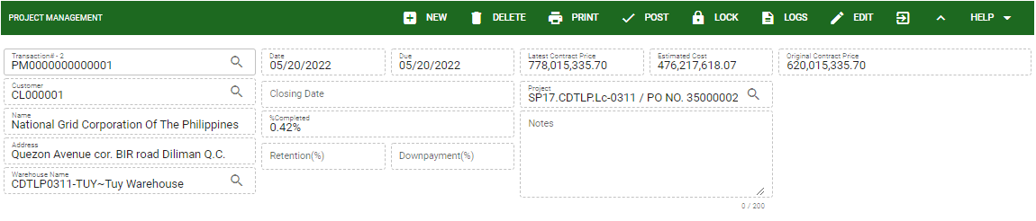

- New: This button for creating new project or transaction.
- Delete: This button for deleting transaction that no previous transaction.
- Print: This button for printing the selected transaction.
- Post: This button is for the finalized transaction.
- Lock: This button is to lock the transaction to avoid unnecessary revision.
- Logs: This button show the activities done in a particular transaction.
- Edit: This button allowed to revised the transaction as long as it is unlocked mode.

