Purchase Order

Know how to create new Purchase Order
- Click the CREATE button to create new purchase order. Upon creating new purchase order transaction, it will allow the user to select particular supplier.

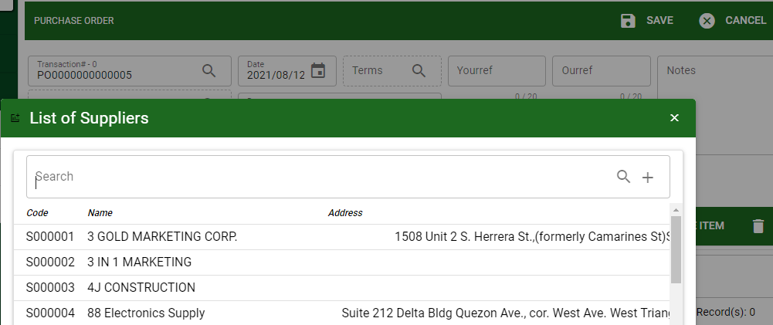
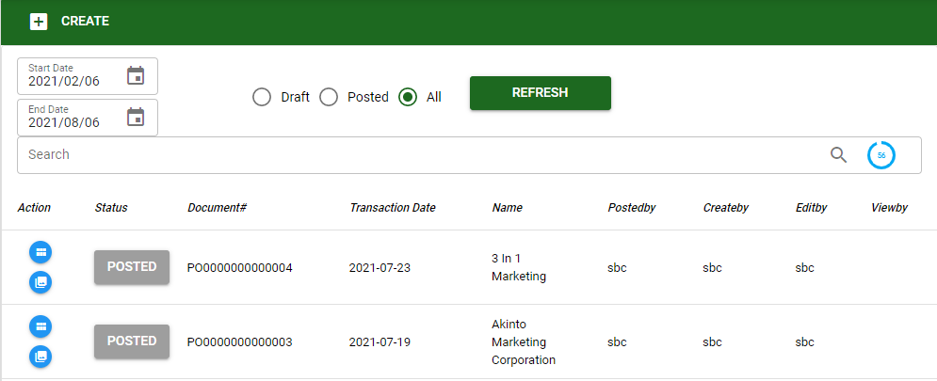

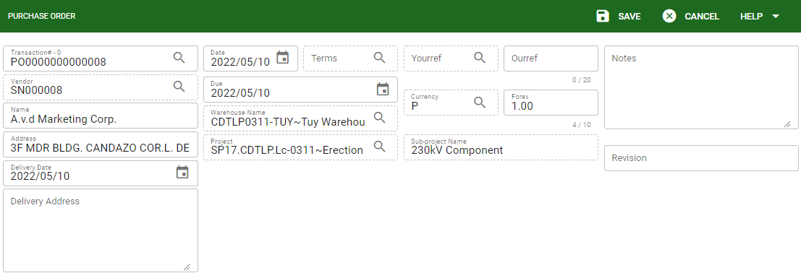
- Transaction#: Every transaction has a document # or transaction# for monitoring of the transaction per supplier.
- Vendor/Supplier code: Designated code for supplier encoded from the supplier ledger.
- Vendor/ Supplier name: Supplier name encoded from the supplier ledger.
- Address: Address details encode from the supplier.
- Date and Due: Date and due of the transaction.
- Project and Sub-project: If the transaction is per project and subproject the user will select particular project.
- Warehouse name: Transaction in purchase order must select a particular warehouse.
- Ourref: For references if the user needs to monitor other transaction#
- Yourref: In creating PO the user need to select particular Purchase Requisition (RQ) to be proceed.
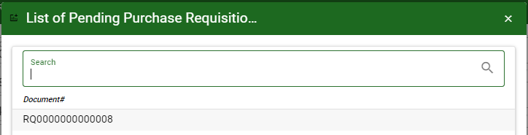


- Notes: For other information or remarks.
- Revision: For tracking and manual encode of number on how many times the transaction is revised.

- Click SAVE to proceed on the transaction.

Know how to add items in Purchase Order
- To add items in PO the user can proceed with the following:
- Purchase Requisition (PR): This will show all the materials created from the PR based from the selected document number in the header.
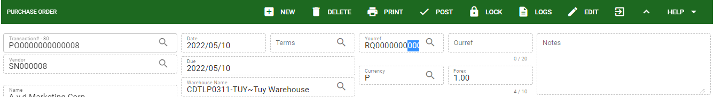
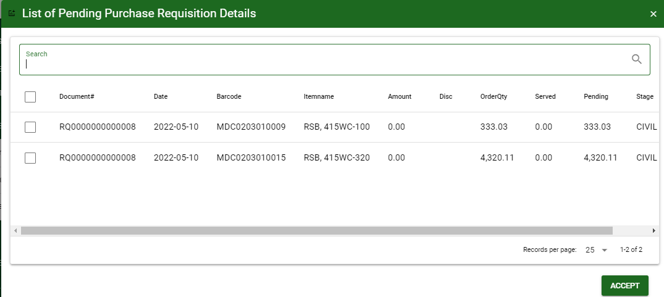

- Add Item: This allow the user to manually select an item to be transacted in the PO.

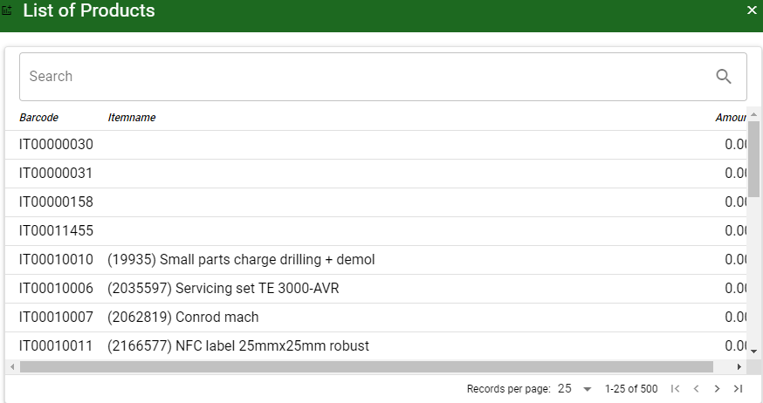

- Quick Add: This allows the user to input manually the item using itemcode or barcode.

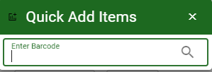
- Click SAVE to save the items and to proceed.
- Click DELETE to delete item that is not included in the transaction as long as the transaction is not yet posted and served.

Know how to use the function buttons

- New: It will allow to create new transaction.
- Delete: It will allow to delete created transaction that doesn’t have yet previous transaction.
- Print: It will allow to print the details of the selected transaction.
- Post / Unpost: It allow to post the transaction if it is finalized and to unpost if there is modification with the transaction.
- Lock: It allow to lock the transaction to avoid necessary modification and if the transaction is for finalization.
- Logs: It allow to view all the activity done with the transaction.
- Edit: It will allow to modify the transaction.

