accounts payable voucher

Know how to create accounts payable voucher
- Accounts Payable Voucher is where we prepare accounts for payment that is not yet available for payment. To create new Accounts Payable Voucher, click the CREATE button to proceed.
- Upon creating new payable voucher transaction, a dialog box will pop out with list of supplier. Type the supplier in the search bar and it will automatically sort out. Then click the selected supplier.
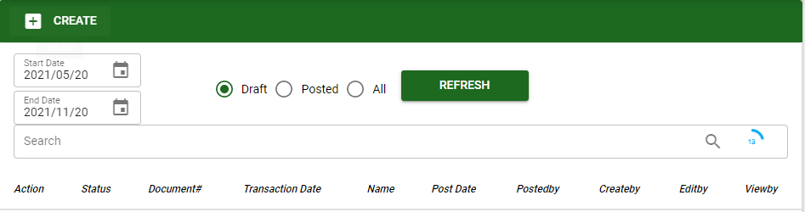
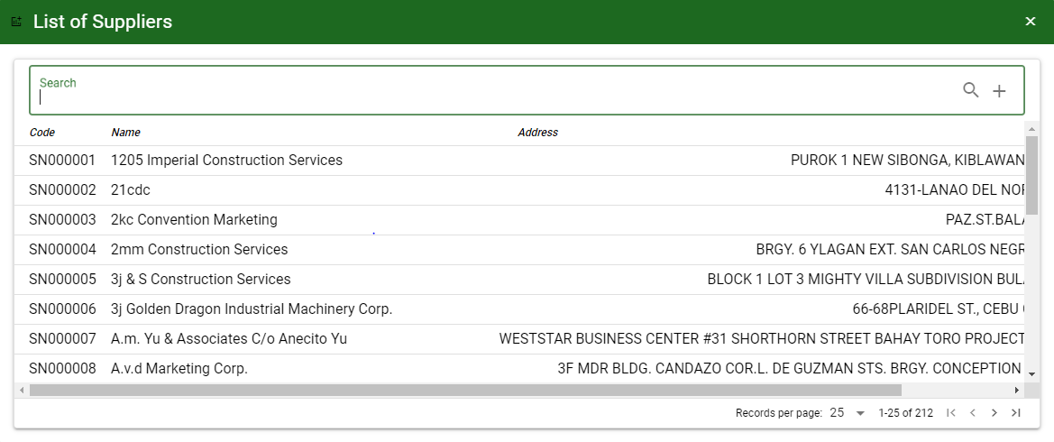

Know how to SELECT ACCOUNT IN Accounts payable voucher
- To select account/s in Payable Voucher, the user can proceed with the following:
a.1. UNPAID: This will show all unpaid payables of the supplier and select it by ticking the checkbox. Click ACCEPT, if done.

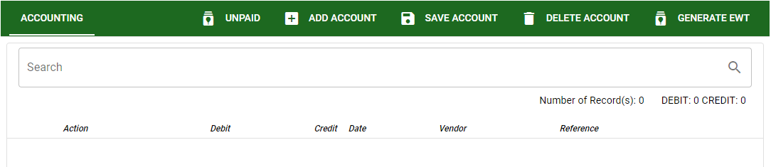

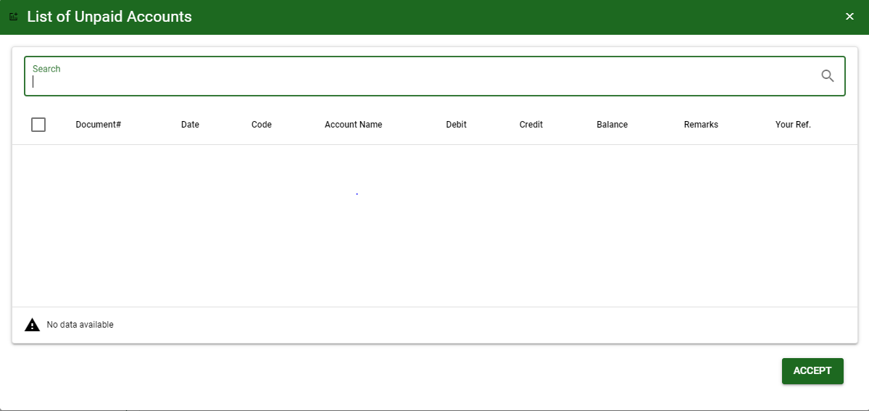

a.2. ADD ACCOUNT: This will allow the user to manually select an account. Click ADD ACCOUNT button then ENTER in Search bar to load all accounts.
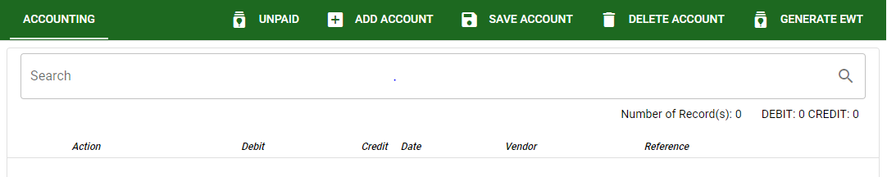
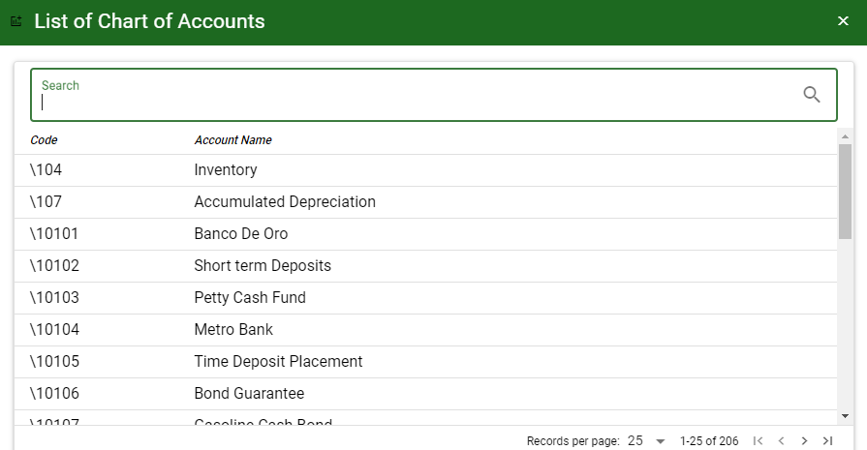
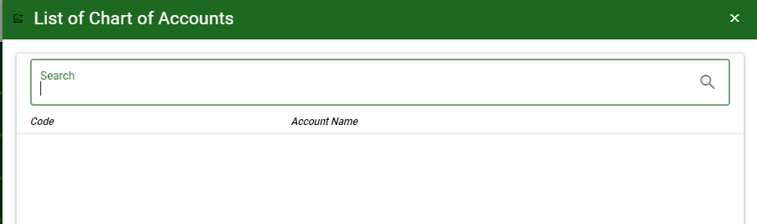

- SAVE ACCOUNT: To save the accounts and to proceed.
- DELETE ACCOUNT: To delete all accounts for the specific transaction.
- GENERATE EWT: This will generate EWT percentage based from EWT Setup under TRANSACTION UTILITIES.

Know how to USE THE FUNCTION BUTTONS IN accounts payable voucher
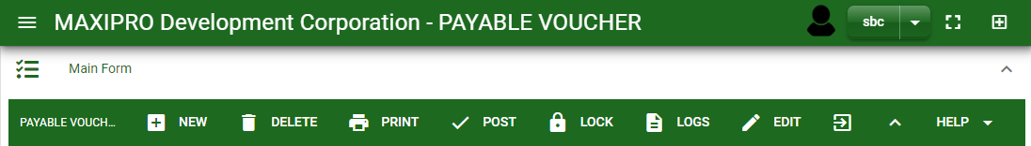

 | FULL SCREEN Button  Use to allow the Payable Voucher – main form to full screen. |  | NEW Button  Use to create new transaction. |  | LOCK Button  Use to lock the transaction to refrain from changing the details in the transaction.
 | OPEN NEW TAB Button  Use to open new tab module you currently using. |  | DELETE Button  Use to delete created transaction that doesn’t have yet previous transaction. |  | LOGS Button  Use to monitor the activities made in the Payable Voucher.
 | BACK TO LISTING Button  Use to go back from Payable Voucher – main form to Payable Voucher main window. |  | PRINT Button  Use to print Payable Voucher printout. |  | EDIT Button  Use to modify the transaction.
 | HIDE HEAD Button  Use to minimize the Payable Voucher – main form. |  | POST/UNPOST Button  Use to post the transaction if it is finalized and to unpost if there is modification with the transaction.

