Purchase Requisition

Know how to create Purchase Requisition
- Purchase Requisition will be created from the site. The user that has an access is the only allow to create requisition. All requisition must come from the posted BOQ. The site cannot request materials and services that are not included in the BOQ.

- To create purchase requisition, click the CREATE button.
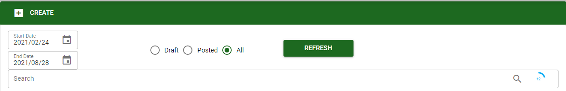

- The user must select the project and sub-project related to the purchase requisition transaction
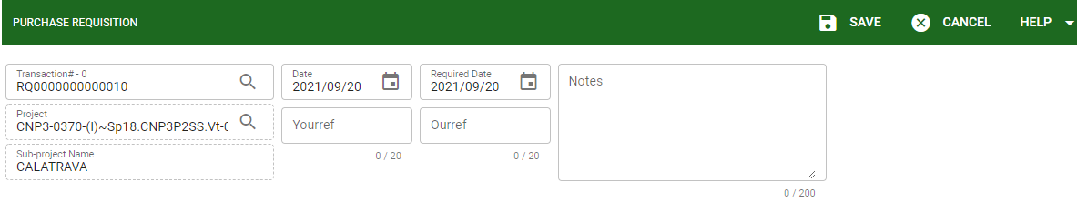

- YOURREF and OURREF can be used by the user in case they want to monitor their internal document# series and notes for other remarks related to the transaction.
- Click SAVE button to proceed the transaction.

Know how to add materials in Purchase Requisition
- The allowed transaction in purchase requisition are the materials only from the posted BOQ.
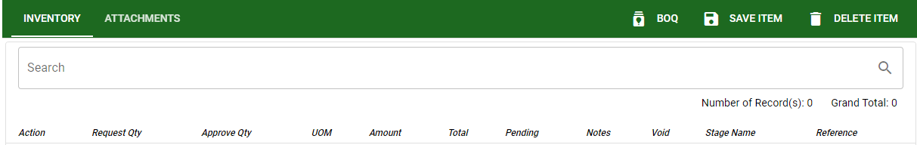
- Click the BOQ button to show all posted BOQ related to the chosen project.
Note: Make sure that the created BOQ related to the project is posted. Services that are included in the BOQ will not be shown and enable to pick in the purchased requisition. It only allowed the material request from the site.
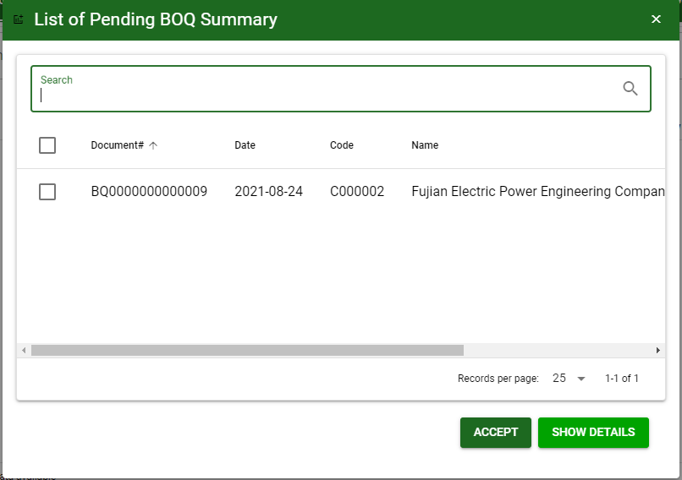
The user can click this SHOW DETAILS to show the materials under that particular BOQ.

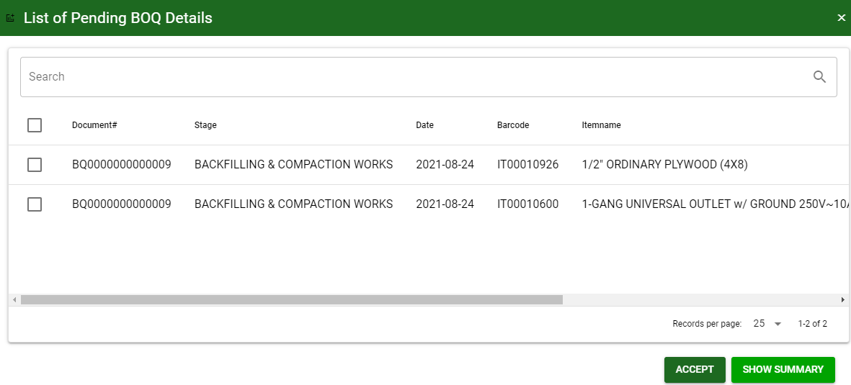
The user can select particular material to be proceed in the purchase requisition.

- Click the SAVE ITEM to proceed. The selected materials requested from the site will need an approval from the head office.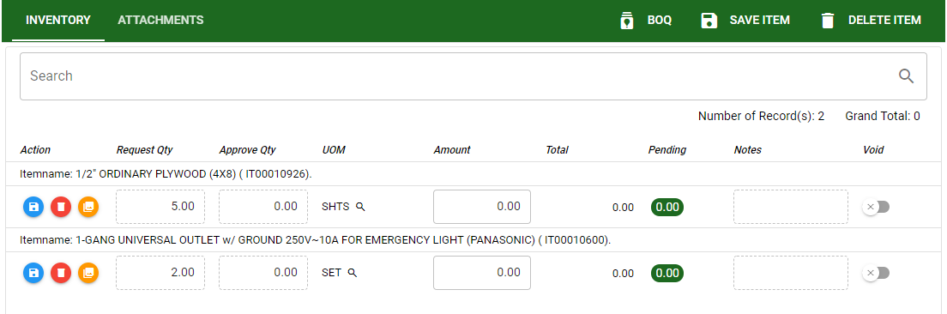

- The user must lock the transaction to proceed in approval. Click LOCK to proceed.
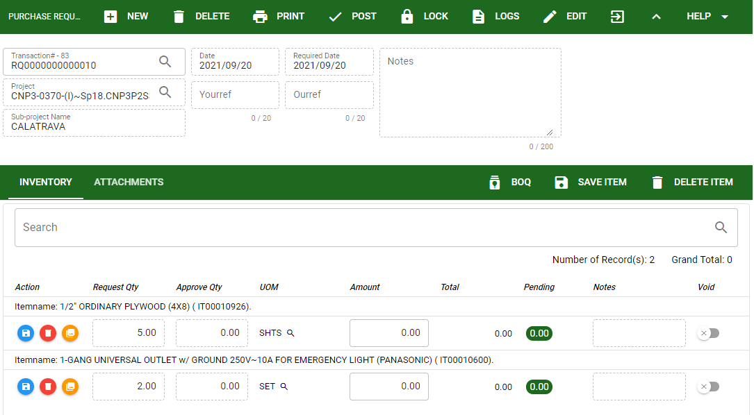

- The user must proceed in the APPROVAL LIST module to approved all the requested transactions.

- Once the transaction is approved it will show the APPROVE QTY provided by the approver.
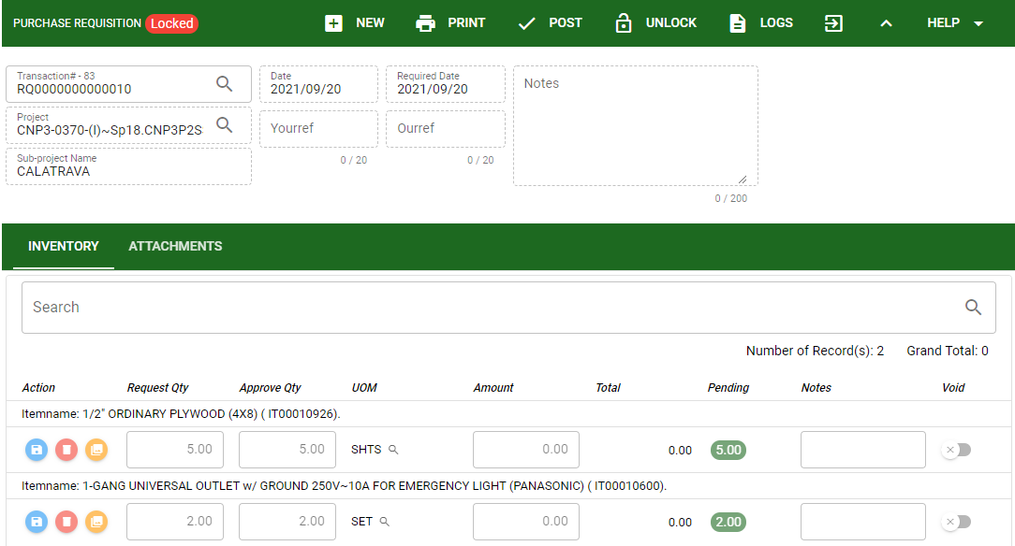
PENDING indicates the total quantity of the material that are not yet served or issued.
- Once the requisition is approved the user can POST the transaction to proceed.

Know how to post transaction in Purchase Requisition
- Click the POST button to finalize the transaction.
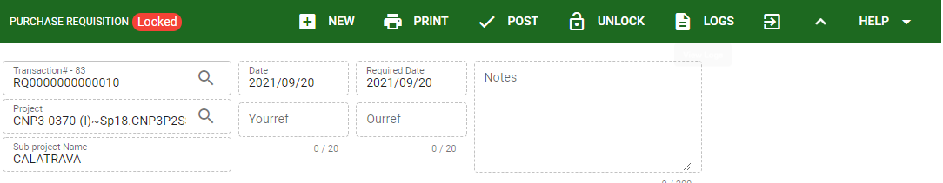
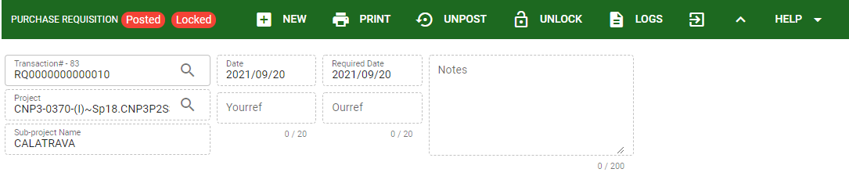

Know how to USE THE FUNCTION BUTTONS IN Purchase requisition

 | FULL SCREEN Button  Use to allow the PR module – main form to full screen. |  | NEW Button  Use to create new transaction. |  | LOCK Button  Use to lock the transaction to refrain from changing the details in the transaction.
 | OPEN NEW TAB Button  Use to open new tab module you currently using. |  | DELETE Button  Use to delete created transaction that doesn’t have yet previous transaction. |  | LOGS Button  Use to monitor the activities made in the PR module.
 | BACK TO LISTING Button  Use to go back from PR – main form to AP Setup main window. |  | PRINT Button  Use to print PR printout. |  | EDIT Button  Use to modify the transaction.
 | HIDE HEAD Button  Use to minimize the PR– main form. |  | POST/UNPOST Button  Use to post the transaction if it is finalize and to unpost if there is modification with the transaction.

