Receiving Report

Know how to create new Receiving Report
- Click the CREATE button to create new transaction and user must select supplier for creating receiving report.
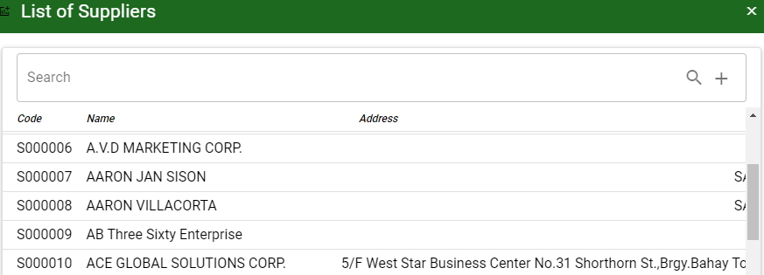
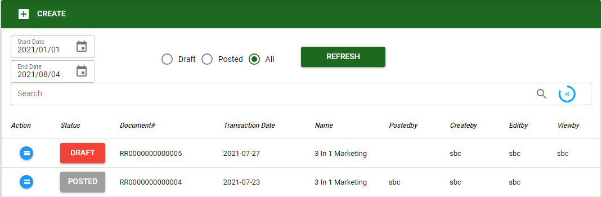

- Use the start and end date to view created transaction based from the covered date set-up.
- Select what type of transaction to be viewed. (Draft, Posted or All)
- Click the REFRESH button to generated transaction based from the filter set-up.
- Use search bar to search specific transaction based from the filter.

Know how to set-up Receiving Report
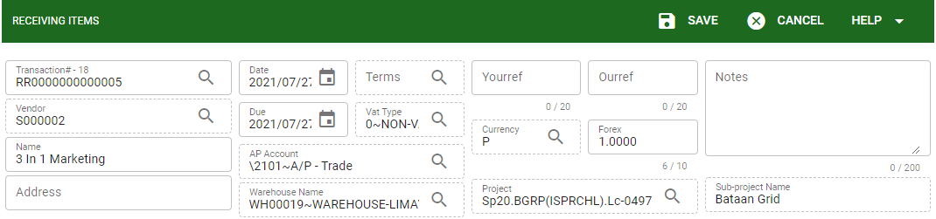
- To set-up the receiving report it is the same process with the Purchase Order.
- SAVE the transaction to proceed.

Know how to add items in Receiving Report
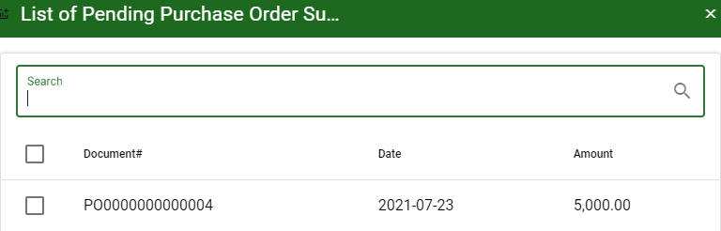
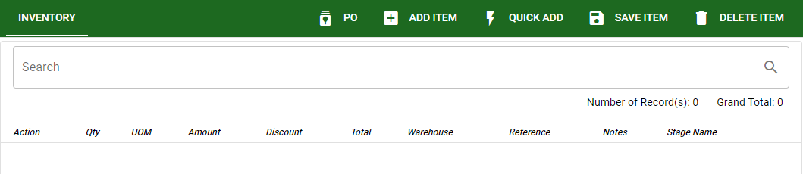

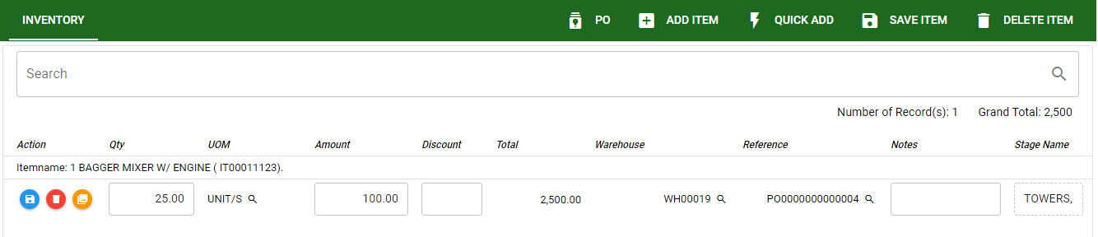

- Add item using PO (purchase order) the user can select posted transaction from PO to transact in the receiving report.
- To add item in receiving report using ADD ITEM, QUICK ADD is the same procedure with adding item in Purchase report.
- After adding item to be transact click SAVE to proceed and finalized the transaction.

Know how to use the function buttons
- To use the following function button in receiving report click this link Functions.

