Stockcard

Know how to create new item in stockcard
- Click the CREATE button to create new item.
- To set-up the details of the item see the example image below.
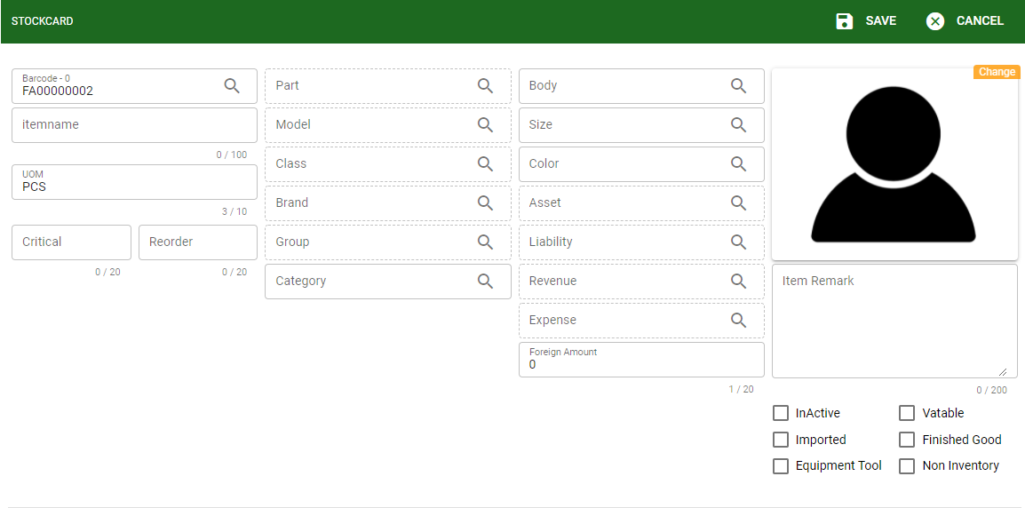
- The following are the required fields to be set-up for creating item (other fields are for other item details or information)
- Barcode: Barcode can be the barcode of the item itself or auto-generated from the system.
- Item name: Item name or Item description of the item.
- UOM: The item must have a unit of measurement. In the system the default UOM is PCS.

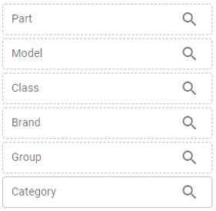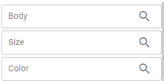
These fields are other details of the item. It helps to categorize the item per group, brand, and etc.
And the data encoded to the following fields will be used to as filter upon generating reports if the user want to generate report with specific item and details of the item

These fields are for the accounting entries, The user can set-up a specific accounting entry to be used if the item will be transacted in the accounting side.

to as filter upon generating reports if the user want to generate report with specific item and details of the item

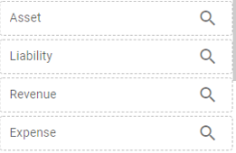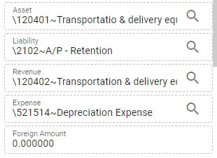
These fields are for the accounting entries, The user can set-up a specific accounting entry to be used if the item will be transacted in the accounting side.

These fields are for the accounting entries, The user can set-up a specific accounting entry to be used if the item will be transacted in the accounting side.

Know how to set-up prices in the item
To set-up the price per item, Click the PRICE button in the stockcard. See image below.
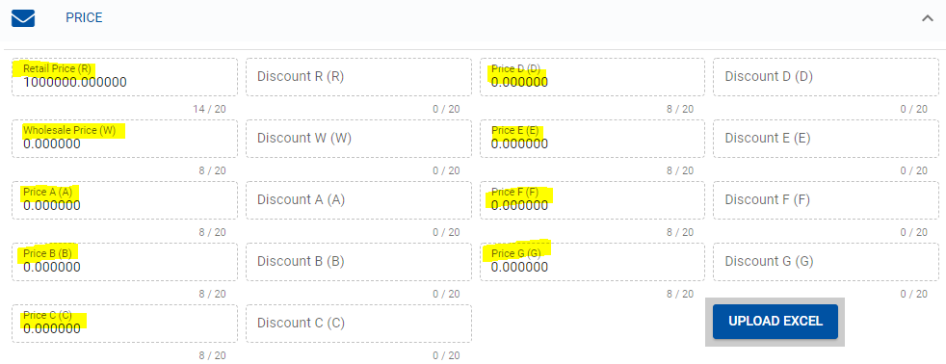
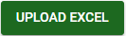
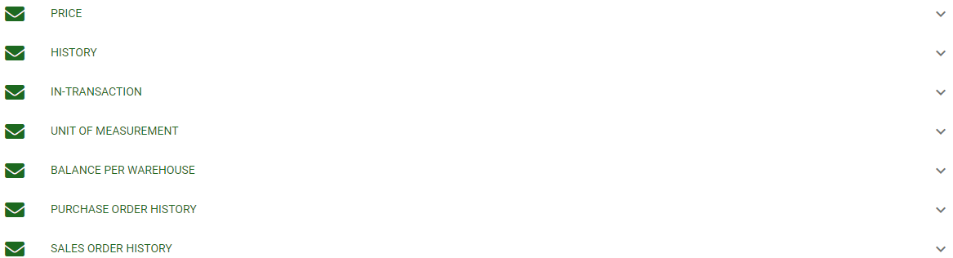

- In the item price there are different available price group that the user can use for the set-up of special prices.
- These prices can be applied with per customer.
- The user can also set-up discount for particular prices

- GROUP OF PRICES
- Retail Price
- Wholesale Price
- Price A to G (for special prices)

Know how to use the STOCKCARD functions button and search existing item
- Link to Know how to use the customer ledger functions buttons
- Link to Know how to search existing customer

Know how to set-up price group per customer
From the CUSTOMER ledger, select the PRICE GROUP it will allow the user to select from the list of price group available from the Item price. If the customer doesn’t have a set-up for price group, the price will default belong to Retail price. See image below.
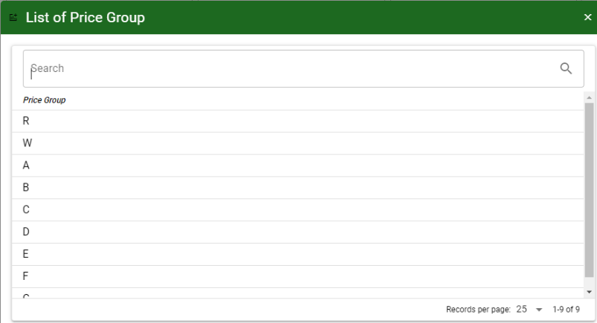
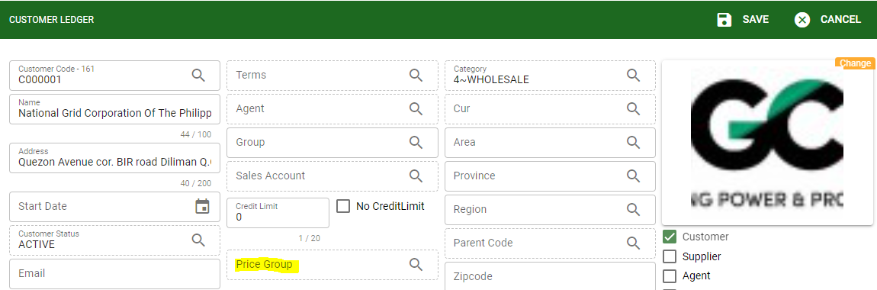

Know how to view transaction history of the item
- These are the list of transaction history in the stockcard:

- Transaction History: It will show transactions created under particular item based from the filtered date.
- In-Transaction History: It will show IN transaction only based from the filtered date.
- Balance per Warehouse: It will show the outstanding balance of the item per warehouse based from the filtered date.
- Purchase Order History: It will show the PO transaction created under particular item based from the filtered date.
- Sales Order History: It will show the SO transaction created under particular item based from the filtered date.

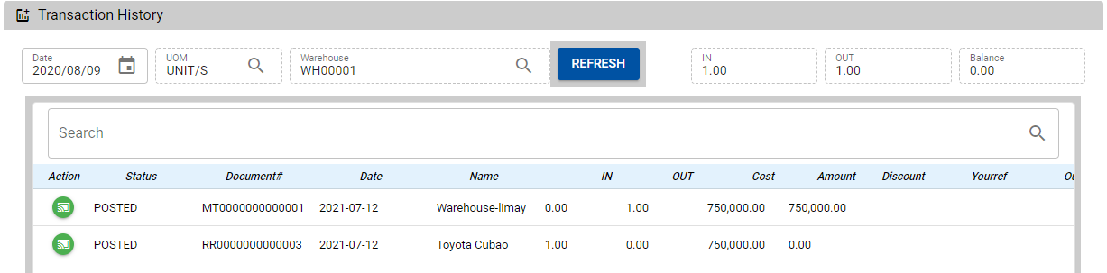
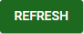
b. To generate history transaction under particular item. Select start DATE then click REFRESH to show the list of history transaction created.
