Supplier ledger

Know how to create new supplier
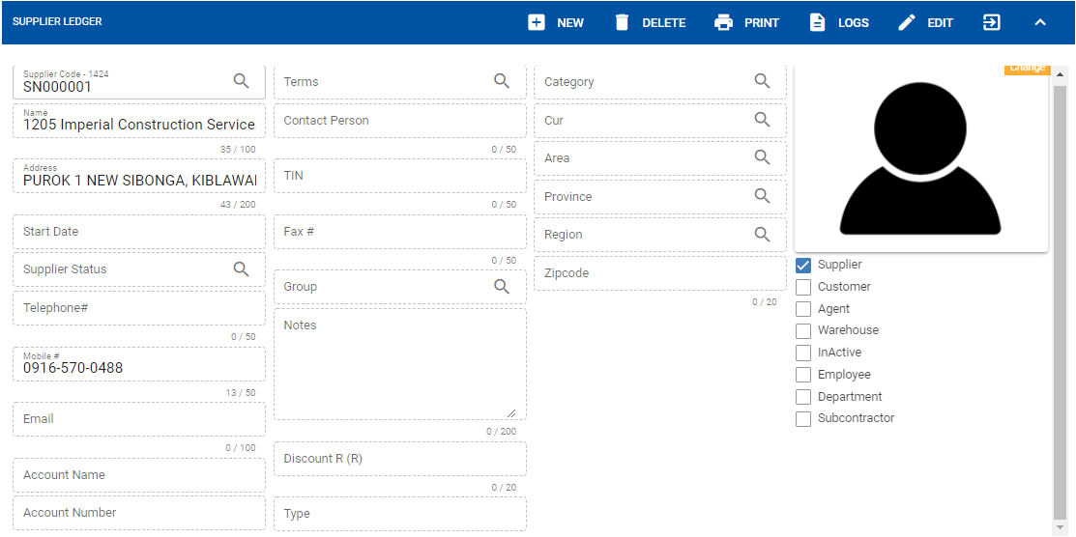

- Click the CREATE button to create new supplier.
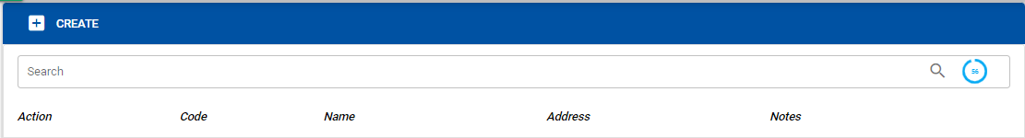

- The user will encode the details of the supplier then click SAVE button.

- Supplier Tagging (same with customer ledger)
- Supplier can be tag also from the following for example customer and customer/warehouse at the same time.
- Note:
- If the supplier is tag from any of the following, the supplier and details will be displayed on the ledger which the customer is tagged.
- If the supplier is not active anymore and has history transaction, it’s not allowed to delete supplier. The user can INACTIVE the supplier.
- The user can also view different transactions history that is related from the existing customer.
- Account Receivable History: It will display the account receivable of the supplier based from the filtered date.
- Account Payable History: It will display the account payables of the supplier based from the filtered date.
- Inventory History: It will display transacted items/inventory under particular supplier and based from the filtered date.

Know how to generate transaction history
To filter history transaction, the user must select start date then click the REFRESH button to view the transaction list.

Know how to search existing SUPPLIER
Use the SEARCH field to enter the supplier’s specific name or keyword then click the search icon. After searching it will show all the supplier that is related from the keyword entered from the search field.

