Warehouse Ledger

Know how to create new warehouse
- Click the CREATE button to create new warehouse.
- To set-up the details of the warehouse see the example image below.
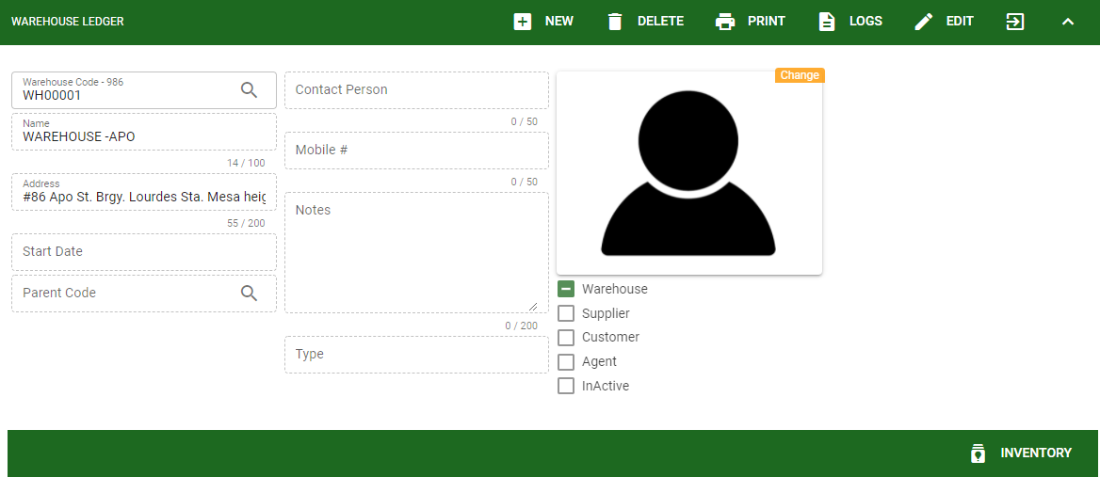
- The user will encode the warehouse code, warehouse name and the address. Other fields are for other information for warehouse
- Warehouse can be tag same with customer and supplier ledger.
- If the warehouse is not active anymore but already had a previous transaction the user can INACTIVE the warehouse.

Know how to view inventory transaction in warehouse
Click the INVENTORY to generate inventory transaction created under particular warehouse. Generating inventory transaction is same procedure with other modules in Masterfile. Link to Know how to generate transaction history

