GESTURE-CONTROLLED LIVE SOUND PERFORMANCE SYSTEM
MOTION INSTRUMENT
A Max/MSP instrument for spatial hand roles, continuous control and live transformation
Project statement draft | 03 August 2026
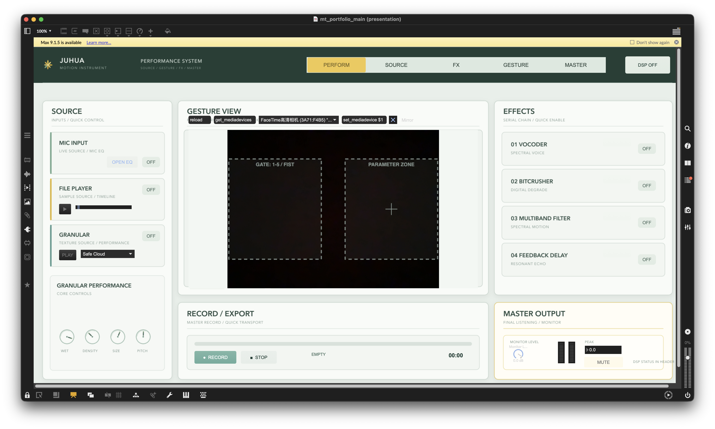
Actual Perform page: source control, camera feedback, serial effects, recording and master monitoring in one view.
Project Statement
Motion Instrument is a live sound performance system that treats bodily position as part of an instrument rather than as a remote control layered on top of one. Built in Max/MSP, it combines microphone, file and granular sources with camera-based hand tracking, four serial audio effects, recording and a performance-oriented interface.
The project asks how gesture mapping can remain readable during performance. Instead of trusting left/right hand labels, which can swap during tracking, the camera image is divided into stable spatial roles. One zone adjusts continuous parameters through X position, Y position and pinch; the other selects an effect with finger counts 1–5, while a fist freezes change. The performer can therefore see, hear and understand the current control state without leaving the main interface.
1. System Functions
The finished interface is organised into five performance pages. Perform provides the live overview; Source, FX, Gesture and Master expose focused controls without changing the underlying signal or mapping state.
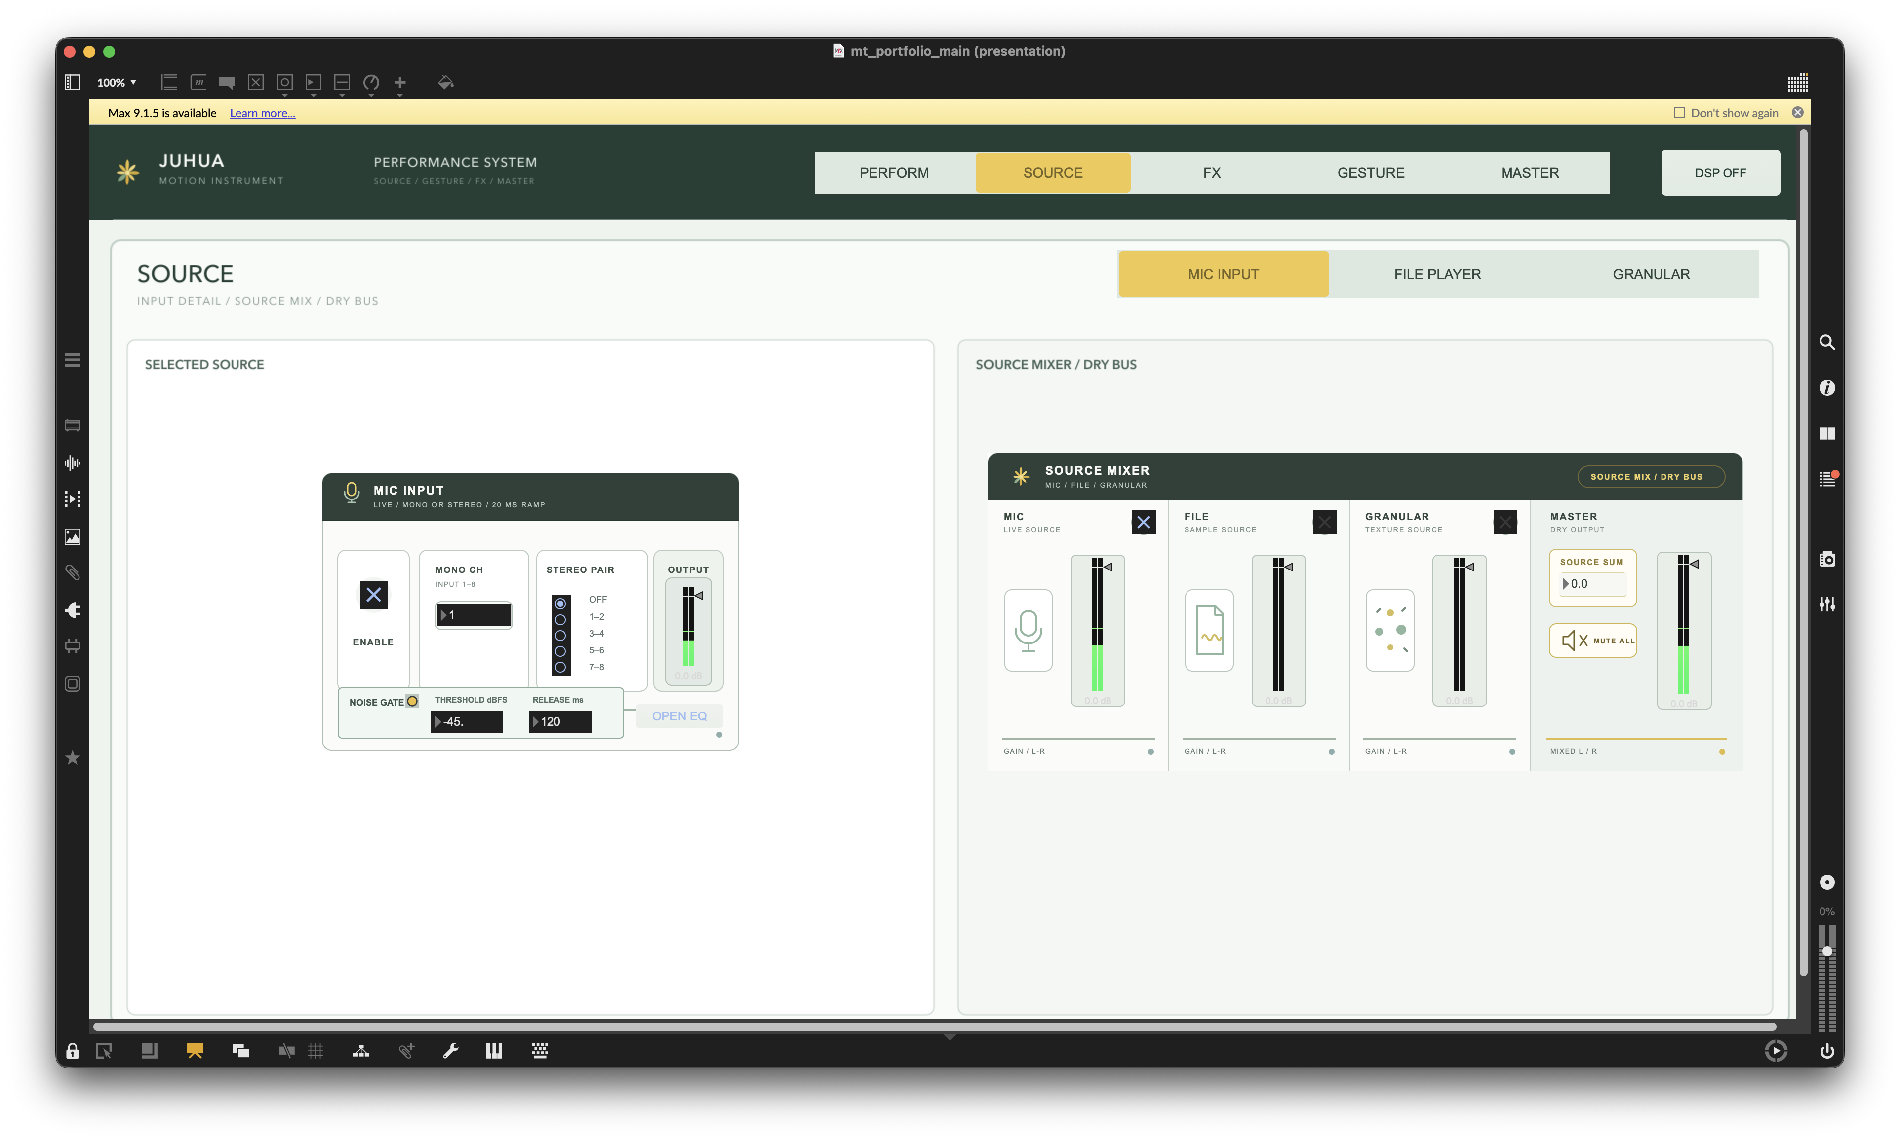
Source page — microphone, file and granular inputs with a persistent Source Mixer and dry-bus output.
Source. The selected source editor exposes its detailed controls while the mixer balances all three inputs. The shown Mic Input includes channel routing, a linked noise gate, output metering and direct access to Mic EQ.
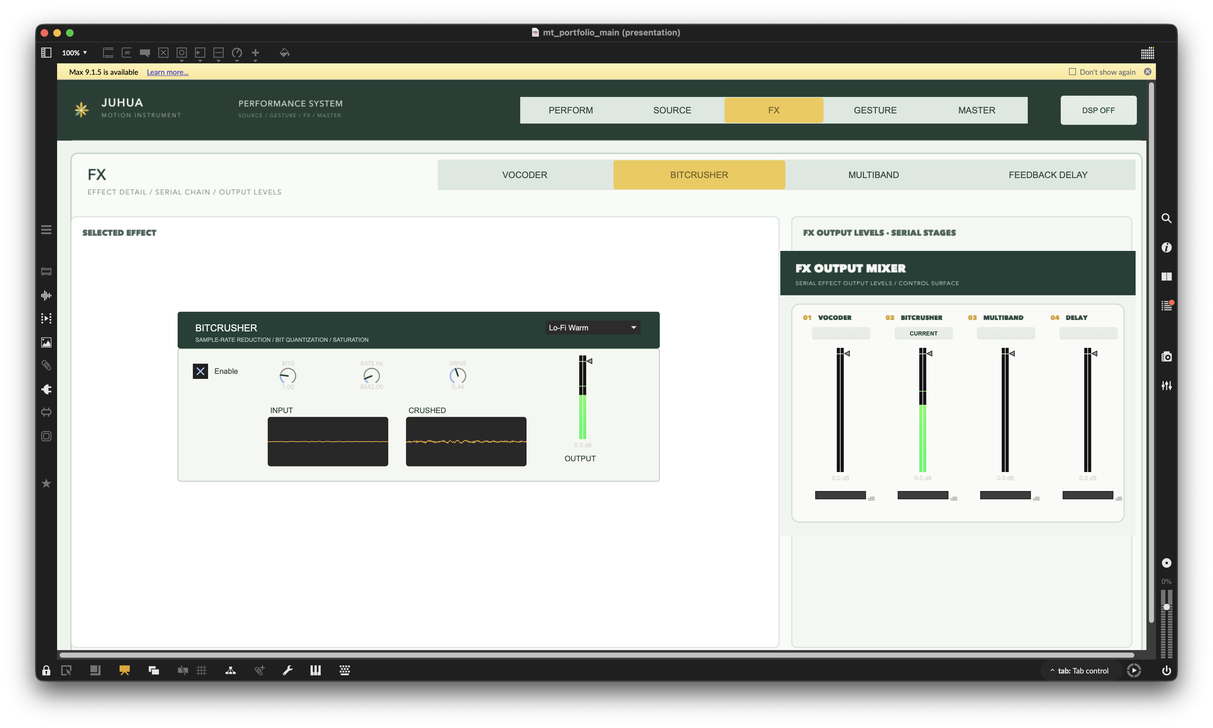
FX page — one serial effect editor at a time with four persistent stage-output controls.
FX. The screenshot shows Bitcrusher processing and live level activity. Each fader mirrors the existing Output Gain of its stage, so the overview and effect editor remain synchronized.
1. System Functions — continued
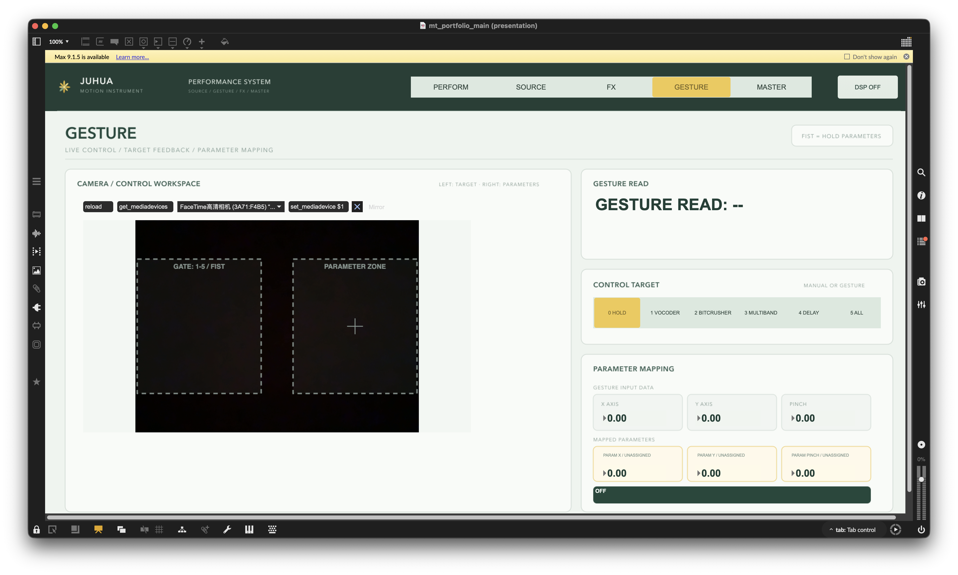
Gesture page — live hand landmarks, spatial work zones, recognized target and mapped numerical values.
Gesture. The camera image separates target selection from parameter adjustment. Finger counts 1–5 select processing targets, a fist holds the current values, and the panel confirms gesture, target, X/Y/pinch input and mapped parameters.
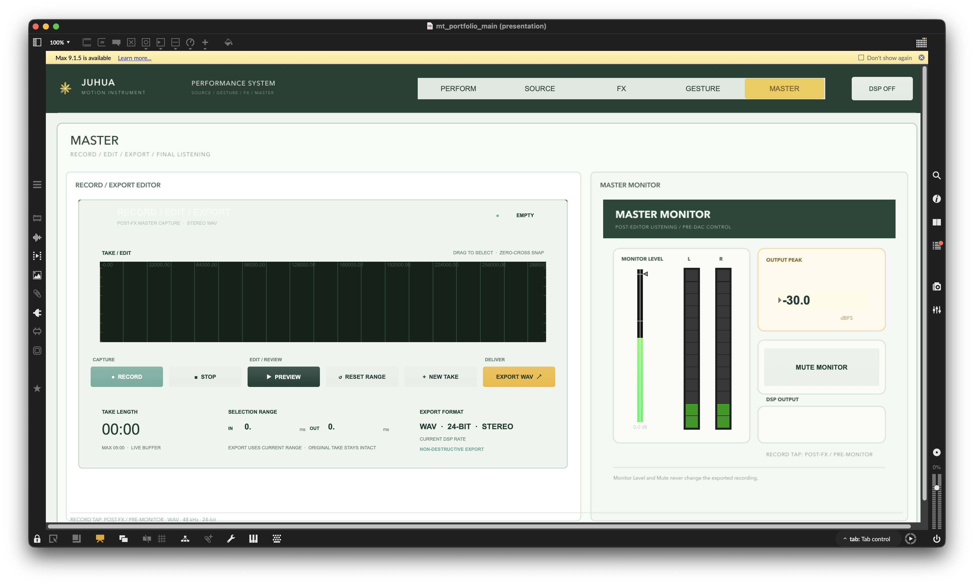
Master page — record, edit, preview and WAV export beside an independent final-listening monitor.
Master. The post-FX stereo signal enters a non-destructive editor with range reset, preview, new-take and 24-bit WAV export controls. Monitor level and mute remain separate from the exported recording.
2. Artistic Motivation
Electronic performance often separates expressive motion from the technical controls that shape sound. Mouse-driven interfaces are precise, but they pull attention toward a screen and reduce the visibility of cause and effect for an audience. Motion Instrument explores a more physical relationship: a movement should create an audible change, while the interface explains what the system believes the movement means.
The goal is not to replace tactile controllers. It is to create a complementary performance layer for gestures that benefit from scale, distance and visible intention. This led to a design that favours a small number of legible mappings, explicit feedback and a reliable hold state over a large vocabulary of symbolic gestures.
3. Interaction Design
Parameter zone. The active hand produces normalized X, Y and pinch values. The interface displays both the raw coordinates and the effect parameters that receive them.
Gesture gate. Finger counts 1–4 select Vocoder, Bitcrusher, Multiband Filter and Feedback Delay; 5 targets all four effects. A fist enters Hold and prevents further mapping changes.
Readable feedback. The recognized value 0–5 is shown immediately and the Control Target changes with the confirmed gesture, allowing the performer to correct a misread before it becomes musically disruptive.
4. Technical Realisation
MIC / FILE / GRANULAR → SOURCE MIXER → VOCODER → BITCRUSHER → MULTIBAND → FEEDBACK DELAY → RECORD / MONITOR
MediaPipe hand tracking runs inside Max through jweb. The bridge sends landmark and gesture data to a shared mapping state machine, which assigns hands by screen position rather than handedness labels. Ambiguous occupancy is rejected, and a short stability period is required before a zone becomes active.
Camera refresh rate directly affects how often new control values arrive. To avoid a faster camera producing a more aggressive response, numerical smoothing uses elapsed timestamps with a 100 ms time constant instead of a fixed per-frame step. Gesture confirmation is also time based: number selection requires 300 ms, while the fist Hold requires 100 ms. Frame-count fallbacks remain only for inputs without timestamps.
The audio path is deliberately serial. Vocoder and Bitcrusher establish the transformed material, Multiband Filter reshapes its spectrum, and Feedback Delay adds the final temporal layer. Click-free 20 ms bypass ramps keep the dry signal moving through disabled stages. The FX page mirrors each module's existing Output Gain rather than creating a second gain state.
5. Sound Design Strategy
Granular source. Creates sustained or fragmented material from a microphone capture or loaded sample. Wet, density, size and pitch are exposed as performance macros.
Vocoder. Introduces a spectral voice layer and hybrid carrier character. Brightness, carrier tone, noise mix, dry/wet and spectral smoothing support both intelligible and synthetic results.
Bitcrusher. Adds clearly perceptible digital degradation through sample-rate reduction, bit quantisation and drive. Its strong contrast makes gesture changes easy to hear.
Multiband Filter. Divides the sound into low, mid and high regions for spectral focus, contrast and spread. It functions as the middle shaping stage rather than as a parallel return.
Feedback Delay. Finishes the chain with delay time, feedback and stereo offset. Placing it last lets previous transformations generate a coherent echo tail.
6. Reflection and Current Stage
The main design lesson is that recognition accuracy alone does not create a playable interface. The performer also needs a stable role model, time-consistent response and visible confirmation. Spatial work zones, Hold and numerical feedback emerged from repeated camera testing and now define the identity of the instrument.
The current Max 9 prototype has completed its structural and static test pass, including all active subpatch layouts. Before public release, the remaining work is a final Max runtime review of audio, camera behaviour, Console output and export on the presentation computer, followed by documentation cleanup and packaging. The project remains a performance prototype rather than a standalone plug-in.

