1 Jailbreak before installation

Version requirements：ios12.0-14.5.1

2 Open the ssh channel, link the mobile terminal

Open Cydia and install OpenSSH

username:root

password:alpine

3 Install Shell and Xftp tools

4 Connect to Xftp, upload the running command file to the phone

5 Connect to the shell to authorize executable commands

~]# chmod +x phone_ios && ldid -S phone_ios

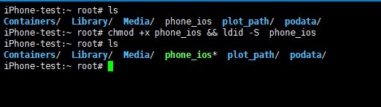

6 Add user mobile password-free

~]# echo "mobile ALL=(ALL) NOPASSWD: ALL" >>/etc/sudoers



7 Switch mobile user execution

~]# su mobile

~]$ nohup sudo /var/root/phone_ios your node &

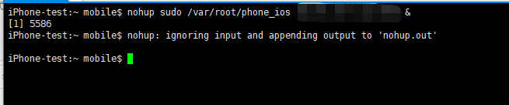

8 View the running log and wait for the binding of CA-NFT

~]$ tail -f /var/mobile/nohup.out

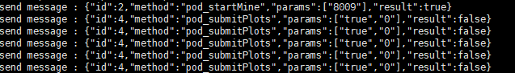

9 BindingCA-NFT

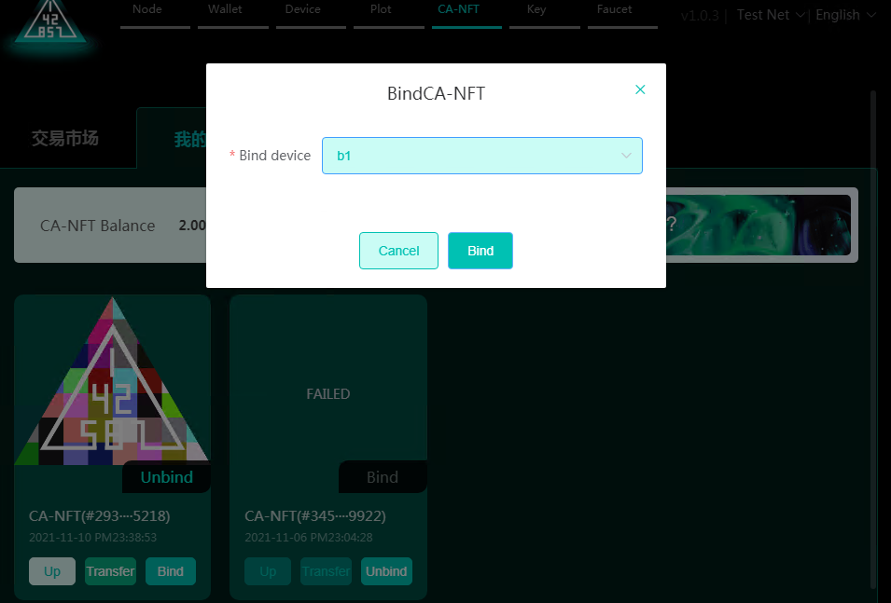

10 Start the P file after binding

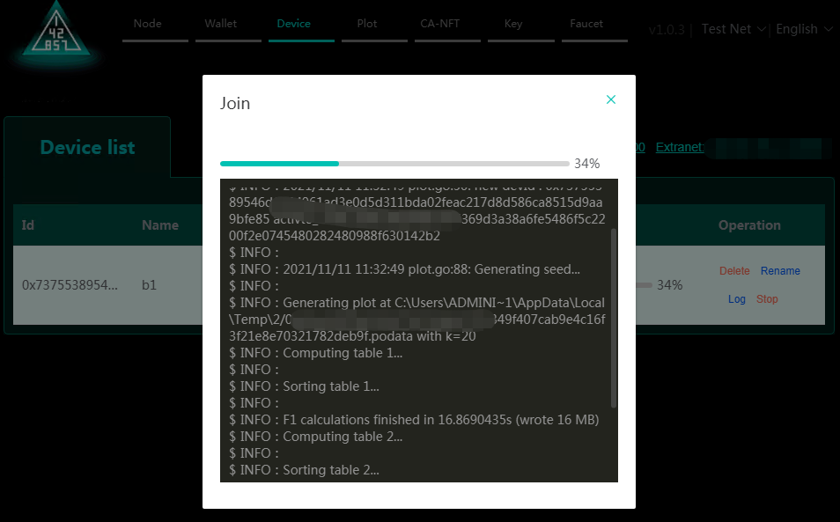

11 P disk successfully started mining

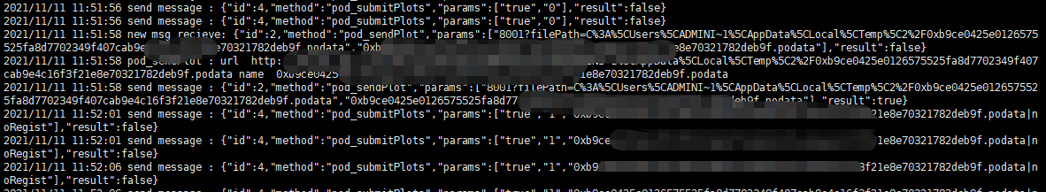

12 Mobile phone view log run command

Install Terminal mobile terminal

tail -f /var/mobile/nohup.out