**Wallet operation document**

**Create wallet**

1、Click "Create wallet"

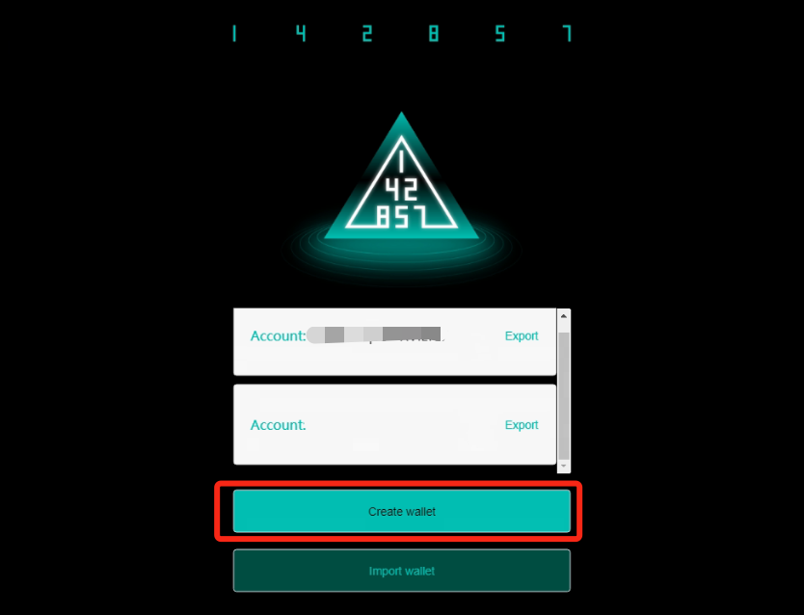

2、Enter the password and confirm the password and click "Confirm"

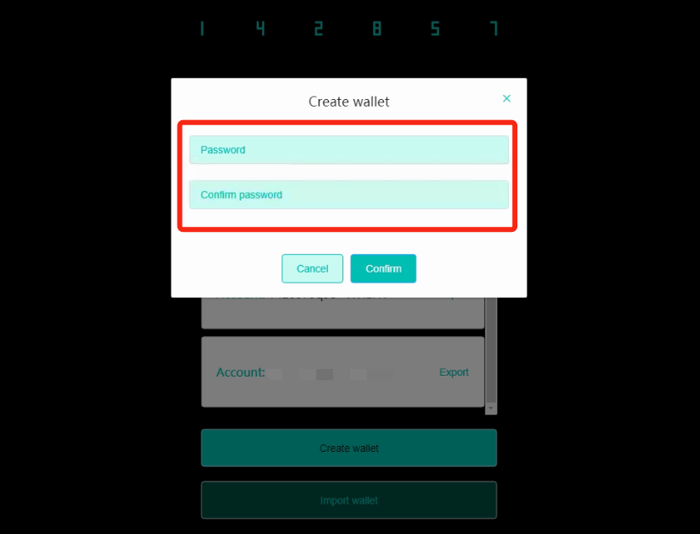

1. After the wallet is created, click on the wallet address to enter the wallet homepage.

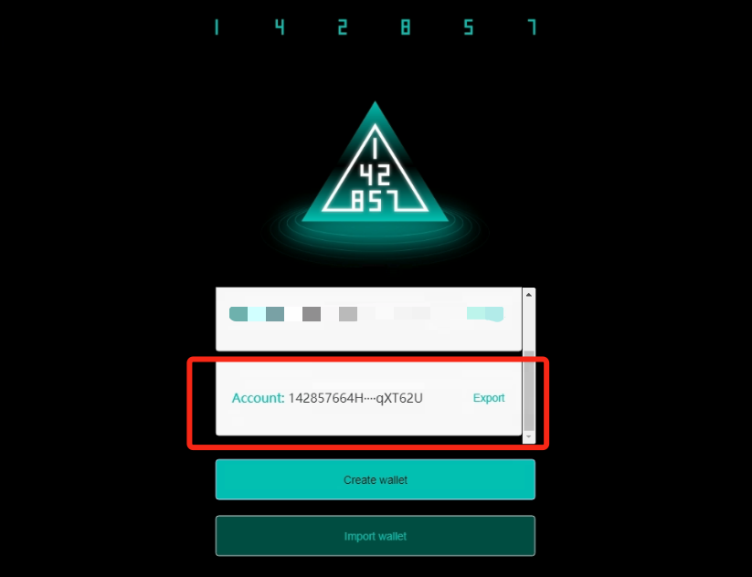

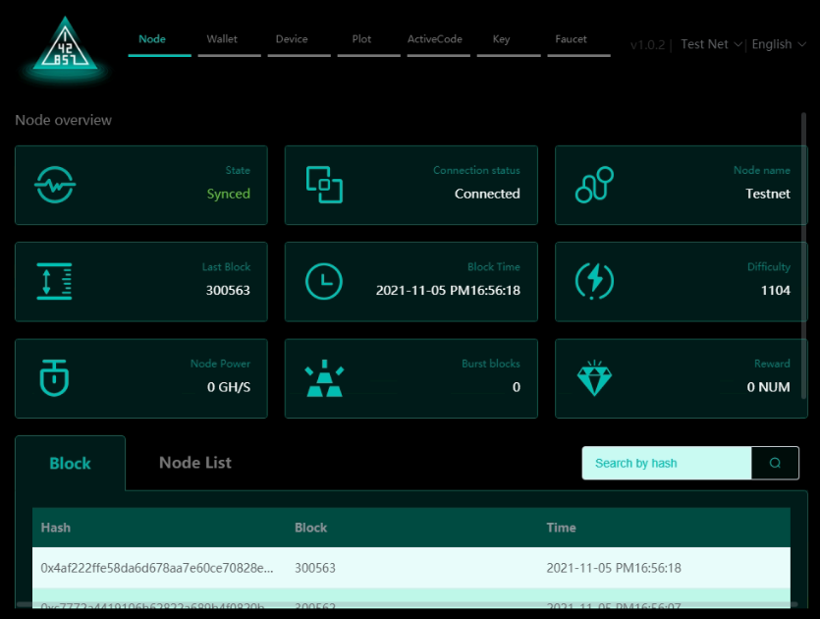

**Export private key**

1. Click "Export", the wallet private key will be displayed, click "Copy" to copy the private key

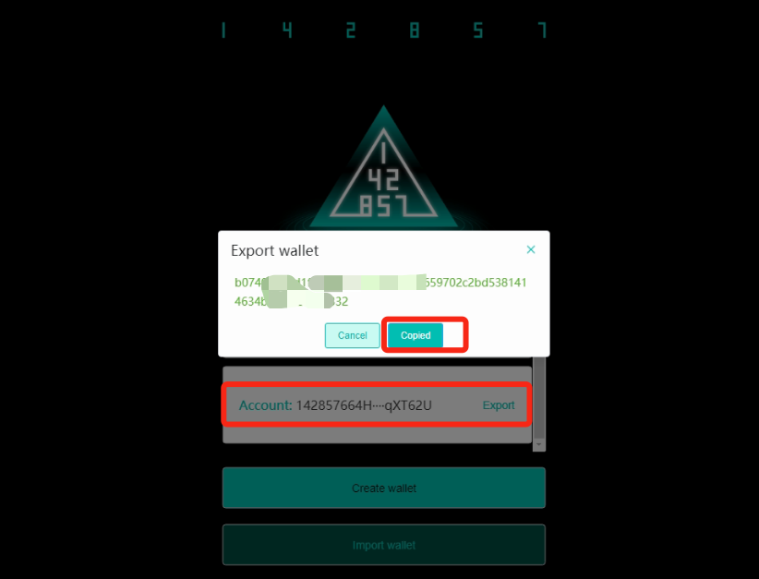

**Connect the device**

1、Click "Device" in the navigation bar to view the network connection method.

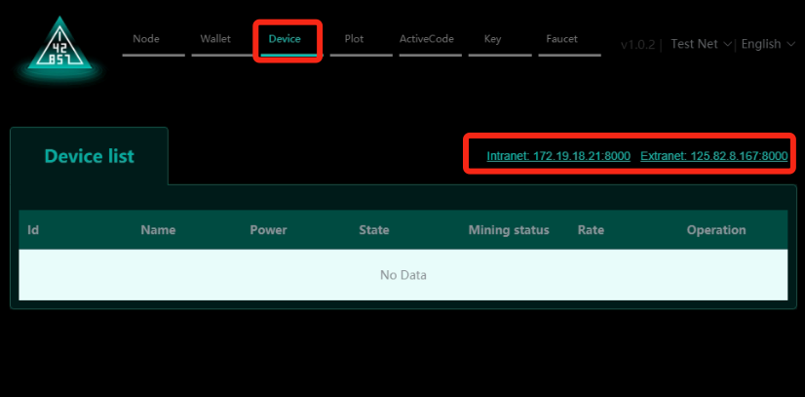

2、Install the mobile mining client, and enter the connection address in the client for the Andorid device as shown below, and click "START Mining"

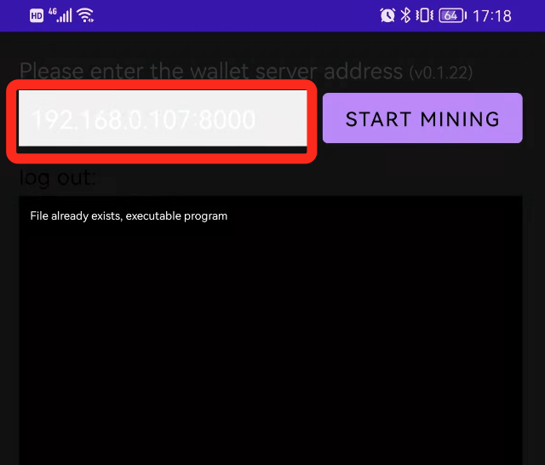

3、After the device is started, you can view the device list on the wallet client. A newly connected device in the list indicates that the connection is successful

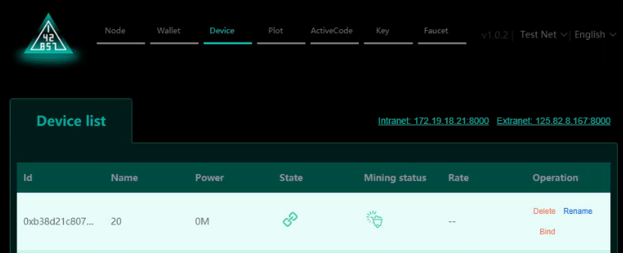

1. Binding CA-NFT
   1. Click "bind" in the device list and select CA-NFT to bind

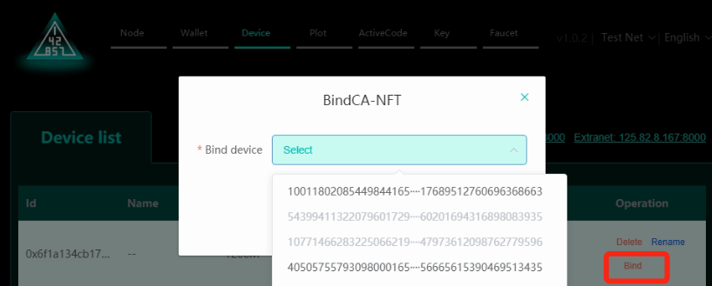

1. P file mining
   1. After binding CA-NFT, you can start the P file, and after the P file is completed, it will automatically start mining

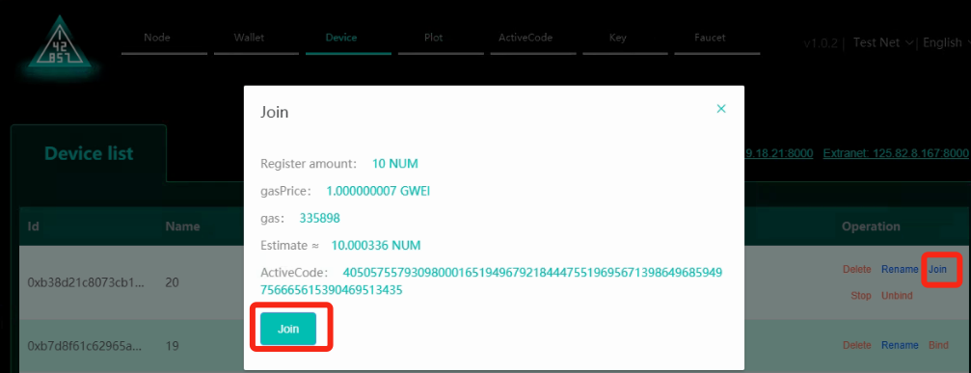

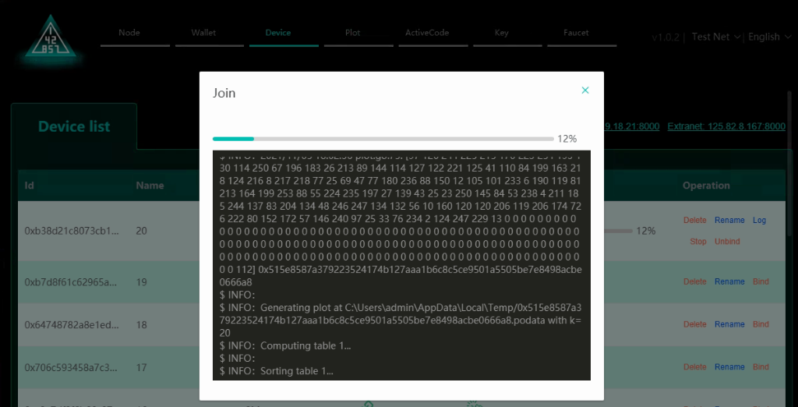

**Active code**

1. How to obtain CA-NFT
   1. The block height is between 0 and 142857 blocks, and the access device can directly mine with speechless CA-NFT activation and P file pledge. A lottery is drawn every 15 blocks, and 1 CA-NFT is drawn each time (the higher the number of burst blocks in 24 hours, the higher the probability of winning)
   2. To buy in the trading market, click "Buy" to purchase, and check in "My CA-NFT" after the purchase is successful

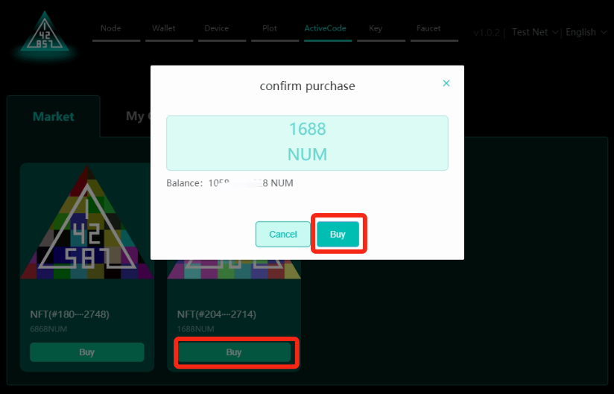

1. CA-NFT is on sale
   1. Click "Up", enter the selling price, click "Up" and wait for the successful listing. After success, you can see your CA-NFT listed in the Market

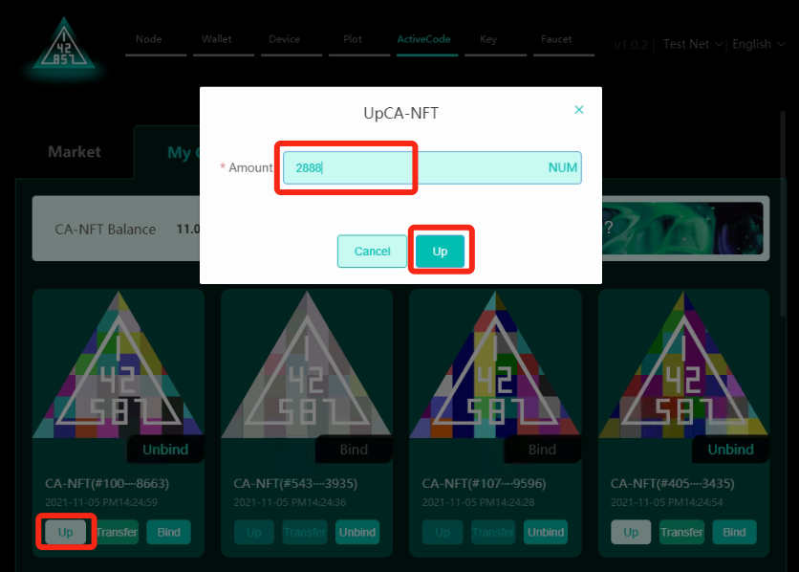

1. CA-NFT transfer
   1. Click "Transfer", enter the receiving address and click "Transfer" to wait for the transfer result

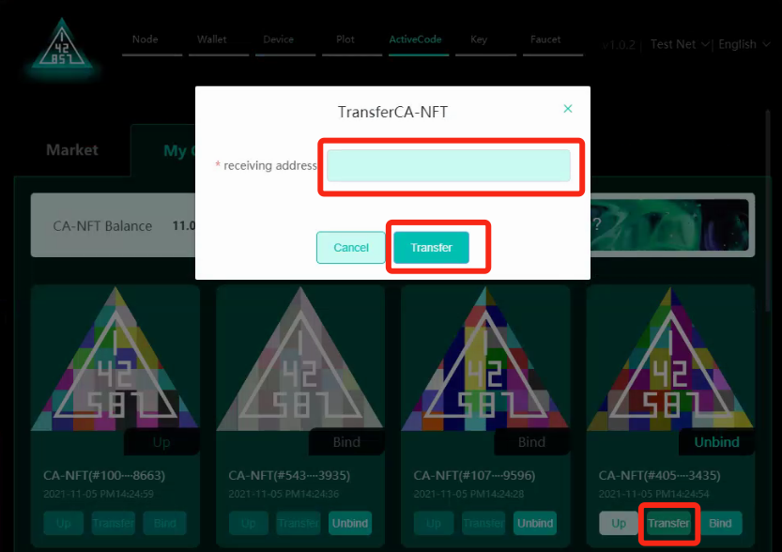

1. CA-NFT unbinding
   1. Click "Unbind", click "Confirm" in the second confirmation form and wait for unbind successfully

