CS 340 README

Project Two

Jeff Caldarelli

## About the Project/Project Title

This project is about setting up a simple dashboard for working with a database in mongoDB. Using a CRUD module that was created in order to be able to apply reusable code when creating, finding, updating or deleting data in a database, we expanded this by creating a separate dashboard for simpler usage, and to present our data, as well as search by location.

## Motivation

A ipynb file was created to produce a simple dashboard that will enable more efficient management of the AAC database with mongoDB. Specifically, this will allow for quick searches for different rescue dogs by location.

## Getting Started

To get a local copy up and running, simply copy the file into a new jupyter project. Maintain the basic logic of the function, however make personalized changes as need be, for example to the particular dataset you will be using. You could also experiment with adding other features.

## Installation

Jupyter, mongoDB access. The latest version of each can be downloaded from the web.

## Usage

See “Code Example” attached via zip file.

### **Tests**

To test the code, simply open and run the file in Jupyter. By clicking the different featured buttons, you can filter your search by specific rescue dog type, be it Water Rescue, Wilderness, or Individual, and you can also reset.

**Output**

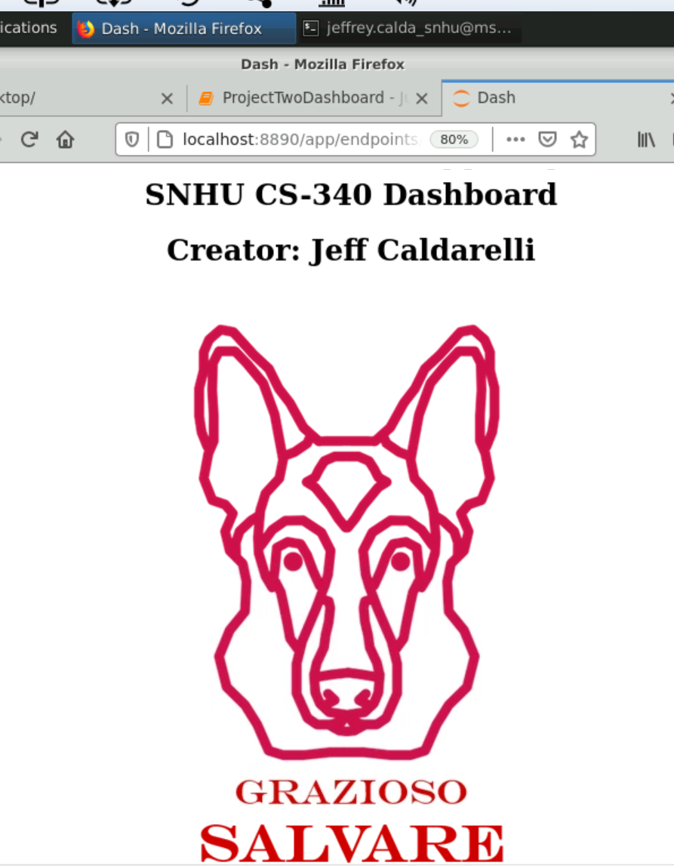  
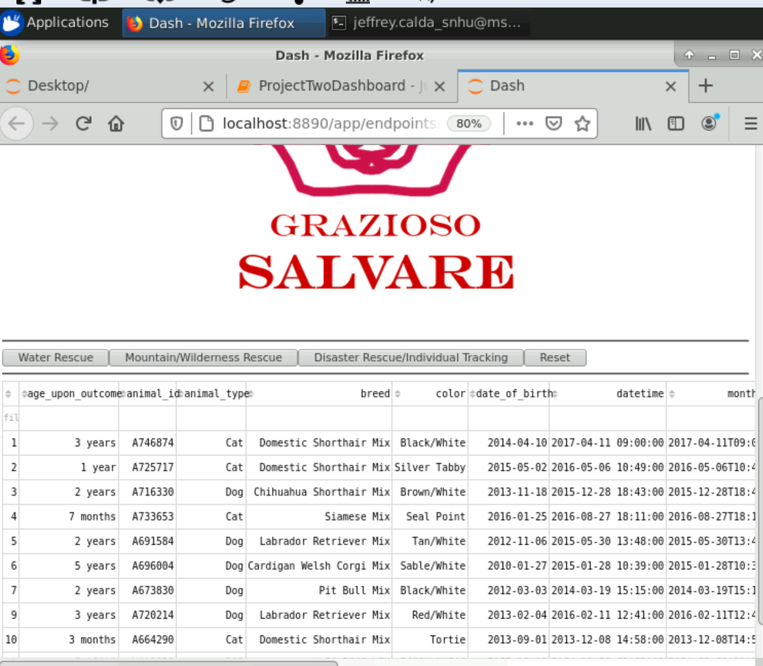

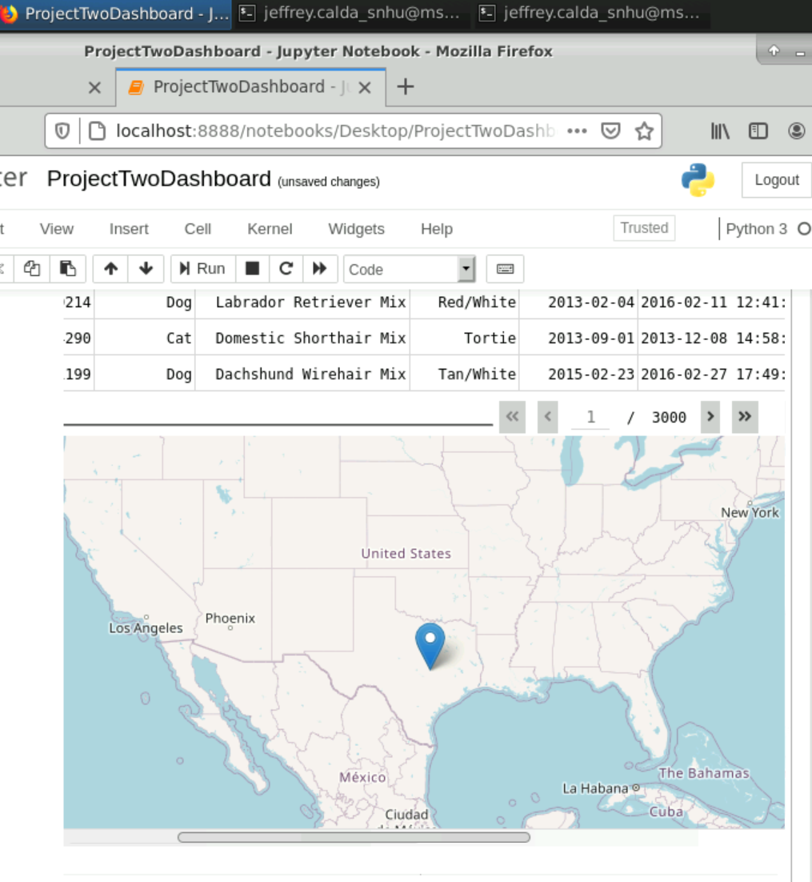

## Contact

Your name: Jeffrey Caldarelli