**Book Bank**

**Introduction:**

Book bank is a very efficient and convenient way to find, upload, sell or buy any book you want to. The module is equally helpful for teachers and students, or any person who is searching any book or wants to sell or share books he owns.

**How to install it?**

After you download this package which is a zip file, unzip it, then put folder under mod, go to site administration, click Notification, the module is installed, the module name Book Bank.

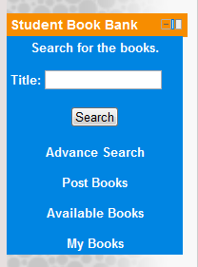

**Search Books:**

You can search for the books you are looking for by using just the Title of the book, or using advance search.

**Advance Search:**

If you have details of the book you are looking for, it might make it easy for you to get it. The advance search option in the book bank feature can make it easy for you to search your book.

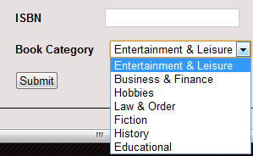  
You can search the book you are looking for by entering book’s Title, its author name, edition, any keyword, books’ ISBN or just by selecting the book category.

**Search Results:**

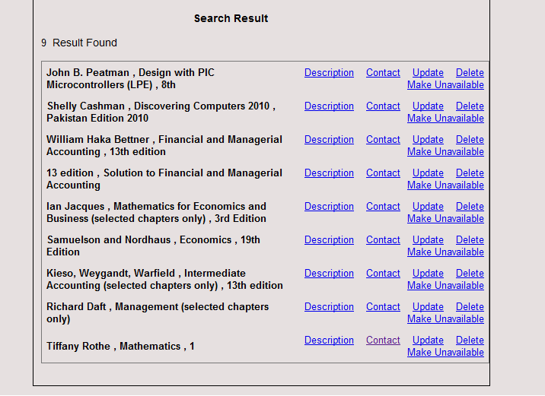After clicking the submit button you can see the search resutls down on the same page.

**Post Books:**

To post a book you just have to click on the Post book option of the block.

The fields with a * sign cant be left unfilled. Books you want to post can be of a price and you can also give out your books for free by setting price to 0 (zero). C

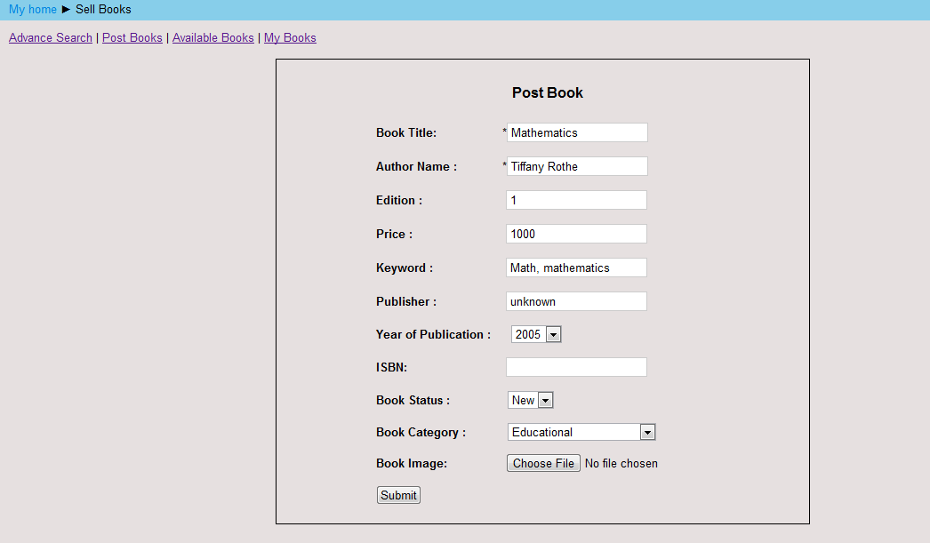

Click on the submit button to post your book in the bank and you can see your posted book in the bank.

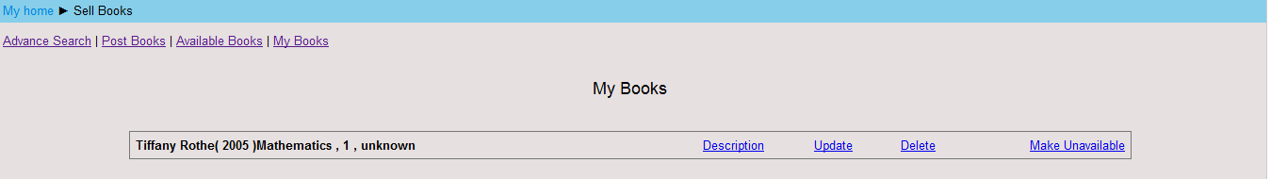

**My Books:**

This link will show you all the books you have ever submitted on the bank.

**Available Books:**

To see all the available books, just click on the link of available books and it will give you all the books available in the book bank.

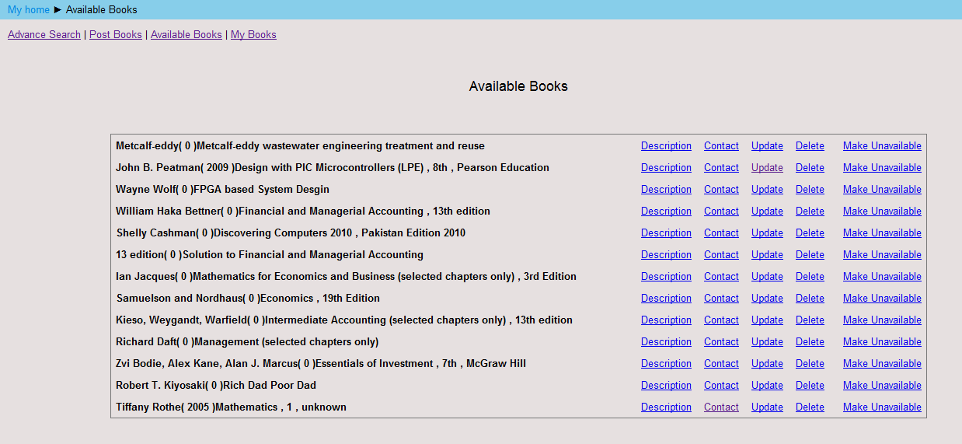

To get an available book, click on the contact option given in front of that book. This will let you send a message to the owner of the book with your contact details etc, and if they are interested in giving the book they will contact you back.

