**Custom Reports – Course Audit Report**

**How to install?**

After you download this package which is a zip file, unzip it, then put folder under mod, go to site administration, click Notification, the module is installed, the module name called Custom Reports.

**Introduction:**

Course audit report lets you know how much resources are being used in a course. This helps to improve the usage of overall LMS, to train specific teacher or pupils for the use of the service.

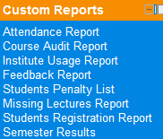**Generate Report**

Click on the course audit report link under Custom Reports Block, once the block is installed.

Select a category from which you want to select a single or multiple courses to generate audit report.

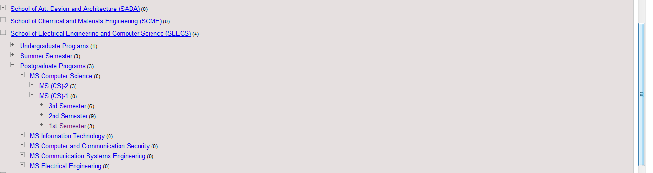  
After selecting a category, select all or some courses that fall under that category. You can also give a specific time in date, in which you want to generate activity report of that course.

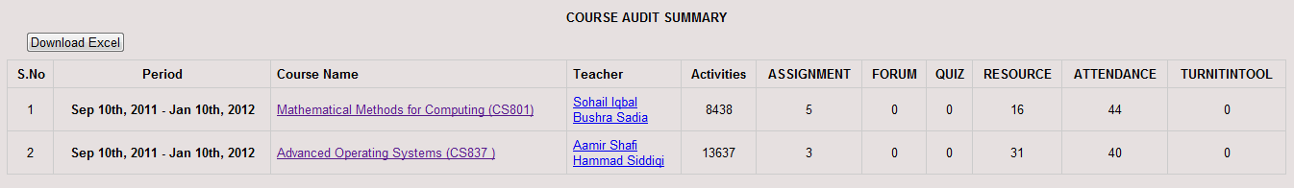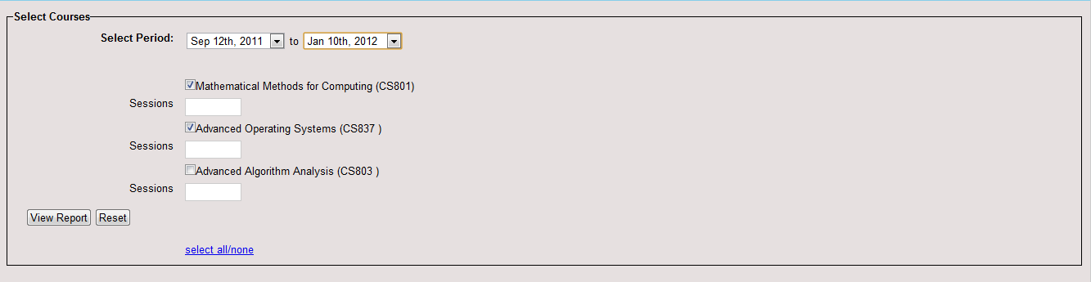  
After selecting a to and from date (which should probably between your course creation date) click View Report.

The report shows the usage of resources in the specific course along with the course instructor name and time period of that course.

**Download Report in Excel File:**



The report can also be downloaded in the excel format for printing and sharing purposes. Just click on the “Download Excel” button on the top of the report to download it.