**Custom Reports – Institute Usage Report**

**How to install?**

After you download this package which is a zip file, unzip it, then put folder under mod, go to site administration, click Notification, the module is installed, the module name called Institute Usage Report.

**Introduction:**

Institute usage report is a very helpful feature which lets you generate LMS usage report of your institute based on several options it allows you to set. Once the module is installed different options can be used to generate usage report of your institute to have a brief or detailed overview of the usage of LMS in your institute.

**Generate Report:**

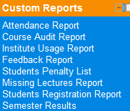To generate an Institute usage report, click on the link inside Custom Reports Block.

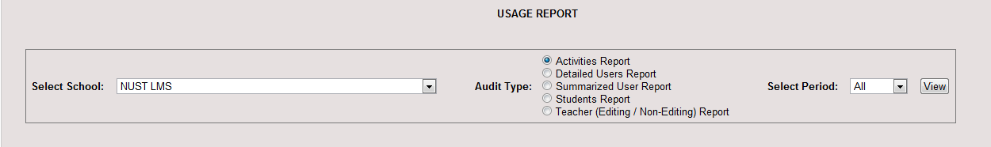

**Select Time Period:**

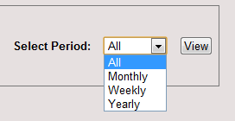You can select from the drop down option “Select Period” to select a time you want to see the usage report of.

**All** Will show the accumulative usage from the time of implementation of LMS at your institute till date. **Monthly** will accumulate the usage monthly. **Weekly** will accumulate weekly usage. **Yearly** will show the accumulative usage of every year.

After selecting a period of time, click View to generate report.

**Types of Usage Reports:**

**Activities Report:**

This report lets you know how much LMS resources (assignments, forums, quiz, resources, attendance etc.) are used by your institute users in a given period of time.

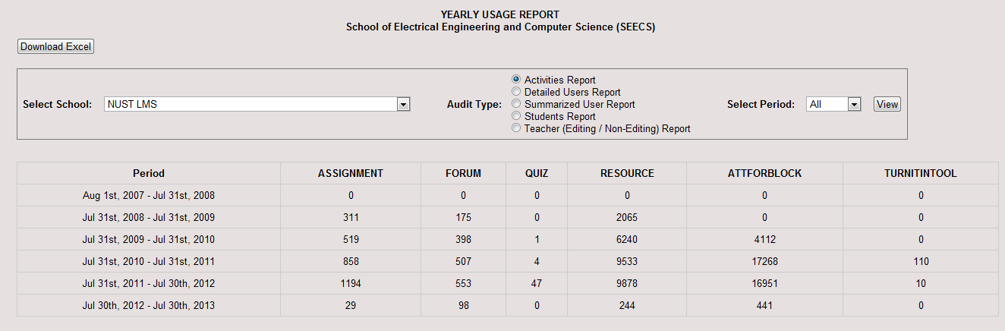**Detailed User Report:**

The report gives you a detailed over view of the users using LMS in your institute including user’s name, their Account type, and time created and last Access and gives total at the end of the time period.

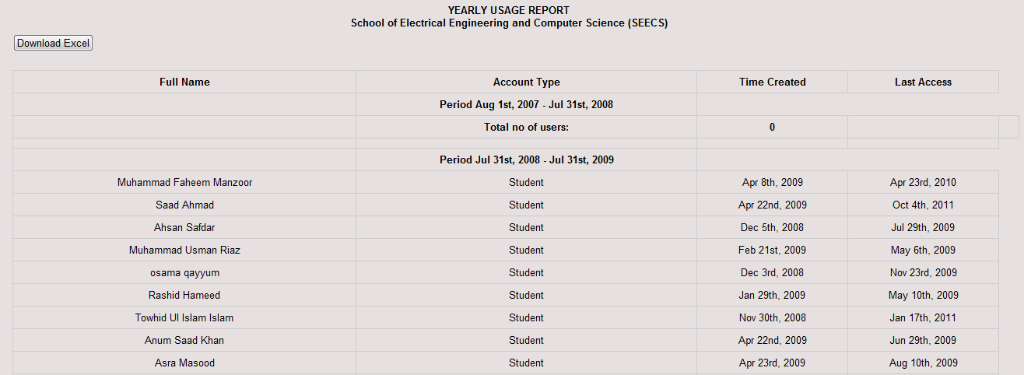

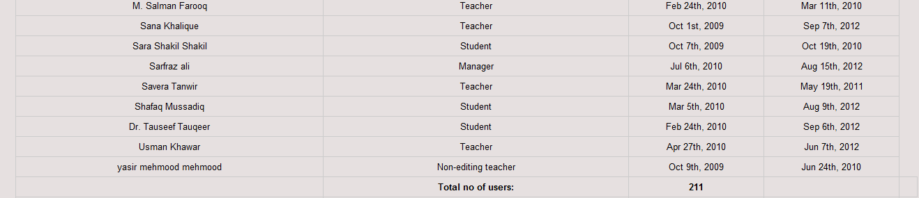And gives total at the end of the time period.

**Summarized User Report:**

The report shows the summarized users of LMS in your institute. The report generate the users as per the roles you have created.

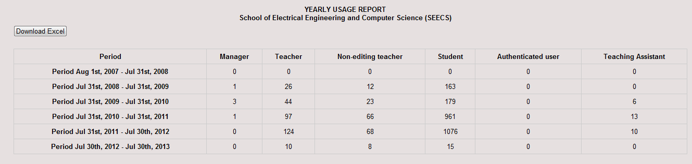**Students’ Report:**

This report is just like Detailed User Report, but it shows name, account type, account created and last access dates of Students alone.

**Teacher’s Report:**

This report is just like Detailed User Report, but it shows name, account type, account created and last access dates of Teachers and Non-editing teachers only.