**How to install it?**

After you download this package which is a zip file, unzip it, then put folder under mod, go to site administration, click Notification, the module is installed, the module name called Quick Feed.

**Introduction**

The purpose of introducing this module on LMS is to allow the teachers to take an instant feedback after class from students. “Quick Feedback” shows the responses of students in the form of a word cloud. The size of the words is proportional to the frequency of responses. This gives an overall feedback about a lecture in class and would help the teachers in gauging the effectiveness of their lectures.

How to use the “Quick Feedback” module on LMS:

1. **Adding the Module:**

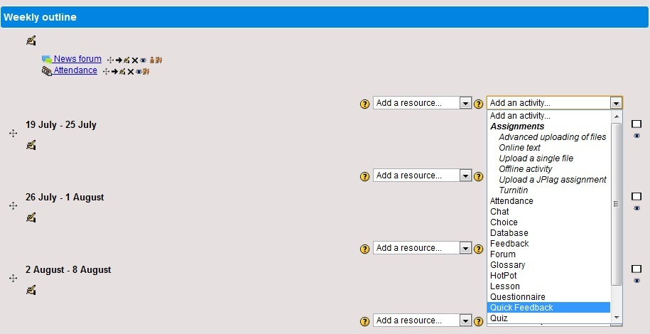Open the course on LMS in which you would like to create this feedback. Click on “Turn Editing On” button in the course; Click on the “Add an Activity” dropdown and select “Quick Feedback” as shown in the screenshot below:

1. **Quick Feedback Settings**

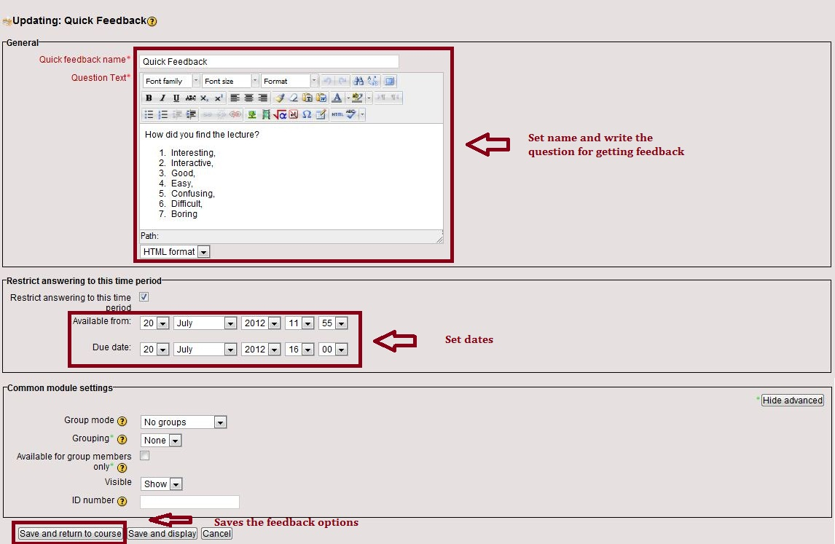The window below would open where the title of the feedback needs to be given and the question text is entered. The duration for which the feedback would be available can also be added and after that the “save and return to course button” is pressed.

1. **View Feedback**

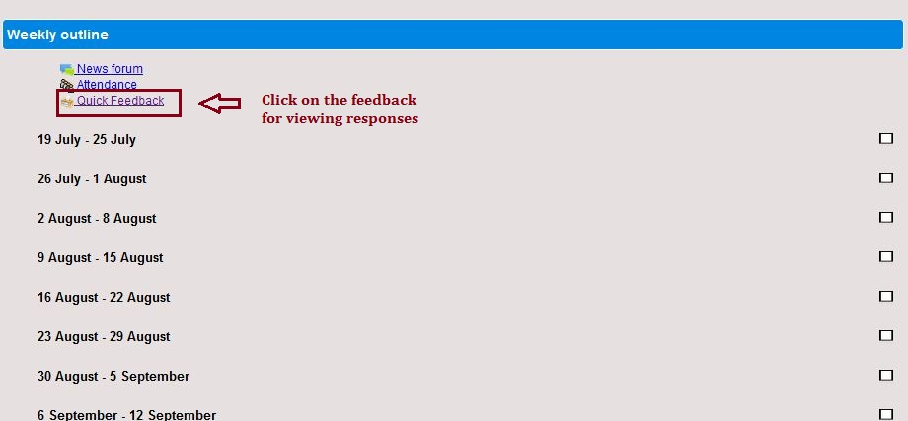The Feedback is now visible in the course view and is available to students for the duration given in the settings as shown in the screenshot:

The responses of the students can be seen by clicking on “View responses” and it would appear in the form of a word cloud as can be seen in the screenshot below:

