PeanutsWifi 测试APP使用说明
此APP主要用于Android手机wifi上下线自动化及背景流量。使用方法如下：
1、安装PeanutsWifi.apk后，打开Peanuts Wifi工具；
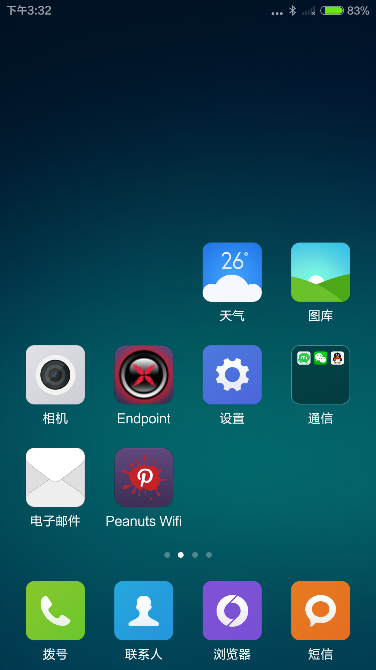
2、界面可显示当前wifi连接情况，手动输入ssid和密码、选择加密类型，点击connect，断开当前wifi后连接指定wifi。
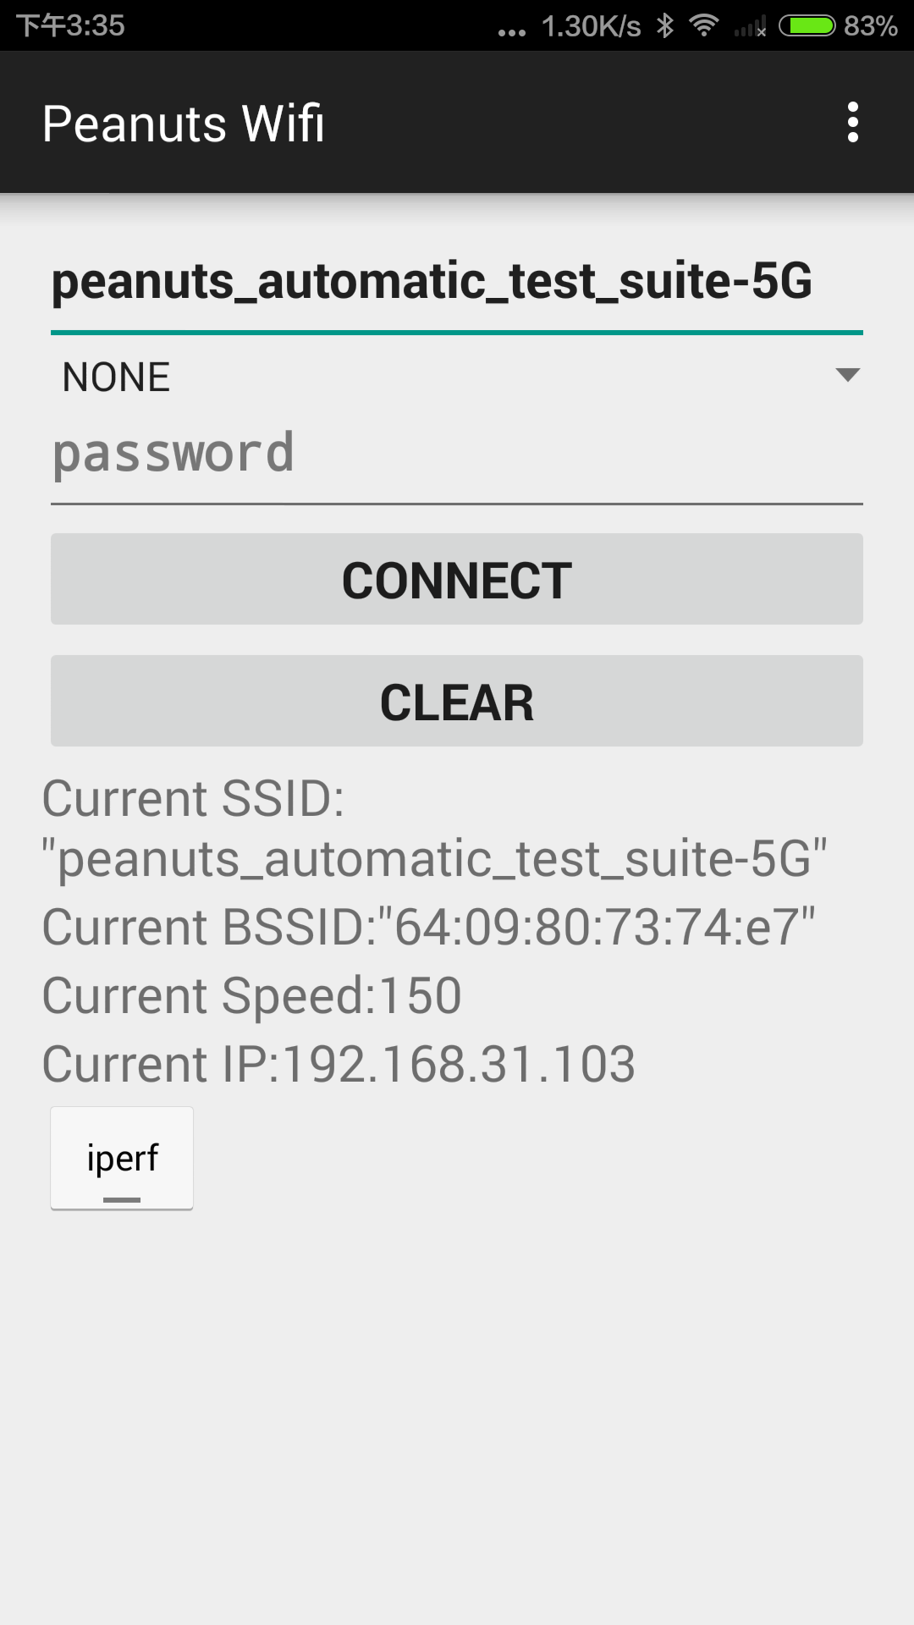
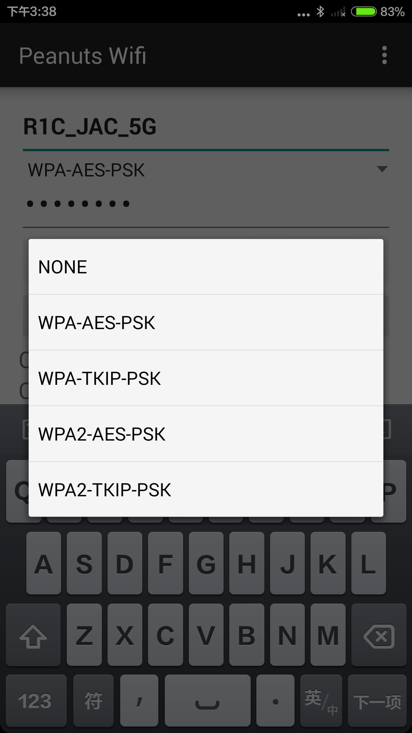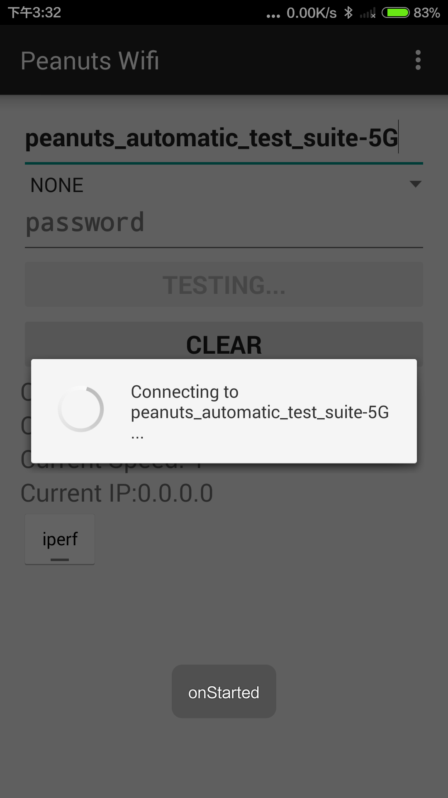
- 点击右上角参数设置，选择Automation settings，勾选Turn on开启wifi自动上下线，可选择参数包括上下线频率（默认30秒）及总共执行次数（默认10次）。
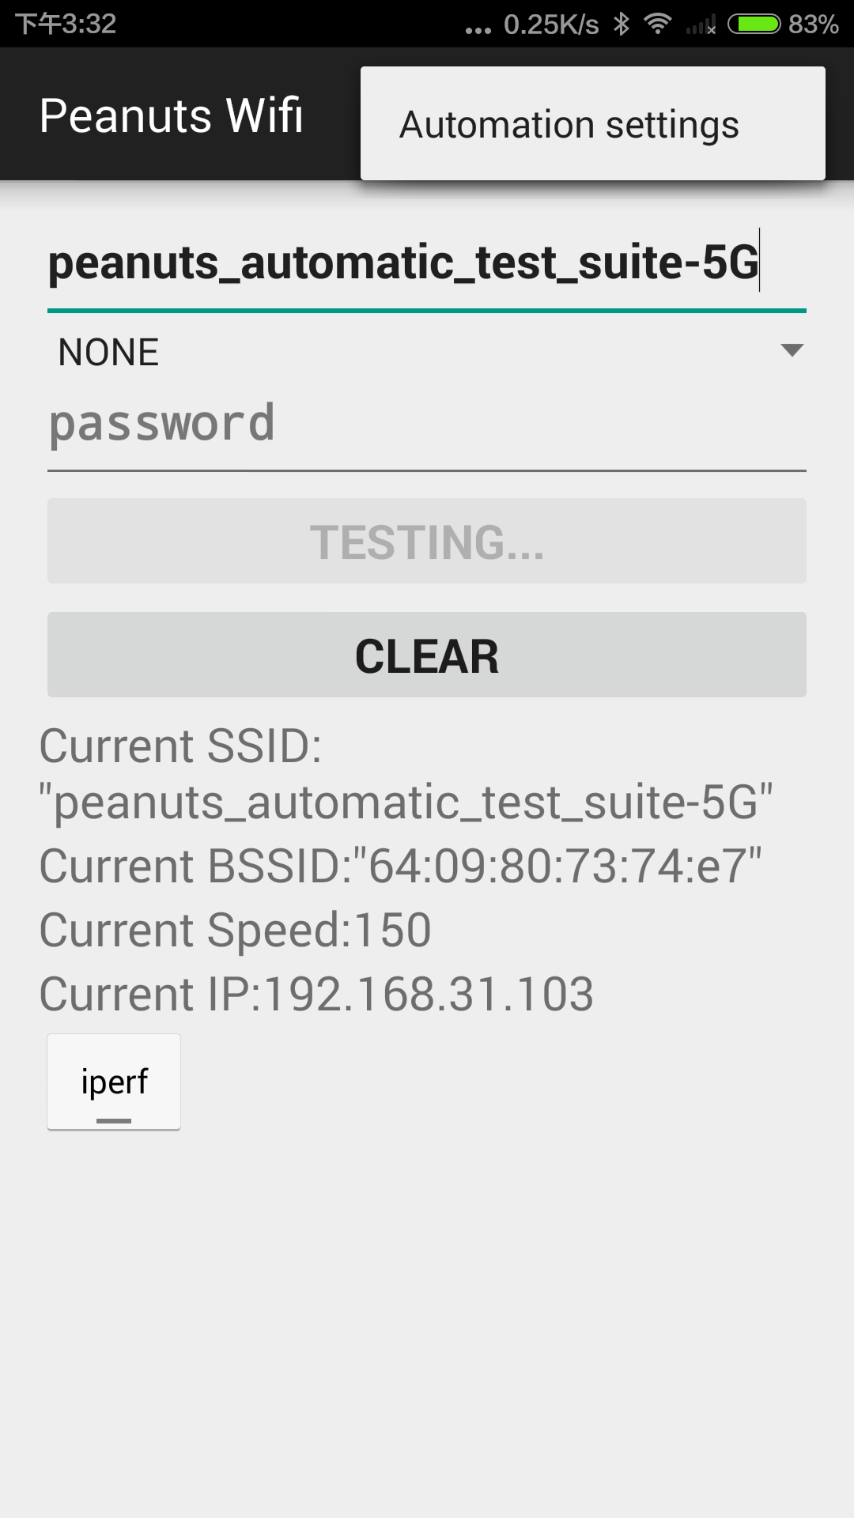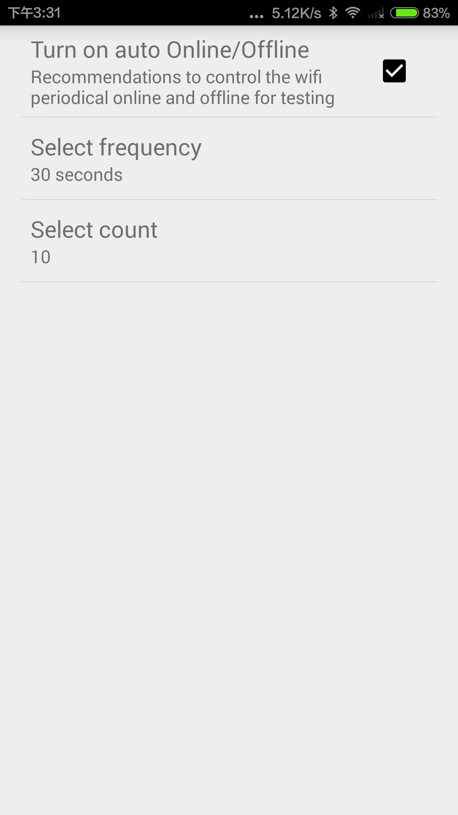
4、退回主界面，点击connect后开始执行自动上下线，如想停止测试，请彻底退出程序。
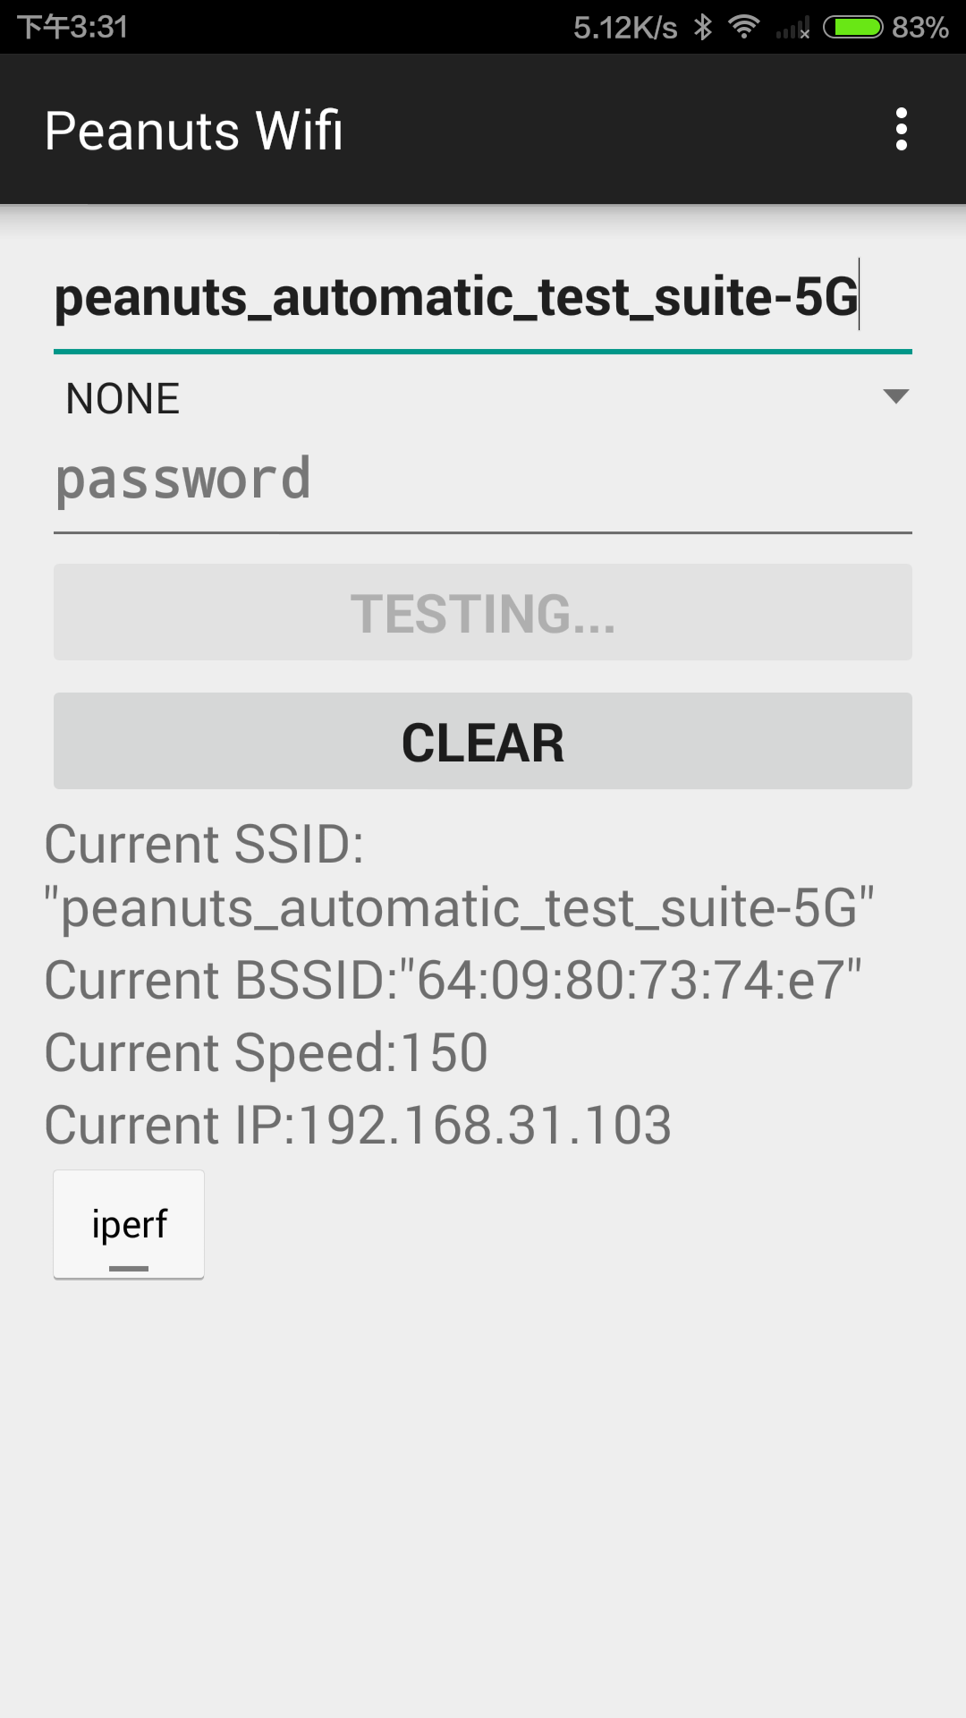
- 此工具集成iperf工具，开启后，可实现带宽测量和背景流量构造。如，在windows上安装iperf后构造与android设备流量。

D:\>iperf -c 192.168.31.103 -t 30 -i 1
------------------------------------------------------------
Client connecting to 192.168.31.103, TCP port 5001
TCP window size: 63.0 KByte (default)
------------------------------------------------------------
[ 3] local 192.168.31.169 port 50819 connected with 192.168.31.103 port 5001
[ ID] Interval Transfer Bandwidth
[ 3] 0.0- 1.0 sec 384 KBytes 3.15 Mbits/sec
[ 3] 1.0- 2.0 sec 896 KBytes 7.34 Mbits/sec
[ 3] 2.0- 3.0 sec 768 KBytes 6.29 Mbits/sec
[ 3] 3.0- 4.0 sec 512 KBytes 4.19 Mbits/sec
[ 3] 4.0- 5.0 sec 128 KBytes 1.05 Mbits/sec
[ 3] 5.0- 6.0 sec 0.00 Bytes 0.00 bits/sec
[ 3] 6.0- 7.0 sec 0.00 Bytes 0.00 bits/sec
[ 3] 7.0- 8.0 sec 0.00 Bytes 0.00 bits/sec
[ 3] 8.0- 9.0 sec 0.00 Bytes 0.00 bits/sec
[ 3] 9.0-10.0 sec 0.00 Bytes 0.00 bits/sec
[ 3] 10.0-11.0 sec 256 KBytes 2.10 Mbits/sec
[ 3] 11.0-12.0 sec 384 KBytes 3.15 Mbits/sec
[ 3] 12.0-13.0 sec 384 KBytes 3.15 Mbits/sec
[ 3] 13.0-14.0 sec 128 KBytes 1.05 Mbits/sec
[ 3] 14.0-15.0 sec 256 KBytes 2.10 Mbits/sec
[ 3] 15.0-16.0 sec 0.00 Bytes 0.00 bits/sec
[ 3] 16.0-17.0 sec 0.00 Bytes 0.00 bits/sec
[ 3] 17.0-18.0 sec 0.00 Bytes 0.00 bits/sec
[ 3] 18.0-19.0 sec 0.00 Bytes 0.00 bits/sec
[ 3] 19.0-20.0 sec 0.00 Bytes 0.00 bits/sec
[ 3] 20.0-21.0 sec 128 KBytes 1.05 Mbits/sec
[ 3] 21.0-22.0 sec 768 KBytes 6.29 Mbits/sec
[ 3] 22.0-23.0 sec 2.88 MBytes 24.1 Mbits/sec
[ 3] 23.0-24.0 sec 1.50 MBytes 12.6 Mbits/sec
[ 3] 24.0-25.0 sec 1.00 MBytes 8.39 Mbits/sec
[ 3] 25.0-26.0 sec 128 KBytes 1.05 Mbits/sec
[ 3] 26.0-27.0 sec 0.00 Bytes 0.00 bits/sec
[ 3] 27.0-28.0 sec 0.00 Bytes 0.00 bits/sec
[ 3] 28.0-29.0 sec 128 KBytes 1.05 Mbits/sec
[ 3] 29.0-30.0 sec 0.00 Bytes 0.00 bits/sec
[ 3] 30.0-31.0 sec 0.00 Bytes 0.00 bits/sec
[ 3] 0.0-31.7 sec 10.6 MBytes 2.81 Mbits/sec

说明：
- 通过setting连接的wifi配置，无法通过app removenetwork
- 从1.0.6版本开始将shutdown wifi改为disconnect ap，这样可以提高连接效率

